Big Era Five

Patterns of Interregional Unity

300 - 1500 CE


Panorama Teaching Unit

Patterns of Interregional Unity

300 - 1500 CE

PowerPoint Overview Presentation
Patterns of Interregional Unity

Table of Contents
Why this unit? | 2
Unit objectives | 2
Time and materials | 2
Authors | 2
Introductory activity | 3
Lesson 1: Population and migration  relatives?  tT | 7
Lesson 2: States and empires  physically human?........................................................................................... | 8
Lesson 3: Trade and transfers of products and technology | 13
Lesson 4: Spread of religion | 16
Lesson 5: Scientific and intellectual exchanges | 21
Lesson 6: Transfer of crops and agriculture | 26
This unit and the Standards in Historical Thinking | 33
Resources ……..33 | 33
Correlations to National and State Standards | 35
Why this unit?
This teaching unit will help students understand and appreciate the many types of interactions that took place among the world’s peoples during the period 300-1500 CE. While many teachers and students are familiar with the histories and contributions of individual civilizations and regions, traditional instructional materials provide few opportunities to link and compare developments that connected societies across regions and around the world. This unit provides an overview of several important varieties of change. Students will get a “big picture” of the rise and fall of empires and states. They will learn how world population changed during this era. They will view examples of cultural exchanges involving trade, migrations, religious expansion, transfer of knowledge, and diffusion of inventions and crops. These exchanges all contributed in one way or another to the speedup of technological, cultural, political, and economic change in the world.

This unit leads teachers and students to appreciate the cross-cultural exchanges that preceded and laid the groundwork for scientific, technological, and other developments often incorrectly assumed to have originated only in Europe. Cultural achievements typically associated only with one particular civilization or another are presented in the larger context of dynamic interrelations among diverse peoples.

Unit objectives
Upon completing this unit, students will be able to:
- Analyze connections between demographic change, migrations, trade, and empire-building, on one hand, and the intensification of cultural exchanges among human societies, on the other, between 300 and 1500 CE.
- Give examples of exchanges that took place in the political, economic, technological, scientific, and cultural spheres, 300-1500 CE.
- Assess the effects of some of the important cultural exchanges that took place during this era.

Time and materials
- Butcher paper
- Black markers for large writing
- Crayons or transparent water-based paint

Time devoted to this unit may vary depending on the number of lessons taught and class time spent on each. Time needed might range anywhere from 60 to 400 minutes.

Authors
Sharon Cohen teaches world history at Springbrook High School in Silver Spring, Maryland. She is a member of the Advanced Placement World History Test Development Committee and a founding member of the editorial board for World History Connected: The EJournal of Learning and Teaching. She joined the World History for Us All development team in 2002.

Susan Douglass is Principal Researcher and Analyst for the Council on Islamic Education, Fountain Valley, CA, and author of numerous teaching units and books on Islam and world history. In 2002, she edited World Eras, Vol. 2, Rise and Spread of Islam (Gale). She joined the World History for Us All development team in 2001.

Introductory Activity: Using the PowerPoint Overview Presentation

Activity 1: How to use the PowerPoint Overview Presentation format
Students take notes from the PowerPoint Overview Presentation regarding the four major factors that increased cultural exchange and helped form patterns of interregional unity from 300 to 1500 CE. Students can use the table in Student Handout 0.1 to record questions they have about the information from the presentation slides.

Students discuss in small groups or as a whole class the questions they raised. If students ask questions that will be addressed in later lessons, the teacher should compliment them by letting them know that they are thinking like historians and that the questions they asked will be answered in the next few lessons.

The teacher may also project the presentation to the whole class on the computer or wall screen, stopping at each slide to help students record the information in the chart. Students are encouraged to write their questions in the third column and to share their questions as the slide is viewed.

The teacher shows students the outline for the subsequent lessons and asks them to match their questions with the lesson outline. If the students’ questions are not addressed in the lessons, the teacher can create lessons to answer those questions, or encourage students to do independent research.

Activity 2: How to use a printed version of the PowerPoint Overview Presentation:
The teacher distributes copies of the PowerPoint Overview Presentation slides to students in small groups. Students use the slides to record the evidence of the four major factors that increased cultural exchange and created patterns of interregional unity from 300 to 1500. They should record their answers in Student Handout 0.2.

As students write down the information from the slides they should also record questions they have about the evidence. Students also write down questions they might like to ask people represented by images in the slides.

Tell students to discuss the questions they raised in small groups or ask students to share their questions as a whole class. If the slide presentation is being used as a preview to the unit, the teacher may tell students that the subsequent lessons will address their questions. If the slide presentation is used as a review of the era, then the teacher may use some student questions as an assessment.
Introductory Activity
Student Handout 0.1—PowerPoint Overview Presentation

Five factors that increased cultural exchange, 300-1500 | Evidence of how these factors  affected cultural exchange | Questions you have about the evidence of cultural exchange
Population Growth and Migration
States and Empires
Trade Networks
Spread of Ideas and Beliefs
Diffusion of Crops and Technologies

Introductory Activity
Student Handout 0.2—PowerPoint Overview Presentation

Five factors that increased cultural exchange | Evidence of how these factors affected cultural exchange | Questions you ask about the evidence of cultural exchange | Questions you would ask the people in slides
Population Growth and Migration
States and Empires
Trade Networks
Spread of Ideas and Beliefs
Diffusion of Crops and Technologies

Lesson 1
Population and Migration

Graph Interpretation
PowerPoint Overview Presentation Slides 8 and 10 show historians’ estimates of world population figures for Big Era Five. Ask students how demographers get data on local, national, and world population during our own era. How do historians gather evidence of population in the recent and distant past? What documentary evidence might be available for ancient times, and how accurate might that data be? Which groups in a society were most likely to be counted or not counted? (Some of the historical evidence on these questions may be found in imperial tax surveys, chronicles of cities, and geographers’ and travelers’ accounts.)

What other methods might demographers use to estimate past populations? (These would include statistical extrapolation from known evidence and information on fertility.) In small groups or as a class, discuss the population trends for each century, over a 500-year period, a 1000-year period, and the whole period of Big Era Five. Ask students to draw upon prior knowledge to make hypotheses about the probable causes of population growth or decline. How might invasions, trade, and the rise and fall of empires have affected population? (For example, there was a major decline in the population of Afroeurasia from 200-600 CE, but then population grew again. What factors might explain that trend?)

Migration
Using the migration map given on slide 16 in the PowerPoint Overview Presentation, identify the groups indicated and associate them with geographic regions of origin and destination. Many major migrations occurred during Big Era Five, which are merely suggested by the map. During your class’s study of this era, assign students to list important migratory movements and the approximate beginning and ending dates. Discuss or write about conditions that gave rise to migrations. (These might include shifts in pastoralism, drought, trade, pilgrimage, invasion, population growth, and the “bumper car effect” of one migrating group on another.) By what means did various groups travel? What evidence of transport technology is available? (See the seafaring vessels shown on the map and investigate types of animals, harnesses, and vehicles used in transport.) How have peoples expressed their migrations culturally? What evidence can be found that newcomers dominated others already living in a region or that the newcomers assimilated to the existing society? (Categories here might include language, religion, cookery, dress, music, visual arts, architecture, and military technology.)

Lesson 2
States and Empires

Part One

Teacher Notes
Students will have prior knowledge of some, though not all of the states and empires that were prominent between 300 and 1500 CE. This lesson will help students learn or review the names, locations, and duration of the major states and empires of the era. Students will discover where states and empires have existed in a single region. This raises questions about historical succession. The lesson should prompt students to ask questions about why one empire replaced another or why most empires in the era tended to be located in particular areas of the world (for example, China but not Australia, the Mediterranean region but not Canada).

Lesson Procedure
Using the political maps on the PowerPoint Overview Presentation slides 20-23, assess students’ prior knowledge of what political maps signify and what symbols (for example, shading) are used to indicate the territory that specific states or empires ruled.

Drawing on their prior knowledge, students should construct maps on blank pieces of paper that show the major states and empires that existed in 1500 for the Americas and in 600, 800, 1237, and 1400 CE for Afroeurasia. It may take students ten to fifteen minutes to create a north-south-east-west orientation, sketch an outline of the continents, and record the location of the major states and empires from memory. Tell students that they will not be graded on the correctness of the continent shapes or the location of the states and empires.

While students are making their maps, the teacher should give positive feedback of students’ accomplishments. For example, “As a group, you know quite a bit about which states and empires existed from 300 to 1500 CE.” Then, tell them that the lesson will help them learn or relearn what states and empires were prominent during the era. Organize students in pairs or small groups to transfer information from a series of maps into a simple chart with columns for the names of states and empires, the regions they dominated, and the duration of their political control (see Student Handout 2.1). Tell students that they can use the table and the maps to study for a quiz. Ask students to discuss how political control of a region for a period of time might have affected economic life, cultural traditions and values, religion, and style of government.

Extension activity
Ask more advanced students why they may remember certain states or empires rather than others. Why have some empires, the Roman empire for example, received more attention than others in textbooks, movies, television, and literature? Students who have attended schools outside the U.S. may contribute their own experience of gaining knowledge about empires of the past. For example, students might report that empires they learned about in their school in the country they came from was different from the ones that most students know about.
Lesson 2
Student Handout 2.1—States and Empires

State or empire name | Dates of rule | Geographic region

Part Two

Have students use the maps indicated in Part One to trace historical succession for states and empires in Big Era Five. Have the class use the Student Handouts and activities below to discuss the following two questions:

- Which empires and states existed in the same regions?
- What geographical factors might have made some regions more favorable than others for the development of states?

Using the climate and vegetation maps (Student Handouts 2.2 and 2.3), have students correlate them with the political maps in order to find out what physical regions and topographical features were encompassed by various states and empires.

Ask students also to consider how a map might be designed to show that the borders of empires expanded and contracted over time and that they were fuzzy and fluid, not sharp and fixed. How might students use computers to design maps that show how empires changed over time?

As an extension activity, scan relevant chapters in the textbook used in class to identify which states and empires get more coverage than others. Discuss what factors might determine how much coverage an empire gets in a textbook. What criteria might textbook authors use to determine which states and empires receive the most attention? Teacher and students might also discuss this issue using the National Standards for World History or state/local content standards.

Assessment: Twister “Find the Empire” Political Geography Game

This activity is designed to put some dynamism into the exercise of memorizing location and time period (historical succession) of states and empires. It is especially appropriate for Big Era Five, when political change was quite rapid.

Students work in small groups to create large maps of the hemispheres, with states and empires in the regions outlined and labeled for each of the time periods shown in the PowerPoint Overview Presentation slides 22-23. Each group reproduces the maps sized large enough so that all members of the group can stand on their map. Have them use colored markers or crayons to shade in the major states and empires in the locations where they belong.

Students tape the big maps of the states and empires to the floor of the classroom. Students then stand in a circle around the maps, either around each individual map or around the group of maps. Then, the teacher calls out a name of a state or empire, and students identify the correct time period map. They also locate the state or empire by placing one hand or one foot on the correct shaded area, taking a maximum of ten seconds to act. The teacher calls out another name of a state or empire, and another student puts a hand or a foot on the correct spot. The winner is the first player who identifies four states or empires by placing all four limbs on the map at once.
Lesson 2
Student Handout 2.2—States and Empires

Map: ©Houghton Mifflin Co.
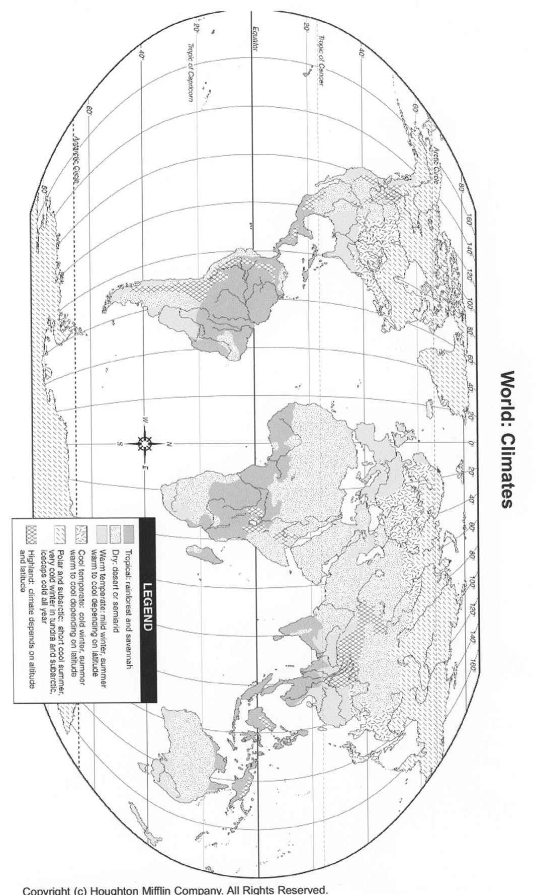

Lesson 2
Student Handout 2.3—States and Empires

Map: ©Houghton Mifflin Co.
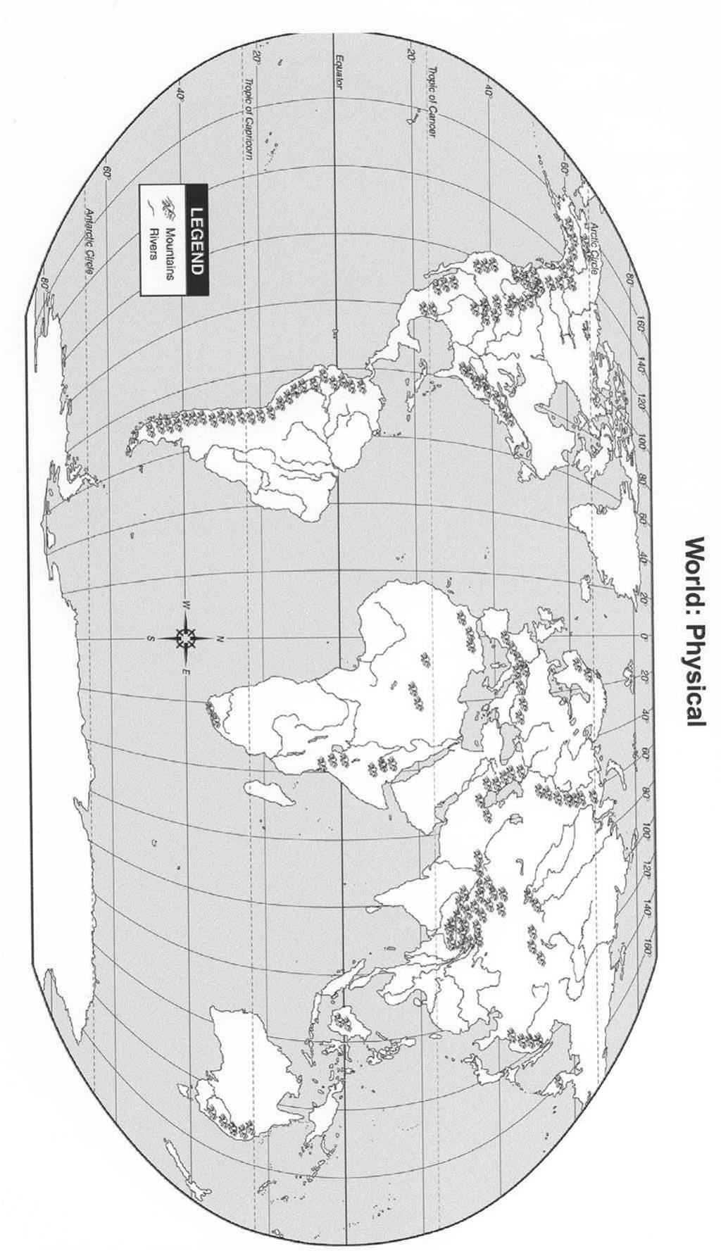
Lesson 3
Trade and Transfers of Products and Technology

The following activities are intended to get students thinking about the transfer of knowledge, technology, and products as a hallmark of Big Era Five.

Procedures
First, assess students’ prior knowledge of map symbols used to indicate routes and places connected with trade during specific historical periods. Using a trade route map in a textbook or other source, ask students to:
- List ten cities through which trade routes passed.
- List all the major seas and oceans that trade routes crossed.
- List geographic regions (e.g., West Africa, Southwest Asia, South Asia, Southeast Asia, Inner Eurasia) that were connected by trade routes with other regions.
- List geographic areas that may have been only infrequently connected by trade routes to other regions, or never connected at all.

In groups of five or six, have students use trade route maps to discuss the following questions, filling in the chart of technologies, goods, and ideas (Student Handout 3.1). A trade route map may found on slide 27 of the PowerPoint Overview Presentation for this era. Other maps may be found in Marshall G. S. Hodgson, The Venture of Islam, Vol. 2 (Chicago: University of Chicago Press, 1974), 75, or in Francis Robinson, ed., Cambridge Illustrated History of the Islamic World (Cambridge: Cambridge UP, 1996), 126.

- Which trade goods may have moved within regional networks and which ones may have been traded on long-distance routes? (Bulk, perishable, and relatively cheap goods locally or regionally; light-weight, precious, prestigious, and expensive goods on long-distance routes.)
- Which crops or resources were particular goods made from, and what technologies were needed to process or manufacture them? (Cotton, metals, clay, dyestuffs, wood, precious stones.)
- What kinds of people or groups might have transferred these items within or between regional networks during Big Era Five? (Merchants, pilgrims, soldiers, migrant farmers, pastoral nomads, and itinerant scholars.)
- Give examples of items that were widely distributed across Afroeurasia during this period. (Paper, silk, cotton, gunpowder, stirrup.) What geographic factors might have caused some items to be desirable in specific regions? (Arid lands need irrigation devices, areas affected by disease need medicines and medical techniques, maritime routes need useful transport technology.)
- What factors in specific regions may have facilitated or motivated people to trade and travel during Big Era Five? (Opportunities for income and profit, religious pilgrimage, invasion, flight from drought or flooding, governments present to maintain and protect routes, and growth of cities.)
- As a class, discuss what factors might have facilitated the movement of some items within specific regions? Across regions? Across Afroeurasia? (Usefulness of new inventions, culture-specific goods in demand like incense for religious rituals, fibers such as cotton, linen, furs and wool suitable for specific climates, books and manuscripts for religious use.)
- How did increases in regional or hemispheric population affect the transfer of crops, trade goods, technologies, and ideas? (It created a demand for goods, increased the available labor force, caused urbanization, or brought more people into contact with one another.)
- What kinds of places were involved in the transfer of goods, ideas, crops, and technologies across the hemisphere? (Permanent and seasonal markets, urban bazaars, royal courts, libraries, universities, caravansaries, monasteries, landowners’ estates, castles, route junctions, and river crossing-points.)
- How did the introduction of specific technologies during Big Era Five affect societies that received them? What evidence might be found to show that an item was accepted, modified, or rejected?
- To include the Americas in this activity, list items that were traded among indigenous American groups (Turquoise, mica, gold, silver, shell). Discuss as a class what might make it difficult for historians to create maps of trade networks in the Americas for Big Era Five? (Lack of written records, disappearance of some groups after 1500 CE, loss of languages, and incompleteness of archaeological record.)

Assessment
Have students use maps and discussions to fill in the chart (Student Handout 3.1) with ideas about the agents, environments, and characteristics of major transfers of technology during Big Era Five, including discussion of modifications to these technologies. (Various fibers for paper, translations of books, new forms of stringed and wind musical instruments, forms of arms and weapons, gunpowder applications and delivery systems, design of sails and ship hulls.) Students may use the information on the charts and maps to perform skits showing how the transfer of goods, ideas, and technologies took place in Afroeurasia.

Lesson 3
Student Handout 3.1—Trade and Transfers of Products and Technology

Technology | Probable place of origin | Type of person who transferred it | Type of place where it might be transferred | Regions it reached | Modifications to the technology across regions
paper
gunpowder
sugar
books on law
books on astronomy and mathematics
books on medicine
stringed instruments
navigation instruments
windmills
waterwheels

Lesson 4
Spread of Religions

Have students examine the map showing the spread of belief systems on slide 31 in the PowerPoint Overview Presentation for Big Era Five. Then ask students to complete the chart (Student Handout 4.1).

If this Panorama Teaching Unit is used as an introduction to Big Era Five, have students fill in the chart drawing on their prior knowledge. If this unit is used as a summative or review activity for Big Era Five, then students should fill it in based on what they have learned. Use the information on the chart to discuss the following questions:

- What were the major religions or other belief systems that spread widely during Big Era Five?
- In which regions of Afroeurasia did the spread of belief systems overlap? Which regions were relatively homogeneous in belief systems?
- What factors might have contributed to the spread of belief systems from 300 to 1500 CE?

Have students read “Overview of the History and Teachings of Islam” (Student Handout 4.2). This essay introduces the last of the major world religions, which emerged in Big Era Five. Have students compare and contrast Islam with the major religions that emerged in Big Era Four, in terms of origin, beliefs, geographic spread, and cultural impact.

Ask students to compare the maps of trade routes and spread of religions in the PowerPoint Overview Presentation to hypothesize about possible relationships between routes of trade and the spread of particular religions in this era. Students may also compare the maps on the rise and fall of empires with the spread of religions map to hypothesize about possible relationships between the success of particular religions and the status of particular empires.
Lesson 4
Student Handout 4.1

Name of belief system | When was the origin of this belief system? | Region of origin | Regions where it spread | States & empires associated with the belief system
Buddhism
Christianity
Confucianism
Hinduism
Islam
Judaism
Daoism
Zoroastrianism

Lesson 4
Student Handout 4.2—Overview of the History and Teachings of Islam

Islam is the third of the major monotheistic faiths, meaning those whose followers believe in One God. Judaism, Christianity, and Islam all trace their origins to the teachings of prophets, or messengers, who received revelations passed down as holy scriptures. Followers believe that these scriptures are the word of God, or inspired by God.

Based on the teachings of the Qur’an, the holy scripture of Islam, Muslims trace the origins of their faith to the first prophet, Adam, to whom God revealed Himself. The Qur’an teaches that God repeatedly sent prophets to humankind with the same basic message of belief in One God and of the necessity to worship and act according to strong moral standards. The prophets and their scriptures are recognized by Muslims as having the same divine source, so the major biblical prophets Noah, Abraham, Moses, and Jesus, as well as lesser known prophets, are honored in Islam. This religion teaches that earlier scriptures were sometimes lost or altered, or were superseded by later revelation. Therefore, Muhammad, the final prophet, completed God’s message to humankind.

The word Islam means “peace through submission to God.” A Muslim is “one who seeks peace through submission to God,” that is, a follower of Islam. The Qur’an teaches that all prophets were Muslim in the sense that they were models of submission to God and seekers of truth. Muslim practice is defined by the Qur’an and also by the Sunna, which is the example of thinking and living set by the Prophet Muhammad and transmitted through the Hadith, his recorded words and deeds. The Islamic requirements of worship are set down in the Five Pillars. These are:

- Shahada. To testify to belief in One God and the prophethood of Muhammad.
- Salat. To pray five obligatory prayers each day.
- Siyam. To fast from dawn to sunset annually during the month of Ramadan,
- Zakat. To pay annual obligatory charity,
- Hajj. To make the pilgrimage to the city of Mecca (Makkah) at least once in a lifetime.

Islamic teachings also lay out a way of life based on moral values and commandments for just relations among human beings in the community and the world. Islamic law, or shari’a, is a system of interpretation of the Qur’an and Sunna based on scholars’ study of the Islamic sources and related disciplines, including logic and Arabic grammar.

Historically, the origin of Islam is the revelation received by Prophet Muhammad, a man born about 570 CE in the city of Mecca, a caravan stop on a trade route that ran along the western side of the Arabian Peninsula between Yemen and the Mediterranean region. Mecca was also the site of an important house of worship called the Ka’bah, which the Arabs associated with the Prophet Abraham (Ibrahim) and his son Ishmael (Ismail).

Muhammad was born into the Quraysh, which was the ruling tribe of Mecca. The Quraysh were caretakers of the Ka’bah and leaders in the regional caravan trade. Orphaned at an early age, Muhammad spent his youth in the care of his socially prominent grandfather and uncle. He worked as a caravan trader, which led to his marriage to the wealthy widow Khadijah. He was known for wisdom and honesty. At about the age of forty, after years of spiritual searching and meditation, he reported receiving a revelation through the Angel Gabriel (Jibril) in a mountain cave outside the city. These revelations continued for the following twenty-three years, between about 610 and 622 CE.

The revelations were transmitted by Muhammad to his followers in Arabic, and they were memorized and committed to writing during his lifetime. These words were known as the Qur’an. Muslims believe this text to be the direct word of God, whose name in Arabic is Allah. The names of the religion, Islam, and its followers, Muslims, were given in the Qur’an.

Soon after Muhammad’s special experiences started, he began to carry out the duties of prophethood, preaching first to members of his family, then to members of his tribe, and finally beyond Mecca. While a few members of his immediate family and others in Mecca accepted his prophethood and its teachings, the leaders of his tribe rejected it. They tried to turn him away from preaching by persuasion and coercion. Finally, with the number of Muslims growing, and the message reaching beyond Mecca, Muhammad and his followers fled to the city of Yathrib which is north of Mecca, where the residents offered them protection. The people of Yathrib agreed to Muhammad’s leadership of the city, and renamed it Madinat al-Nabi, or “City of the Prophet” (shortened to Madina). The migration to Madina is called the Hijrah, and marks the beginning of the Islamic calendar. The Hijrah of year one occurred in 622 CE (Common Era).

The leaders of Quraysh, fearing loss of control and influence if Islam continued to gain strength, continued to oppose Muhammad and his followers. The Muslims, on the other hand, had lost all their property and family ties in order to escape persecution. The years following the Hijrah were marked by conflict between Quraysh and the Muslims, including several major battles and a treaty. The conflict ended with the surrender of Mecca to Muhammad. This was a bloodless victory. Islam had experienced overwhelming growth in strength during the ten years at Madina, attracting followers throughout Arabia and coming to the attention of the Byzantine and Persian Empires, the two major regional powers.

Following Muhammad’s death in 632 CE, the Muslim community became well established in the Arabian Peninsula. Muslims represented a growing political, military, and religious force in the region. Four successors to Muhammad’s political power, called the “Rightly Guided Caliphs,” carried on the legacy of his leadership, but not his prophethood or revelation. Caliph, or in Arabic khalifa, means “successor of the messenger of God.” During the following century, the Muslim state expanded to incorporate a vast territory extending from North Africa to Inner Eurasia. The early state of the “Rightly-Guided Caliphs” gave way to a civil war over the succession in 660 CE, resulting in the founding of the Umayyad dynasty, with its capital at Damascus, Syria. In 750 CE, a revolution against the Umayyads resulted in the founding of the Abbasid dynasty, with its capital at Baghdad, which lasted until 1258 CE.

During the centuries following the rise of Islam and the expansion of the Muslim state, the religion spread among the populations of Muslim-ruled territories in Afroeurasia. The growth of cities was both a cause and an effect of the spread of Islam and of economic growth in Muslim-ruled areas. Cultural developments in literature, arts, sciences, manufacturing, and trade accompanied the spread of Islam and its influence on religious, intellectual, economic, and political life in a large part of Afroeurasia. Although unitary Muslim rule lasted only about a century, both the spread of Islam and the development of Muslim culture and society continued to flourish. By 1500, Islam had spread to West and East Africa, to western and coastal China, and to India and parts of Southeast Asia. It was also advancing in southeastern Europe and experiencing permanent loss of territory only in the Iberian Peninsula owing to the conquests of Christian Spanish and Portuguese.
Lesson 5
Scientific and Intellectual Exchanges

In this lesson students analyze historical evidence and interpretations of scientific and intellectual transfers during Big Era Five. For homework, have students read Shaffer’s essay “Southernization,” or the summary of this essay (Student Handout 5.1). The full text of this article may be found in:

- Journal of World History 5 (Spring 1994): 1-21.
- Ross E. Dunn, ed., The New World History, A Teacher’s Companion (Boston: Bedford St. Martin’s, 2000), 175-191.
- Heidi Roupp, Ed., Teaching World History: A Resource Book (Armonk, NY: M.E. Sharpe, 1997), 110-118.

As they read the essay, students should consider the following questions:

- What does Lynda Shaffer mean by “southernization”?
- What is the thesis of her essay?
- How did Arabs and Mongols contribute to southernization?
- Why does she say that Europeans were most fully affected by southernization after they acquired tropical colonies?
- Do you agree with her thesis? Why or why not?

Discuss “Southernization” in a brief Socratic seminar. Split students into two groups, A and B. Students in group A discuss the essay based on questions 1 and 2. The second group discusses it based on questions 3 and 4. The whole class discusses question 5. The teacher only speaks to start and end the discussion session, reminding the students that each one must make one comment about the article and must ask one question of the group or an individual about the reading. Students get full credit if they make two contributions to the discussion but lose points if they prevent others from making two contributions. The entire discussion (both groups) should only last about 20 minutes, 10 minutes for each group.

Use the map activity titled “Paper Trail” (Student Handouts 5.2, 5.3, and 5.4) to help students trace and date the spread of papermaking technology across Afroeurasia and to identify some historical evidence documenting its diffusion. The transfer of papermaking is a good example of a technology transfer during Big Era Five. Its diffusion is historically well documented for parts of Afroeurasia. Paper also had a wide-reaching cultural, intellectual, religious, and economic impact because as a writing material it is lightweight, inexpensive, forgery-resistant, recyclable, and easy to manufacture from a variety of fibers. Have students cut out the callouts about evidence of the spread of paper and glue them onto the outline map in the proper geographic location.
Lesson 5
Student Handout 5.1—Summary of essay by Lynda Shaffer titled “Southernization.”

This article has generated controversy in the field of world history for making sweeping claims about the contribution of Asians to the development of ideas, agriculture, and material life across the world. The argument contrasts with the familiar claim that the making of the modern world has been a process of Westernization led by Europe and Europeans. Many scholars have found her thesis convincing. Others have not, rejecting, for example, her suggestion for a revised periodization of world history.

Summary of her major arguments: “Southernization” is Shaffer’s term for the contributions of Asians to the development of ideas, agriculture, and material life between the fourth and eighteenth centuries. She deals with the major crops, ideas, and inventions that Indians, Malays, and Chinese developed. Her argument is that southernization preceded westernization and that the economic development of Europe was dependent on Asian inventions and ideas. A list of relationships among key foods, ideas, and goods follows:

- Cotton from India contributed to sail-making for Chinese ships.
- Gold from Siberia, the Malay peninsula, and Zimbabwe contributed to production of coins for trade.
- Indian, Persian, Arab, East African, and Malay knowledge of monsoon wind patterns contributed to the development of trade routes throughout the Indian Ocean basin.
- Indian development of cinnamon and pepper production and trade made these spices available throughout Afroeurasia. Malay development of nutmeg, clove, and mace production and trade had similar impact.
- New Guineans originally grew sugar cane, and Indians later invented crystallized sugar.
- Indians’ full development of the concept of zero in Afroeurasia contributed to advances in mathematics in Southwest Asia, China, Europe, and all over the world.
- Fast-ripening Champa rice from the Malay peninsula contributed to China’s population increase during Sui and Tang Dynasties (sixth-tenth centuries), which in turn contributed to China’s remarkable urbanization, commercialization, and industrialization between the eleventh and thirteenth centuries.
- Chinese invention of the compass contributed to advances in maritime navigation that allowed longer sea voyages out of sight of land.

Shaffer then explains how Muslim and Mongol empires contributed to spreading ideas and goods throughout Afroeurasia, and very importantly to the European peoples north of the Mediterranean. Without southernization first, the Portuguese would not have rounded Africa and reached the coast of India in the sixteenth century. Moreover, she argues that the early European nations needed to make colonies in tropical and subtropical areas in order to control basic goods like sugar, cotton, spices, and rice, whose spread had resulted from southernization. Shaffer concludes that “westernization” which is associated with industrialization, capitalism, and international trade, owes a debt to the peoples who earlier achieved southernization.

Lesson 5
Student Handout 5.2—Paper Trail Map Key
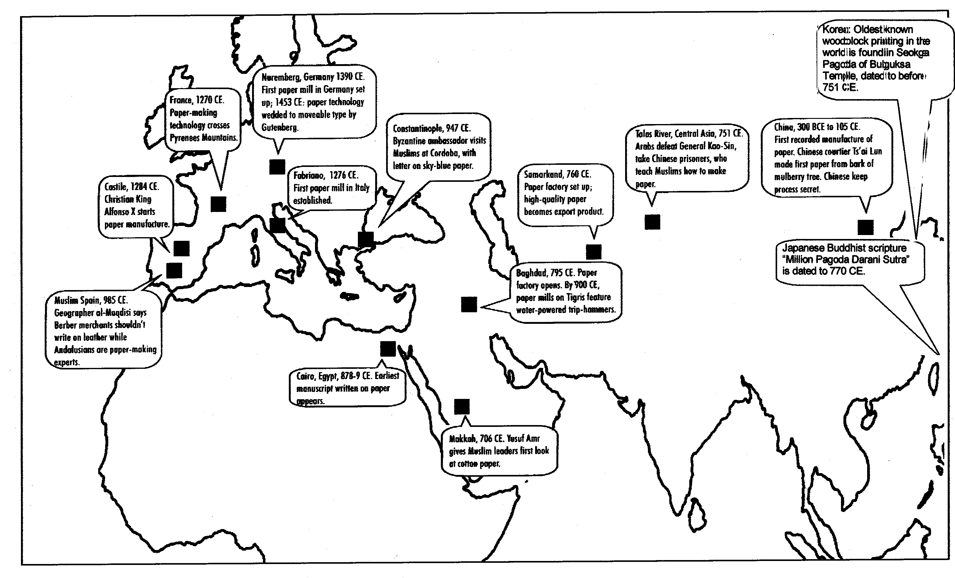
Map from S. Douglass and K. Alavi, Emergence of Renaissance Cultural Interactions between Europeans and Muslims (Council on Islamic Education, 2000), 127-129.

Lesson 5
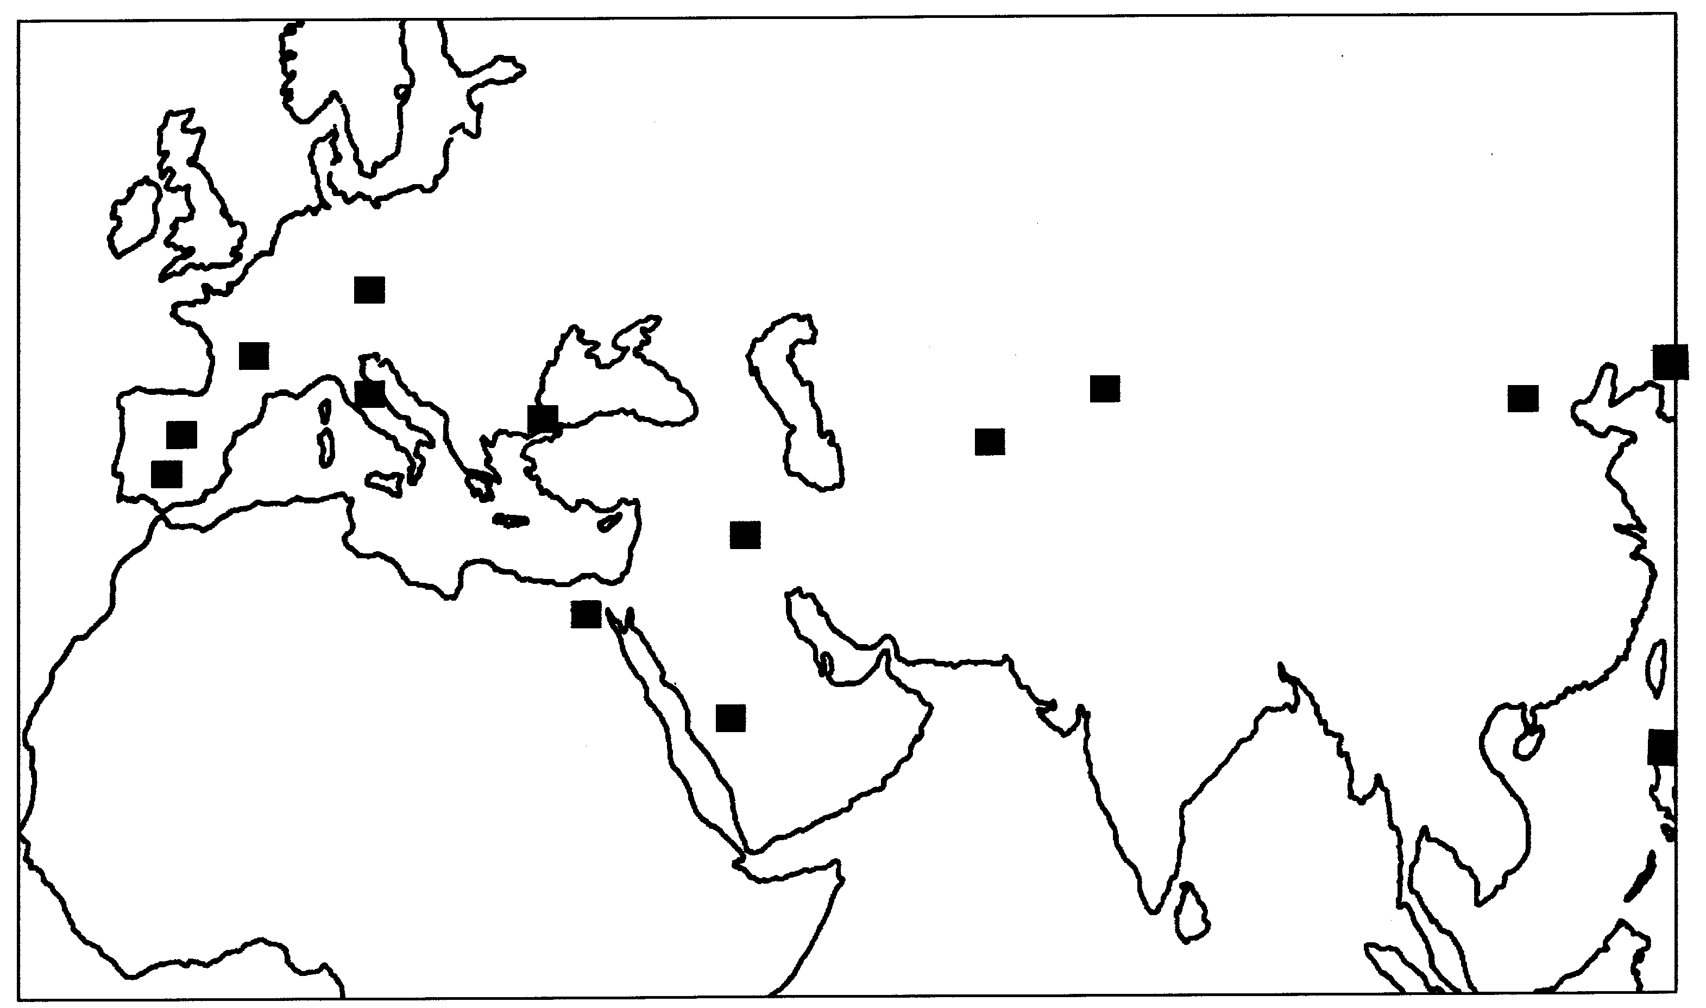
Student Handout 5.3—Paper Trail: The Spread of Paper-making Technology

Map adapted from S. Douglass and K. Alavi, Emergence of Renaissance Cultural Interactions between Europeans and Muslims (Council on Islamic Education, 2000), 127-129.
Lesson 5
Student Handout 5.4—Paper Trail Text Balloons

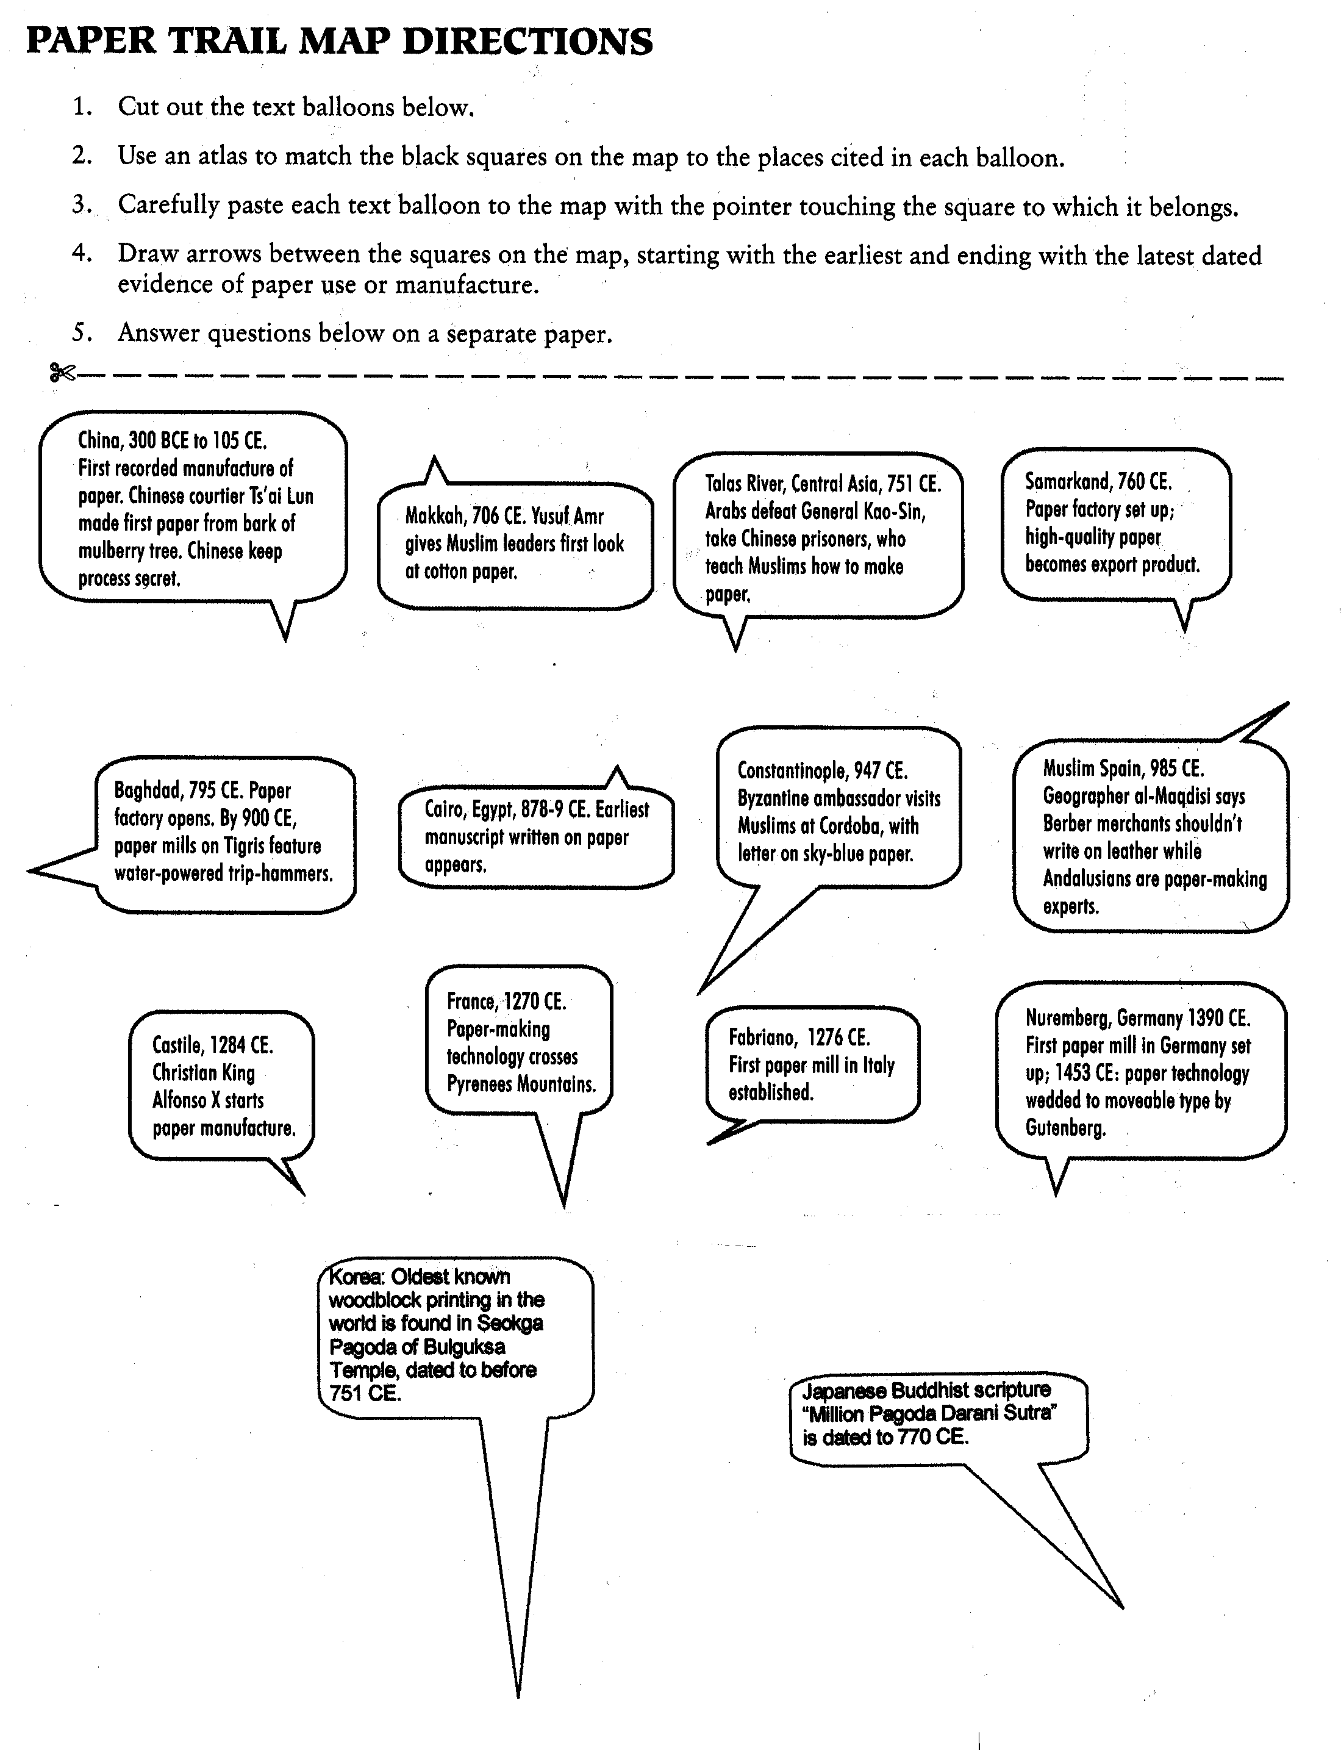
Lesson 6
Transfer of Crops and Agriculture

Have students read Student Handout 6.1. Discuss factors necessary for a new plant or animal to be introduced by farmers. Have students think about or research specific historical examples of agents and media for diffusion, and how the political, cultural, and economic features of societies may have encouraged or discouraged crop or animal diffusion. Students can use the key on the map in Student Handout 6.1 to trace the routes by which major crops diffused before and during Big Era Five. Have them make historical hypotheses about paths of diffusion, agents, cultural mediums, and demand and supply factors in relation to particular regions shown on the map. How accurate might such a map be? What examples of evidence are likely valid or questionable in explaining the appearance of a new food in a place?

Use Student Handout 6.2 to help students discover the characteristics of particular crops that diffused during Big Era Five. Have students identify what created demand for the crop, where it grows today, and what conditions it needs to grow (for example, irrigation or rainfall, hot or cold weather, special means of propagation). Have students use the Internet to find out the volume of trade in these crops today, and the major importers and exporters. What additional crops have become important globally since 1500 CE?
Lesson 6
Student Handout 6.1—Transfers of Crops and Agricultural Techniques Across Afroeurasia, 300-1500 CE

Between 300 and 1500 CE, many of the food and industrial crops that we know today diffused over great distances across Afroeurasia. Important nutritional staples such as rice, hard wheat, and sorghum were added to the diets of larger numbers of people in areas where they were never grown before. Vegetables such as spinach, asparagus, artichoke, and eggplant enriched cuisine in new places, and fruits such as oranges, bananas, apricots, and melons added vitamin-rich refreshments to peoples’ tables. Sugar became an irresistible and increasingly affordable sweetener in many new lands. Cotton, a vegetable fiber that was inexpensive, washable, absorbent, and colorful, was made into fabrics for all classes of people. It could be woven strong enough for sails and tents, and fine enough for see-through veils and laces. Animal products such as silk, wool, milk, and meat also traveled along the routes of diffusion. Some domestic animals—camels, horses, oxen, donkeys—were bred for pulling and carrying products along the trade routes.

The story of how these crops and animals traveled across the hemisphere is less famous than the trans-oceanic “Columbian exchange” of the sixteenth century CE. In fact, earlier exchanges across Afroeurasia paved the way for the Columbian exchange between the Western and Eastern Hemispheres. Historians have asked questions about:

- Paths of diffusion: By what routes did plants and animals reach new lands, and when?
- Agents of diffusion: Who first brought them to new lands?
- Mediums for diffusion: How did culture play a role in encouraging or resisting diffusion?
- Demand and Supply: Why did people in particular regions want to raise new crops? What factors enabled farmers to grow new crops?

Paths of diffusion: Tropical Southeast Asia was the source of many food and fiber crops that diffused during Big Era Five. First cultivated by farmers there, they spread to India, where they were first cultivated on a large scale. As they passed through India, the plants were refined for higher yields and other desirable qualities that improved their value as field crops. Another pathway to India led from East Africa via Yemen at the southern end of the Arabian Peninsula. Other crops originated in India, and its women and men played important roles in the agricultural development of Afroeurasia. Evidence from literary and other sources shows that during the Islamic period, starting in the seventh century CE, many crops diffused rapidly across the Mediterranean to North Africa, Spain, and West Africa and eastward to China. During the Mongol empire, a species of lemon was introduced from Persia to China, and a type of millet from China to Persia. After 1500 CE, certain crops, including sugar, rice, bananas, indigo, and cotton, crossed the Atlantic, where they played important roles in European colonization of the New World. Many are still global cash crops today.

Agents of Diffusion: Many sorts of people were involved in diffusing crops across Afroeurasia. The most obvious agents of transfer were farmers who migrated to new lands, taking seeds and animals with them. After all, they had direct knowledge of how to grow and raise these products. Some plants do not multiply by seeds, but by cuttings and grafting. Others, such as rice, need special care at certain times. Rice seedlings have to be put into flooded fields at a particular time of year and the fields later drained so that the crop will ripen. Both irrigation and animal breeding techniques are specialized skills required for success in a new environment. At the top end of the social scale, royalty also played an important role in diffusion. Kings and queens received gifts from ambassadors that sometimes included rare plants for royal gardens and even a gardener to go with these plants. Military expeditions sometimes included scientists and geographers who collected plant and animal specimens, for example the scholars who accompanied Alexander the Great on his conquests in the fourth century BCE. Traders and pilgrims were more likely to bring news of new products than the plants or animals themselves, but they might also be harbingers of later diffusion.

Mediums for Diffusion: Movement of people, goods, and ideas favors diffusion. A major reason for the rapid transfer of crops during Big Era Five was the rise and spread of Islam. The conquest of a huge territory at the center of Afroeurasia and the subsequent creating of human links through a common religion and language (Arabic) encouraged rapid diffusion. The diverse regions connected together contributed native crops and farming practices, aided by economic prosperity and urbanization. The development of Muslim culture was a dynamic process of mingling among ethnic and religious groups. People were encouraged to make pilgrimages, trade, migrate, and spread learning. Further east, China under the Tang dynasty (618-907 CE) reached a high level of manufacturing, trade, and agricultural production that involved diffusion of important crops such as sugar, cotton, and new varieties of rice. Along the trade routes, fruits and vegetables traveled in iced packing for the wealthiest consumers, but dried fruits and grains reached ordinary tables in quantity. Books on medicinal plants, veterinary medicine, and nutrition carried with them the seeds of demand for new crops. Wealthy rulers and elites opened new lands to irrigation and farming on a large scale.

Demand and Supply: Introduction of a crop or domestic animal alone does not amount to diffusion, because it may not become established in its new home. For example, finding historical evidence in a document of the introduction of a plant to a particular society is helpful but insufficient. The mention of a crop in a marketplace, cook book, poem, picture, song, or land tax records is evidence that it was successfully introduced. To become important, however, a new crop had to be in demand. Farmers are almost always conservative, because their investments in land, seed, and labor must succeed every year if they are to survive. They cannot risk producing what people may not want to buy. People do not easily change what they eat and wear, but an expanding society that is prosperous and open to novelty more easily creates demand. For example, the development of a sophisticated, urban Muslim society encouraged acceptance of new ideas, demand for new products such as cotton textiles, and desire among ordinary people to imitate what the wealthy elite consumed. Opening new lands to farming, building and maintaining irrigation works, providing ample labor, and encouraging merchants and sellers to ply their trades all increased the supply of new products.

The most remarkable part of the story of agricultural diffusion is the long period of time and the diversity of people involved in the cultivation, refinement, and spread of crops and animals. Also, intellectual and spiritual influences were as important as the economic and political factors. Crops evolved and moved with the history of human civilization from earliest farming to the present day. Today, rice, wheat, silk, cotton, sugar, coffee, tea, bananas, citrus fruits, olive oil, sheep, cattle, and thousands of other products travel around the world from one marketplace to another.

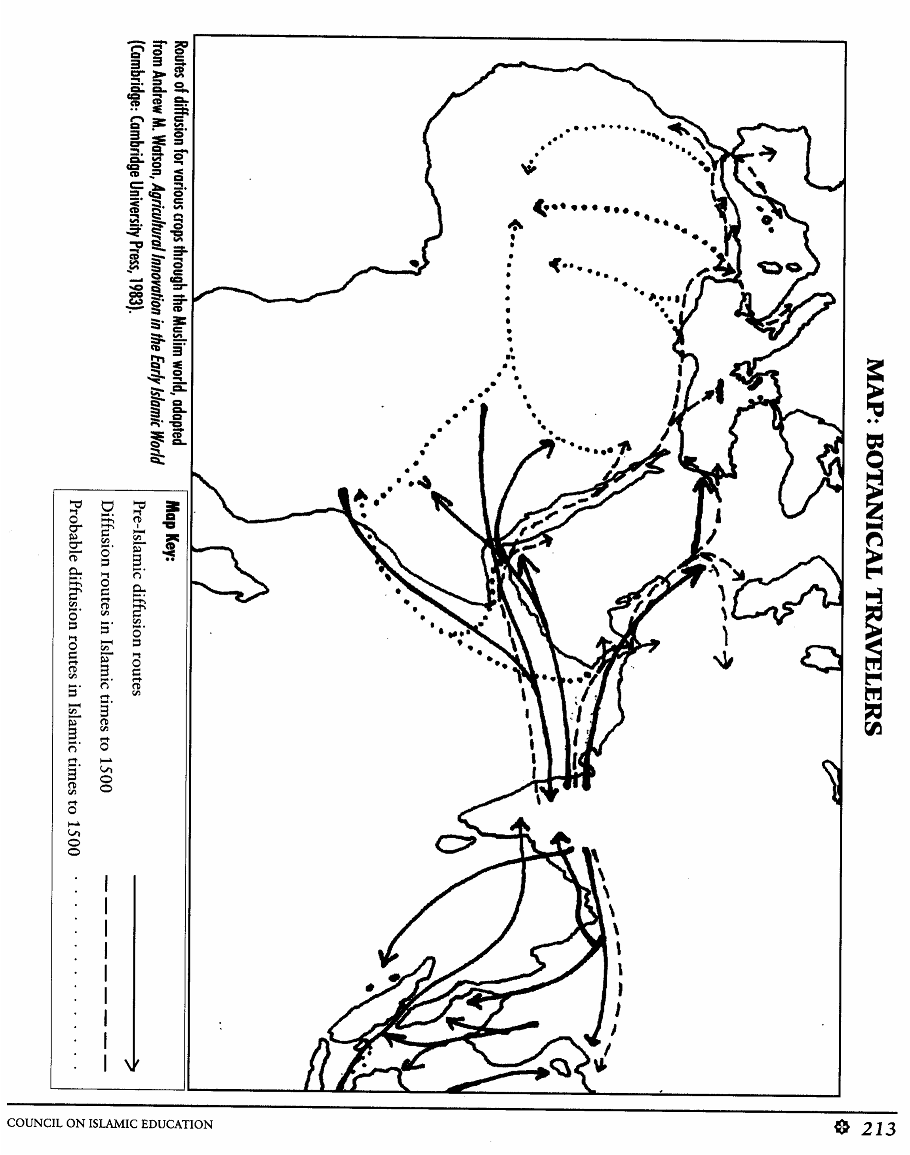

Map reprinted by permission from Douglass and Alavi, The Emergence of Renaissance: Cultural Interactions between Europeans and Muslims (Council on Islamic Education, 2000)
Lesson 6
Student Handout 6.1—Botanical And Zoological Travelers

COFFEE In early Islamic times, coffee began to be grown in Arabia, near the Red Sea. Coffee cultivation did not, however, become important until the 15th and 16th centuries, when many trees were planted in Yemen, and the taste for coffee began to spread to other Muslim lands. Coffee merchants became very wealthy in cities like Cairo, and coffee drinking spread to Europe. After a Turkish diplomat introduced it to Parisians in 1669, the consumption of coffee skyrocketed in Europe during the 17th century, with the growth of coffeehouses that also sold two other new drinks—chocolate and tea. Coffeehouses played an important role in the social and political life of European cities. Like sugar, coffee was introduced into Europe’s overseas colonies, and became a vital cash crop. In 1714, the French brought a live cutting of a coffee tree to Martinique in the West Indies. With this single plant, the coffee business in Latin America began. Today, it is a major source of revenue for several African and Latin American countries. A global commodity, coffee may be a major contributor to the modern work ethic.
(Sources: Ferdinand Braudel, The Structures of Everyday Life, Vol. 1 (New York: Harper & Row, 1979), 256-260; “Coffee,” Microsoft¨ Encarta¨ 96 Encyclopedia (Microsoft 1993-95).

CITRUS FRUIT Lemons, limes and oranges were once rare, exotic items. A few hundred years ago, a child who received a single orange as a gift would have been quite happy. Citrus fruits grow on trees whose fragrant blossoms made them a favorite in royal gardens. The use of citrus juice and rinds in cooking, for marmalade, in candied lemon and orange rinds, and in various cosmetics and medicincs helped this crop spread around the world. Cultivation of citrus fruits began in China, India and Malaysia. Each region domesticated different varieties, like kumquat, sweet orange, sour orange, lemon, lime, and citron. Grafting produced new varieties as cultivation spread. Some types of citrus had not spread west of India before Islamic times. Possibly reintroduced to the Mediterranean, the citron became widespread, and other types of citrus, like the lemon, the lime, and the sour orange were commonly mentioned in literature by the tenth century. Spain became the most famous place for oranges and other citrus, with its famous gardens celebrated in poems and songs, and in groves planted by royal gardeners that still stand today, like the Patio de los Naranjos in Cordoba. From royal plantations to backyard gardens, citrus trees have been part of Muslim culture. Citrus played an important role in the Age of Exploration itself, when captains learned to protect their crews from scurvy (a seaman’s disease caused by lack of vitamin C) by carrying preserved lemons or limes on board. English seamen, for this reason, were called “Limeys.” European explorers, once in India, are credited with introducing varieties of sweet oranges from there to the rest of the world, but as with cotton, the techniques for growing them had been learned centuries earlier. Citrus is an important global cash crop today, and a vital source of Vitamin C.

COTTON This fiber crop may have originated in India or ancient Egypt, and its textile varieties and cultivation techniques were certainly developed in India. Indian cotton goods were exported widely from India in ancient times across the monsoon and overland routes, but its cultivation spread slowly. During pre-Islamic times, it had spread into China, and probably as far west as East Africa. Much of this early diffusion, however, is cotton of an annual variety. High-yielding annual varieties of fine cotton fiber and their widespread cultivation diffused as a result of the economic development of Muslim lands, with their vast production of textiles of all kinds. Cotton was grown on a very wide scale, and processed at many centers. This new cotton plant spread as far as the frontiers of Christian Europe and Sub-Saharan Africa. Techniques for growing cotton became known to the Spanish and became very important in the New World. There, Old World familiarity with cotton and the methods for growing it united with New World varieties that produced longer fibers. With that, another of the cash crops that supported European colonization and economic growth of the Americas was born. Importation of these varieties back into the Old World gave the early industrial revolution a great push. The cotton mills of England, by 1830, were importing raw cotton from the Middle East and the American South, and selling calico printed cottons (whose styles and techniques were learned at Calicut, India) all over the world, fueling both industrial revolution and the growth of empire. Cotton, the word for which came from the Arabic qutn, also contributed to the development of the United States’ economy and global trade. On a personal level, cotton has also played a role in providing inexpensive, comfortable clothing for the masses, contributing to health and hygiene.

SUGAR CANE This is another “industrial crop” that has had a major impact on agriculture, economics, and social life around the world. It may also have encouraged the professional development of dentistry more than any other food. Sugar cane produces more calories per acre than anything else known, and it has many uses. Its juice can be sucked raw on the stalk or cooked and eaten. Its best-known use is refined sugar, crystallized from the juice boiled to syrup. Depending on how many boilings, it may be brown, red or white. Molasses is a mineral-rich byproduct of sugar. The crushed cane is excellent for feeding cattle. Sugar cane, like so many other important crops, was originally cultivated and refined in India, Southeast Asia, or Indonesia, from a wild grass high in sugar content. It has been grown for so long that it is not known when it was first domesticated. Imay have reached China as early as 1000 BCE, and Yemen and Persia by the seventh century. Small amounts of sugar may have been exported to western Afroeurasia as medicine or curiosity in ancient times. From Persian areas to the Levant, Cypress, North Africa, Sicily and Spain, sugar cultivation and refining followed the spread of Muslim culture. By 1500, it had reached some islands in the Atlantic, like Madeira and the Canaries. It was produced on a large scale for domestic use and for export in Muslim lands, India, and China. Sugar, whose name is derived from the Arabic sukkar, most likely became known to Western Europe by way of Muslim Spain. We can imagine the Christian rulers and elites adopting candies (also a word derived from Arabic) and sweetened desserts from their Muslim counterparts. There is also literary evidence of this transfer. One of the lasting memories of the translator-scholars who visited Toledo’s famous libraries must have been marzipan, a confection of almond paste and sugar that was a specialty of the city. The Crusaders tasted sugar and saw it growing in the Levant. European visitors to the Ottoman court tasted Turkish delight and other sweet pastries, and wrote rapturously about it to folks back home. Nevertheless, sugar remained a luxury until the seventh century, when supplies from plantations, worked by slave labor, began to arrive in larger quantities. Sugar is another cash crop that financed Europe’s colonization of the world, both as refined sugar and as rum, one of the products of the triangular trade that bought African slaves to the Americas. The popularity of sugar in Europe stimulated production in other places, too, and another global commodity was born. In 1747, German chemist Markgraff isolated sugar from the sugar beet. This brought the sweetener within reach of northern climates and within the budget of the masses. Sugar had conquered the world and made fortunes for many.

HARD WHEAT (pasta and semolina) Italian food calls to mind pasta and sauce, but it might surprise you to know that both tomatoes and the hard wheat used to make all sorts of pasta were introduced not too many centuries ago to Italy and the rest of Europe. Pasta is an invention of long distance travelers. Hard wheat was ground into flour, mixed with water and salt to make a dough and sieved into couscous, formed into small balls, rings, or tubes that could be strung on strings to dry, or laid in the sun. A highly nutritious, compact traveling food that stored well for a long time, it needed only to be boiled in water to eat. It could be mixed with meats, beans and sauces. Hard wheat is important because it can grow with less rainfall than other types, and it can also be stored longer without spoiling. Hard wheat contains a lot of gluten—the substance that makes its dough very elastic. Its flour is also excellent for making flatbreads. Hard wheat may have originated in East Africa or the Eastern Mediterranean, but its cultivation spread widely under Muslim influence. It became an important crop in Spain and Italy, from where it spread to Europe. Along with the spread of hard wheat, which is high in gluten, went the art of making many forms of pasta. The proof of its spread to Europe from Muslim lands lies in the various words for noodles derived from Arabic terms. Thin pastry is also a product that must be made with hard wheat flour.

TOMATOES The other spaghetti ingredient—tomato sauce—did not appear until tomatoes were brought from the Americas during the Colombian Exchange. Tomatoes were first thought to be poisonous, as members of the nightshade family, but they soon caught on, and became so much wedded to Mediterranean and Middle Eastern cooking that it is hard to imagine them as not being a very old food item in the region. The rapid spread of tomatoes around the world offers a good example of rapid global diffusion of new products and foods after 1500, when the routes of the Columbian Exchange linked up with existing cultural connections in the Old World.

RICE This grain originated as a food crop in the Far East, except for some wild varieties in the Americas and elsewhere. Rice is the only grain that can be eaten just by boiling it; most others must be ground into flour. Rice offers excellent nutrition and high yield per acre. Rice, however, can only be grown where there is enough water for the fields to be flooded for the young plants; therefore, rice cultivation spread hand-in-hand with Muslim irrigation technology and widespread organization. A staple food crop in the Far East, rice was often a luxury, though a very popular one, in other lands where it was not so heavily cultivated. Muslim farmers, merchants, and even monarchs contributed to bringing cultivation of Asian rice from China and Southeast Asia into Muslim lands around the Mediterranean, then on to East and West Africa, and to Spain and Italy. Rice was also imported into Europe from Muslim lands, as it does not grow in colder regions. Rice and its cultivation played a decisive role in the colonization of the Americas, where it was an important crop used to feed slaves. It was grown together with cotton and with sugar cane to feed those who labored on the plantations. It also became an American food staple that is still grown.

Excerpted by permission from S. Douglass and K. Alavi, The Emergence of Renaissance: Cultural Interactions between Europeans and Muslims (Council on Islamic Education, 2000).
This unit and the Standards in Historical Thinking
Historical Thinking Standard 1: Chronological Thinking

The student is able to (F) reconstruct patterns of historical succession and duration in which historical developments have unfolded, and apply them to explain historical continuity and change.

Historical Thinking Standard 2: Historical Comprehension

The student is able to (G) draw upon data in historical maps in order to obtain or clarify information on the geographic setting in which the historical event occurred, its relative and absolute location, the distances and directions involved, the natural and manmade features of the place, and critical relationships in the spatial distributions of those features and historical event occurring there.

Historical Thinking Standard 3: Historical Analysis and Interpretation

The student is able to (D) draw comparisons across eras and regions in order to define enduring issues as well as large-scale or long-term developments that transcend regional and temporal boundaries.

Historical Thinking Standard 4: Historical Research Capabilities

The student is able to (C) interrogate historical data by uncovering the social, political, and economic context which it was created; testing the data source for its credibility, authority, authenticity, internal consistency and completeness; and detecting and evaluating bias, distortion, and propaganda by omission, suppression, or invention of facts.

Resources

Instructional resources for teachers

Abu-Lughod, Janet L. Before European Hegemony: The World System A.D. 1250-1350. New York: Oxford UP, 1989.

Bentley, Jerry H. Old World Encounters: Cross-Cultural Contacts and Exchanges in Pre-Modern Times. New York: Oxford University Press, 1993.

Christian, David. Maps of Time: An Introduction to Big History. Berkeley: University of California Press, 2004.

Curtin, Philip D. Cross-Cultural Trade in World History. Cambridge: Cambridge UP, 1984.

Douglass, Susan L. World Eras, vol. 2, Rise and Spread of Islam, 622-1500. Farmington Hills, MI: Gale, 2002.

Hodgson, Marshall G. S. The Venture of Islam. 3 Vols. Chicago: University of Chicago Press, 1974.

McNeill, J. R., and William H. McNeill, The Human Web: A Bird’s-Eye View of World History. New York: Norton, 2003.

Pearson, Michael. The Indian Ocean. New York: Routledge, 2003.

Risso, Patricia. Merchants and Faith: Muslim Commerce and Culture in the Indian Ocean. Boulder, CO: Westview Press, 1995.

Shaffer, Lynda. “Southernization.” Journal of World History 5 (Spring 1994): 1-21.

Watson, Andrew M. Agricultural Innovation in the Early Islamic World: The Diffusion of Crops and Farming Techniques, 700-1000. Cambridge: Cambridge UP, 1983.

Instructional resources for students
“Rise of the Shogun: Life in Medieval Japan.” Calliope: Exploring World History 16 (Jan. 2006).

“The Silk Road.” Calliope: Exploring World History 12 (Feb. 2002).

“When Spice Ruled.” Calliope: Exploring World History 16 (Feb. 2006).

The World in Ancient Times Series. New York: Oxford UP, 2005.

Bingham, Marjorie Wall. An Age of Empires, 1200-1750.

Des Forges, Roger and John S. Major. The Asian World, 600-1500.

Hannawalt, Barbara A. The European World, 400-1450.

Kelly, Donald R. and Bonnie G. Smith. The Medieval and Early Modern World: Primary Sources & Refernce Volume.

Pouwels, Randall. The African and Middle East World, 600-1500.

Wiesner-Hanks, Merry E. An Age of Voyages, 1350-1600.

“The World’s Oldest Revealed Religion: Good Words, Good Thoughts, Good Deeds: Zoroastrianism.”
Calliope: Exploring World History 15 (Jan. 2005).

Correlations to National and State Standards
National Standards for History
Era Four: Expanding Zones of Exchange and Encounter, 2A: The student understands the emergence of Islam and how it spread in Southwest Asia, North Africa, and Europe. 3A: The student understands China’s sustained political and cultural expansion in the Tang period.

Era Five: Intensified Hemispheric Interactions, 1D: The student understands how interregional communication and trade led to intensified cultural exchanges among diverse peoples of Eurasia and Africa. 5B: The student understands transformations in Europe following the economic and demographic crisis of the 14the century. 6A: The student understands the development of complex societies and states in North America and Mesoamerica.7: The student understands major global trends from 1000-1500 CE.

California: History-Social Science Content Standards
Grade 7.2: Students analyze the geographic, political, economic, religious, and social structures of civilizations of Islam in the Middle Ages.
Grade 7.3: Students analyze the geographic, political, economic, religious, and social structures of the civilizations of China in the Middle Ages.
Grade 7.4 Students analyze the geographic, political, economic, religious, and social structures of the Sub-Saharan civilizations of Ghana and Mali in Medieval Africa.
Grade 7.6 Students analyze the geographic, political, economic, religious, and social structures of the civilizations of Medieval Europe.
Grade 7.7 Students compare and contrast the geographic, political, economic, religious, and social and structures of the Mesoamerican and Andean civilizations.

Texas Essential Knowledge and Skills for Social Studies
113.33 World History Studies. (c) Knowledge and Skills. 19) Culture. The student understands the history and relevance of major religious and philosophical traditions.

Virginia History and Social Science Standards of Learning
World History and Geography to 1500 AD. Era III: Postclassical Civilizations, 500 to 1000 A.D.
WHI.7 The student will demonstrate knowledge of the Byzantine Empire and Russia from about 300 to 1000 A.D.
WHI.8 The student will demonstrate knowledge of Islamic civilization from about 600 to 1000 A.D.
WHI.9 The student will demonstrate knowledge of Western Europe during the Middle Ages from about 500 to 1000 A.D. in terms of its impact on Western civilization.

World History and Geography to 1500 AD. Era IV: Regional Interactions, 1000 to 1500 A.D.
WHI.10 The student will demonstrate knowledge of civilizations and empires of the Eastern Hemisphere and their interactions through regional trade patterns.
WHI.11 The student will demonstrate knowledge of major civilizations of the Western Hemisphere, including the Mayan, Aztec, and Incan.
WHI.12 The student will demonstrate knowledge of social, economic, and political changes and cultural achievements in the late medieval period.
WHII.2 The student will demonstrate an understanding of the political, cultural, and economic conditions in the world about 1500 A.D.

