Big Era Six

The Great Global Convergence

1400 – 1800 CE

Landscape Teaching Unit 6.3
Rulers with Guns: the Rise of Powerful States
1400-1800 CE
Table of Contents
Why this unit? | 2
Unit objectives | 2
Time and materials | 2
Author | 2
The historical context | 2
This unit in the Big Era timeline | 3
Lesson 1: What is Gunpowder?  tT | 4
Lesson 2: Bells, Buddhas, and Bombards: Military Gunpowder Technology | 10
Lesson 3: Bombs, Bullets, and Bureaucracies: the Growth of Centralized States | 17
Lesson 4: Effects of Gunpowder in Different Societies | 22
Lesson 5: Portraits of Potentates | 28
This unit and the Three Essential Questions | 38
This unit and the Seven Key Themes | 38
This unit and the Standards in Historical Thinking | 38
Resources | 39
Conceptual links to other lessons | 40

Why this unit?
The invention and spread of gunpowder technology is a case study in technological diffusion and one that had profound effects on human society. For some historians, the appearance of firearms marks the beginning of the modern era because it had a huge impact on the direction of human history. Students need to understand the nature of this innovation, its military and civilian applications, and the profound changes that political leaders’ use of it brought about. From a world historical perspective, it is important to widen the lens from a traditionally narrow focus on events in Europe related to this new technology to take in the consequences for peoples and societies around the world.

Unit objectives
Upon completing this unit, students will be able to:
- Describe the origins, transfer, and uses of gunpowder technology in warfare.
- Analyze the effects of firearms on the development of powerful, centralized states.
- Compare societies that made use of, or were affected by, gunpowder weapons in various parts of the world from 1400 to 1700 CE.
- Analyze the material and cultural impact of powerful monarchies based on gunpowder military expansion through visual analysis of royal portraits.

Time and materials
These lessons will take 3-4 class periods to complete.
Materials needed are 8 ½ x 11-inch paper, butcher paper, pencils, and colored markers.

Author
Susan Douglass is the Educational Outreach Coordinator at Georgetown University’s Alwaleed bin Talal Center for Muslim-Christian Understanding. She is the author of numerous teaching units, books, and web projects on Islam and world history, including the edited volume World Eras: Rise and Spread of Islam, 622–1500 (Gale, 2002), companion websites for documentary films, and the online teaching resource The Indian Ocean in World History (www.indianoceanhistory.org). She has been a member of the World History for Us All team since 2001.

The historical context
Historians generally view the period from 1400 to1800 CE as four centuries of immense global change in numerous historical realms. Communication and exchange networks became more dense and complex, and after 1500 they circled the globe owing to advances in maritime ship-building and navigation. Permanent contact with the Americas brought ecological consequences, such as the Great Dying that took place as a result of the exchange of microorganisms and the Columbian Exchange of food crops and domestic animals. A global economy emerged, with a market system supported by trade in silver and also in textiles, spices, tea, coffee, and numerous other products. The military and economic power of states with access to gunpowder weapons grew enormously in several parts of Afroeurasia from northwestern Europe to China and from West Africa to Indonesia. The need that states had to pay for expensive firearms also propelled the expansion of governments, bureaucratic administrations, and systems for gathering taxes from ordinary people. This unit offers an in-depth look at the development and impact of gunpowder weapons around the world. Certain European states gained power owing to possession of gunpowder armies and navies but so did states in other parts of Afroeurasia. Only near the end of the period between 1400 and 1800 did European states move well ahead of other monarchies and empires in the extent and quality of their “firepower.”

This unit in the Big Era Timeline

Lesson 1
What is Gunpowder?

Preparation
Prepare copies of Student Handout 1.

Activities
- Distribute Student Handout 1 (What is Gunpowder?) and ask students to read it. After checking for comprehension, focus the discussion on the science of gunpowder, both in terms of how it works as a mixture of substances and how the explosive quality can deliver projectiles of various kinds. Use students’ prior knowledge or conduct brief research to find answers to questions that arise.
- Use the four discussion questions to explore the history of gunpowder technology based on the reading. Write down other questions students may have about gunpowder.

Lesson 1

Student Handout 1—What is Gunpowder?

Gunpowder is made of a few simple substances. It works on the idea of rapid oxidation, that is, combustion of carbon to create an explosion that can take place in a closed chamber. The ingredients of gunpowder are ground charcoal, sulphur, and saltpeter. Saltpeter, or potassium nitrate, is the oxidizer. It is a white, crystalline, organic chemical—a byproduct of animal dung. It can be mined in ancient bat caves or bird dung piles as the substance called guano. Or it can be produced by subjecting dung to a special process, similar to composting, for about a year.
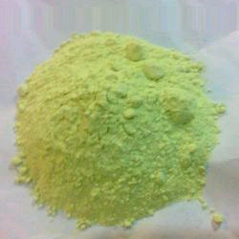
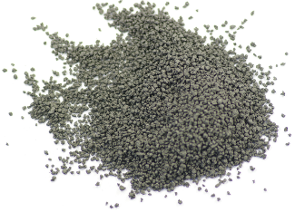
Saltpeter | + | Carbon | + | Sulphur | = | gunpowder

Gunpowder explodes because the nitrates in saltpeter release oxygen when they are heated, even by a small flame like a match or by a spark made when metal strikes flint (a stone used to make fire). The released oxygen from potassium nitrate acts as a catalyst. It causes the carbon and sulfur to burn (oxidize) rapidly in a quick chemical reaction, that is, an explosion. Normally, combustion occurs in the open air, but the action of saltpeter with heat makes gunpowder burn in a closed place like a rocket tube or the barrel of a cannon.

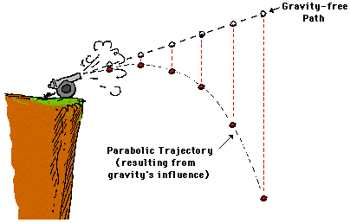
The proportions of the three ingredients of gunpowder can be varied to produce different explosive force, depending on the desired use—fireworks, mining, handguns, or cannons. The force must be enough to create the desired explosion but not so much as to destroy the barrel of the weapon. On the creative side, a paper or bamboo tube used for fireworks is disposable. The explosion in the tube produces a show by shooting out chemicals that produce colors when burned. On the destructive side, an artillery shell that is shot from a gun and that itself contains gunpowder will explode on impact, scattering dangerous shrapnel and setting things on fire.

An explosion in a tube that is closed on one end will make an object (projectile) placed between the gunpowder and the open end shoot. This happens because the explosion causes gas to expand. In the case of a rocket, the tube itself is set into motion by the explosion. Laws of physics (force, motion, and gravity) determine the path, or trajectory, of the projectile such as a bullet, cannonball, or rocket. Knowledge of how to predict the trajectory of a flying object allows the user to aim the weapon at a person, mounted soldier, fortress wall, or ship. The trajectory will vary depending on the weight of the projectile, the angle of the barrel, and the force of the explosion.

Who invented gunpowder and its use in warfare?
The origins of gunpowder are easier to trace than its spread. It is possible that there were several different centers for parts of the invention. Both Buddhist and Muslim alchemists tried to make potions that would give a person immortality or create substances that would change base metals into gold. Both efforts led to experiments with various substances. Although alchemy is considered a pseudoscience (a theory or practice that is not well grounded in scientific evidence), these experiments led to the real science of chemistry, that is, understanding the properties of matter and producing chemical substances with many uses.

Gunpowder is a byproduct of alchemy experiments. Alchemists knew about organic compounds in urine and dung as powerful substances. They experimented with acidic and alkaline substances. They learned in the case of saltpeter that some substances can “transform” others in chemical reactions. Alchemists happened upon knowledge of gunpowder and shared this knowledge widely. A Chinese Buddhist alchemist wrote, “Some have heated together the saltpeter, sulfur, and carbon of charcoal with honey; smoke and flames result, so that their hands and faces have been burnt, and even the whole house burnt down.” Honey contains sugar molecules made of carbon, hydrogen, and oxygen, so it would have accelerated the reaction by providing extra fuel. In the Muslim tradition of alchemy, scholars recorded discovery of new substances and processes, as well as equipment such as furnaces and glass vessels, in detailed books on alchemy. Manuscripts that became known in the Latin West included works by Jabir ibn Hayan (d. ca. 815) and al-Razi (d. 925). These books recorded recipes for nitric and other acids, called “sharp waters” or aqua regia in Latin translations. The knowledge of how to reproduce and purify substances accurately was as important as the knowledge of compounds and their uses.
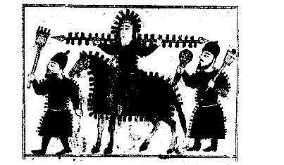
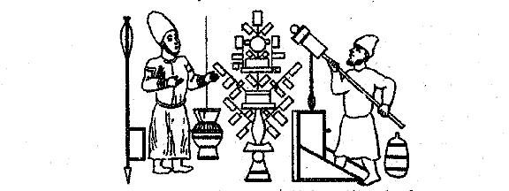

Two illustrations from the Petersburg manuscript
showing the first use of explosive gunpowder and cannon.
Source: History of Science and Technology in Islam, http://www.history-science-technology.com/Articles/articles%2072.htm
Military uses of incendiary and explosive materials in western Asia date to the mid-first millennium CE. Natural seepage of petroleum, called naft, occurs in Southwest Asia. People also know that pitch (tar) and resins are very flammable. In the seventh century, the Byzantines used naphtha, or “Greek fire,” in warfare. This may have been one source of the knowledge that European Crusaders gained in the eleventh century and later. Knowledge of how to distil substances led to use of compounds in fire-throwing devices. Knowledge of these tools was later applied to gunpowder technologies to make more refined weapons. By the time of the Crusades, grenades and rockets that contained explosives were in use. Examples exist in museums today. Arabic books of that era refer to saltpeter by different names, including “Chinese snow” or “Chinese salt,” which points to the spread of knowledge of this substance westward across Inner Eurasia.

The first recorded use of gunpowder in warfare in China dates to 919 CE, as shown in this tenth-century fire lance image from the Dunhuang caves in western China. Song historical documents indicate the use of explosive gunpowder in projectiles thrown from catapults. These documents contain terms that refer to cannons, rockets, and firebombs. A Chinese battle that took place against an invading army in 1126 featured bamboo tubes that shot flaming missiles. Bamboo cannons as offensive weapons featured in 1132, when they were mounted on a wheeled platform to attack a city’s walls. Catapults evolved from bamboo tubes to a device with a metal, bottle-shaped barrel that would shoot arrows. Archaeologists have discovered a very early gun at a site in Manchuria dated to about 1290.

Chinese bronze cannon
late 13th century
National Museum of China
Photo by R. Dunn

By the time of the Mongol invasions, both the technology for making gunpowder and its use in weaponry had reached Muslim lands. There is evidence that Mongol forces used Chinese engineers with gunpowder weapons to attack Iran and Iraq. Iranian engineers, using an Arab-designed trebuchet (a machine for throwing projectiles against or over defensive walls), served with Mongols who attacked northern China. European Crusader armies were exposed to gunpowder weapons in the eastern Mediterranean, and forces of the Egyptian Mamluk state used them against the Mongols in Syria.

One of the best sources on gunpowder weapons is The Book of Military Horsemanship and Ingenious War Devices, by Najm al-Din Hasan al-Rammah (d. 1295). Written in about 1270, it details “inherited knowledge of the forefathers,” including 107 gunpowder recipes, 22 kinds of rockets, and other kinds of gunpowder weapons. Al-Rammah reported modern proportions of ingredients for explosive gunpowder: 75 percent potassium nitrate (saltpeter), 10 percent sulfur, and 15 percent carbon.

Muslim soldiers in Spain used gunpowder weapons against Spanish Christian forces. Muslim armies possibly served as the path of gunpowder knowledge to Europeans. Contacts between European powers and the Mongols may have been another pathway. The two ideas that were coming together at this time, both in China and in Muslim regions, were the use of high-nitrate gunpowder, and the use of wooden or metal tubes for shooting projectiles.

Chinese gun barrels from 1288 and 1332 date earlier than anything similar found in Europe. The technology may have come to Europe through Russia during Mongol rule. In Spain, both cannon and guns were in use by 1330, and the illustration from an Arabic military treatise (known as the Petersburg manuscript) shows the use of explosive gunpowder and cannon. Illustrations in books show bottle-shaped guns developed in China and Europe, even as far north as Sweden. Although the Mongols were aware of incendiary weapons, they did not develop guns, since these devices did not fit with the culture of warrior horsemen. At most, guns played a part in sieges but not yet with the devastating force of the weapons developed in later centuries.

English scientist Roger Bacon referred to gunpowder recipes in the thirteenth century, probably taken from translated Arabic texts on alchemy. Practical knowledge may have come to England from noblemen fighting in Spain in the fourteenth century. The ability to make gunpowder and use it in battle spread into numerous European countries, where devastating weapons were developed over the course of the fourteenth and fifteenth centuries.

Questions for discussion
- Why is it difficult to determine the time and place of the invention of gunpowder weapons?
- Why do you think the discovery of gunpowder did not occur earlier in history?
- What steps took place in the development of gunpowder weapons?
- What factors contributed to the spread of this technology?

Lesson 2

Bells, Buddhas, and Bombards: Military Gunpowder Technology

Preparation
Prepare copies of Student Handout 2, and have ready extra paper and pencils or colored markers.

Activities
- Distribute Student Handout 2 (Bells, Buddhas, and Bombards: Military Gunpowder Technology) and ask students to read it. Pre-check for vocabulary and post-check for comprehension.
- Have students make a spider diagram based on the reading, writing “gunpowder weapons” at the center in an oval. The ideas in the reading can be arranged in any order, but the exercise is designed to get students thinking about the complexity of these weapons and their application in warfare, as well as the defensive dilemmas they posed. Encourage students to look at the issue from all sides. Compare diagrams.

Here is a sample diagram.

Artillery
Huge cannons
Mobile guns
Idea
Destroy city walls
Scare factor
Fire
Kill soldiers
New defenses
Etc.
Changed armies
Cavalry,
foot-soldiers

GUNPOWDER WEAPONS

Lesson 2

Student Handout 2—Bells, Buddhas, and Bombards: Military Gunpowder Technology

Gunpowder weapons reached Europe by several pathways across Afroeurasia. This involved both the technology of producing gunpowder to create an explosion and the applied technology to deliver a destructive projectile–bullet, ball, or bomb. European political, geographic, and military conditions favored the development of gunpowder weapons into an efficient, destructive technology. This knowledge contributed to the growth of strong, centralized states and the expansion of overseas empires. Together with other developments, such as improvements in ships and navigation and the expansion of trade, the development of gunpowder weapons changed the nature of warfare in the world.

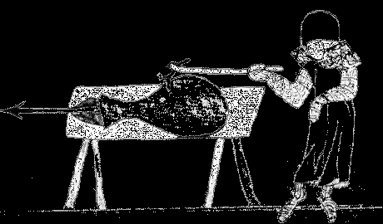
How did military and technical advances result in gunpowder weapons? A bottle-shaped device designed to shoot an arrow with explosive force was the first documented gunpowder weapon. The bore was narrow, but the metal near the touch-hole, where the explosion took place, was thickened to prevent cracking from the explosion. Examples have been found in both Chinese and European manuscript illustrations from about the late thirteenth and early fourteenth centuries. Historians believe China was the source of the invention, and the Mongols probably spread the idea. Technical advances followed with devastating effects: Europeans built bigger and more powerful guns and learned to aim them against castle and city walls. In one direction of development, gunpowder technology led to large weapons called bombards; they were later known as cannons or artillery. Artisans also invented handheld weapons (handguns) for foot soldiers.

Three elements—the idea, the resources, and the technical knowhow—were the ingredients for advancement of gunpowder weapons

- First, the idea refers to knowledge of how to make weapons and of what they could do. Early gunpowder weapons could frighten mounted cavalry, or they could shoot flaming objects to set things on fire. Two new ideas were using cannons to break down walls and giving foot soldiers and cavalry a new type of weapon that was not simply a sharp object. Cannons and handguns were the result.

- The second element was access to metal, at first bronze or brass (made by combining copper with other metals) and later iron. Advances in mining technology and local availability of the needed metals gave an advantage to some lands over others. Deposits of iron, copper, tin, lead, and nickel were found in Germany, England, France, and elsewhere. Mechanical devices for pumping water out of deep mines spread to Europe by way of Arabic works on mechanical engineering. Using gunpowder explosions to break through rock was another new idea. Metal ingots (cast chunks of purified metal) could be imported, but when large armies began to use large numbers of guns, local access to metals was an important advantage.

- The third element was the technical skill to cast and forge the barrels of guns and cannons and to make metal bullets and cannonballs. A thick, strong tube closed on one end was needed to contain the explosion of gunpowder in the barrel and direct the projectile out of the other end. Casting large gun barrels required the skill to heat a large amount of metal and create molds that would not break. Interestingly, the ability to cast large metal objects came through the European experience of casting bronze or brass church bells. A cannon, after all, is similar in size and shape to the great bells that rang in the cathedrals being built in many European cities at the time. In China, metalworkers had possessed casting and forging skills for centuries. Japanese metalworkers also had experience with furnaces for casting huge bronze statues of the Buddha, as well as skills in forging fine steel for swords. Steel-making arts in India, Persia, Syria, Spain, and elsewhere helped to spread European advances in the technology of gun-making to many places beyond Europe after gunpowder weapons were introduced.

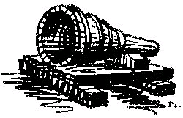
The earliest bombards were stumpy, short tubes that could shoot a stone ball. They were also hard to aim and might explode, killing the gunners who fired them. They were made of iron bars bound with wrought-iron hoops. They rested on a platform, like this illustration from 1330. By 1430, bombards made in Europe were huge. They were 12 to 15 feet long and could fire a stone about 30 inches in diameter. Bombards were so heavy that in major campaigns, the metals might be brought to the battlefield and cast on the spot. The great cannon cast in 1453 by Mehmet the Conqueror, ruler of the Ottoman Turkish empire, was the biggest bombard made to date. It was cast within range of the walls of Constantinople during the siege in which Mehmet took the city from the Christian Byzantine state. Its purpose was to break through heavy walls and allow soldiers to enter the city quickly rather than camping outside the walls and waiting for the people inside to run out of food. In Europe, the king of France defeated the English by bombarding their fortifications. This tactic helped end the Hundred Years’ War in 1453, when the English had to surrender most of their possessions on the European continent.
The king of France and other monarchs used gunpowder weapons to defeat aristocratic landowners and bring them under unified control. As gunpowder weapons were used in Europe, an arms race led to improvements and new inventions. Platforms were made adjustable for more accurate aiming, like the fifteenth-century artillery piece on the right. Cannons were set on mobile platforms so they could be moved into place quickly and transported easily. Cannons were made smaller but stronger. Instead of stone balls, smaller cast iron balls proved even better at breaking through stone walls. Smaller guns were loaded onto wooden carriages with wheels like the one on the left, developed by the military expert Gustavus Adolphus in 1630 as “light artillery.”

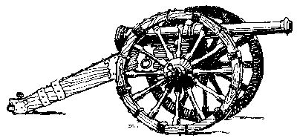
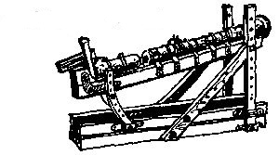

Light guns on wheels tipped the balance of power for a while. A ruler with enough money to own some of these new weapons, together with troops and supplies, was able to defeat lords who challenged the king, or even foreign enemies. The gunners could place mobile cannons on a hill and fire them into the walls of a town or castle. Soldiers then poured into the breach. On the battlefield, artillery explosions could scatter charging cavalry.

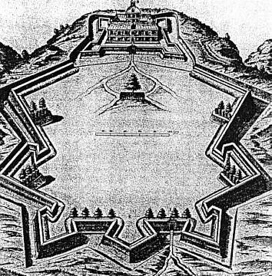
As powerful monarchs tried to increase their territory, like Charles VII of France did in 1494 by invading Italy, defenders invented new ways to counter the effects of artillery. For example, in 1500, the commanders of the city of Pisa discovered that if the city’s walls were reinforced with earthen banks inside and a big ditch outside, they could absorb the force of cannonballs without harm. Attacking armies were at a disadvantage when they had to navigate a ditch. Defensive cannons placed along star-shaped walls could be aimed in any direction to defend the fortress. This new style of fortifications was called the trace italienne (left), and for a while it checked the power of cannons. Nevertheless, the stream of new ideas continued: shells that would explode when hurled over walls, new kinds of projectiles, and guns that were easier to aim and less likely to blow up in the face of the gunners.

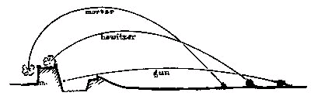

Offensive artillery and its use in attacking fortifications.
Source: The Project Gutenberg eBook of Artillery through the Ages by Albert Manucy http://www.gutenberg.org/files/20483/20483-h/20483-h.htm

How did handguns develop?
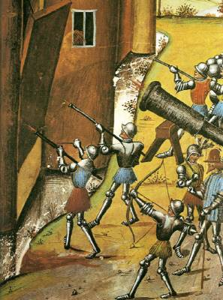
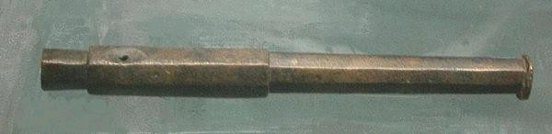
Personal weapons, or handguns, developed from the “fire-stick,” a handheld rod of bamboo or wood with a small metal head in the shape of a bulb, open at the narrow end, where the explosive charge exited. The word gonne was used in Europe to name a device that was a lot like a miniature cannon on a stick. There are numerous illustrations of Chinese versions of this gun, like the Dunhuang example shown earlier. Some were made to fire multiple charges. The gonne example from Germany shown above (about 1399), give an idea of how simple the device was. It was a tube that could be mounted on a stick. Gunpowder was put into the bore, followed by a lead ball. The gunpowder was ignited by a hot wire or slow-burning “match” made of chemical-soaked string. This match was poked into the touch hole on the top to ignite the explosion. Modern testing of such handguns shows that they could pierce armor and definitely kill people. They were very difficult to aim and could only be fired a second time after the soldier repeated the steps of cleaning, loading, and igniting. These weapons did not yet replace bows or swords, as the painting of a castle siege from 1468 shows.

Hand-held firearms went through a series of innovations that made them more practical, effective, and deadly. By the time of the English Civil War in the mid-seventeenth century, guns had become easier to load. But they were still heavy and needed to be steadied on a forked rod held separately.

The matchlock musket, or arquebus, was an invention that had a lever, or trigger, which moved the slow-burning match to the touchhole while the soldier aimed at the target. Matchlocks were
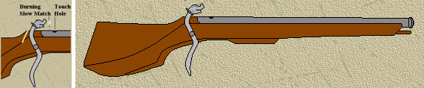

Musket.
Source: The Arquebus & Matchlock Musket Page, http://www.geocities.com/Yosemite/Campground/8551/arquebus.html (no longer available)
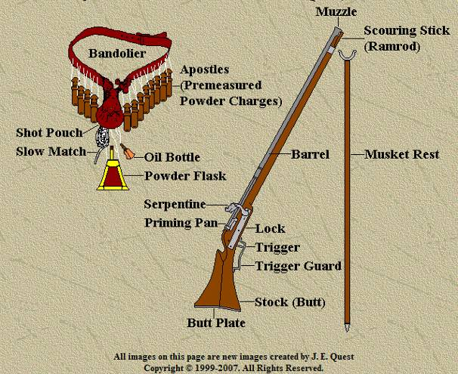

Musketeer’s equipment.
Source: “The Arquebus & Matchlock Musket Page,” http://us.geocities.com/jequest1/equipment.html (no longer available)

the first guns to be widely manufactured. They could be fired once to twice a minute with practice. The flintlock musket, the next major improvement, was invented in the late seventeenth century and was used for a long time. It replaced the match with a trigger, which made a spark between metal and flint to ignite the powder. Flintlocks were then fitted with bayonets, that is, long, stiff blades attached by a ring alongside the bore of the gun. They enabled foot soldiers armed with guns to replace both swordsmen and pikemen, equipping modern armies for the next 150 years.

Lesson 3
Bombs, Bullets, and Bureaucracies: the Growth of Centralized States

Preparation
Prepare copies of Student Handout 3, with change chart at the end.

Activities
- Distribute Student Handout 3 (Bombs, Bullets, and Bureaucracies: the Growth of Centralized States) and ask students to read it. Pre-check vocabulary and focus on concepts in the reading that may be unfamiliar (state, bureaucracy, centralized, unified, and others). Post-check for comprehension by asking students to list one or more changes in government and society that took place as a result of the use of gunpowder weapons. The concepts in the reading are complex, but combined with the introductory readings on the development of gunpowder weapons, students should follow easily. Understanding the changes requires some leap of imagination and ability to visualize large-scale or long-term effects.

- Students should write on the chart the changes they wrote down in the comprehension exercise. Using the reading, and bearing in mind information from the previous readings, students should consider the effects of firearms on government, upper classes, commoners, soldiers, civilians, urban, rural, and pastoral peoples. Teachers may wish to make a two-column chart, combining the last two columns for simplicity.

- Comparison: Have students name other innovations in weapons and discuss the changes they brought about. Examples are the use of metal vs. stone, iron vs. bronze, siege engines, heavily-armored knights on horseback, war elephants, camel saddles, and so on. Call to mind specific examples of societies already studied in the course.

- Foreshadowing: Project further innovations that occurred in gunpowder weapons after the early modern period. These might include the size of guns, the speed of fire, and the capacity to destroy people and property. Try to place these advances in chronological order. A couple of note-takers or a recorder on a computer or whiteboard will help save the results for future reference.

Lesson 3

Student Handout 3—Bombs, Bullets, and Bureaucracies: the Growth of Centralized States

During Big Era Six, from 1450 to 1800, “gunpowder empires” developed in some parts of the world. Historians have used this name to describe states that used firearms to expand their territories and control their own populations. In those 350 years, the largest land-based empires were:
- The Ottoman in the eastern Mediterranean region
- The Safavid in Persia
- The Mughal in India
- The Chinese under the Ming and Qing dynasties
- The Russian
- The Kanem-Bornu in West Central Africa
- The Songhai in West Africa
- The Austrian Hapsburg in Central Europe

Other, smaller states in Asia and Africa that used firearms technology were Japan, Siam (Thailand), Ethiopia, and Morocco.

In Western Europe, even with gunpowder weapons, no single, land-based empire was strong enough to take control of all Europe. Instead, intense rivalry in firearms technology and use led to the creation of numerous strong, centralized monarchies. These were closely-matched military competitors. Some of them turned their military power to building sea-based, that is, maritime, empires. Portugal, Spain, the Netherlands, France, and Britain built the largest overseas empires.

A strong, central government was necessary to bring together all the elements of modern warfare. Control over standing armies (rather than seasonal or temporary ones), artillery experts, access to supplies of metal, financial resources from taxation and lenders together reinforced the power of the state. Monarchs who gained power over local lords or seized new territory extracted taxes from farmers and from trade. These resources made them wealthier and therefore able to continue their military expansion. Supporting the rulers of these states were increasingly bureaucratic governments, that is, with officials who counted the population, gathered taxes, managed the state ministries (departments), and supplied the standing army. Power and riches, then, were the rewards of gunpowder warfare. The portraits of kings, queens, and emperors of these powerful states give an idea of their wealth and confidence.

Social changes in the military were an important part of the transformation. Before the coming of firearms, the fighting in most states was done by male members of the elite class, that is, nobles or aristocrats, for example, knights in medieval Europe. These noble warriors often fought on horseback. Soldiers of the lower classes, including peasant farmers, frequently provided support or went to war with simple weapons like pikes. Among pastoral nomadic peoples, warriors on horseback armed with bow and arrow or other weapons had great mobility and often overran defensive armies of foot soldiers.

Gunpowder weaponry, however, tipped the balance in favor of centralized states that had enough financial resources to afford to equip large numbers of troops with cannons and handguns. These states conquered smaller ones that did not have these weapons, or not enough of them. Rulers of centralized states used guns to break the power of local aristocrats and nobles, ending their careers as professional fighters. The long era of the power of pastoral nomadic states, such as the Mongol empire, came to an end. Cavalry warriors armed with bows and arrows could not stand up against the fire of rows of artillery. And as the costs of firearms went down, rulers recruited larger numbers of peasants to serve in standing armies.

In gunpowder states, foot soldiers were drawn from the common social classes, but modern methods of military drill made them into loyal armies able to march and maneuver in a unified body in response to commands of officers. Military leaders in Japan may have been the earliest to use these methods. In the Netherlands, Prince Maurice is recognized for his role in modern military organization and professional soldiering. He developed highly-organized drills carried out by groups of soldiers divided into battalions, companies, platoons, and squads. In these drills, troops with muskets practiced over and over again the many steps of preparing and firing their guns. These drills were designed to make soldiers into cohesive fighting forces that would obey their officers automatically. The image above shows just six out of the forty-eight steps in carrying, presenting, loading, and firing a musket. Soldiers were trained to carry out these steps with their weapons in sync with other soldiers in a massed group. Much like workers on an assembly line, soldiers memorized the exact position for marching, holding their feet and hands, and carrying out each muscle movement with precision. Soldiering was transformed. The new troops, called infantry, became the backbone of European armies. The drills made them professional soldiers who served growing states at home and abroad.
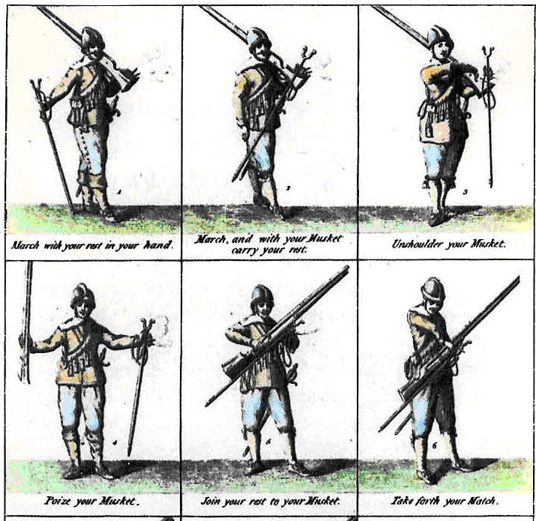

Change brought by gunpowder weapons | Reason for the change | Effect on the state/government

Lesson 4
Effects of Gunpowder Weapons in Different Societies

Preparation
Prepare copies of Student Handout 4. Have ready a map of the world (preferably a map showing states and empires from 1500 to 1750, or map/image slides 30-35, Big Era Six Panorama PowerPoint), as well as chairs, butcher paper, and markers.

Introduction
This activity consists of short vignettes that build on the background readings in Lessons 1-3. It can be used as a culminating activity for the era of gunpowder empires and the rise of monarchies in Europe, or it can be used to introduce the problem of gunpowder and to help students develop a conceptual vocabulary for discussing the issue before in-depth study.

Activities
- Divide students into ten groups or assign pairs or individuals to the vignettes numbered 1-10 in Student Handout 4 (Gunpowder Weapons’ Effects in Different Societies). Students should have with them copies of the readings in Lessons 1-3 and any other materials they have been assigned from the textbook on the era of gunpowder weapons.

- Have each group or pair read the excerpt and use butcher paper to list the advantages and disadvantages to each society of the use of gunpowder weapons. The vignettes are brief and can be used without supplemental readings. But students should draw on what they have learned about gunpowder weapons and their effects from the Lessons 1-3 readings and from textbooks or other sources.

- After 15 minutes or so, turn the activity into a roundtable presentation and discussion on the impact of gunpowder weapons on military power, government, and society. The group work and discussion that follows gain interest by drawing in students’ knowledge from other readings and from encouraging them to challenge each other on the advantages and disadvantages of firearms.

- As the round proceeds, have students fill in their individual charts using the information on each vignette, adding material from their own notes. The chart may be completed as homework or a notebook assignment.

Lesson 4

Student Handout 4—Effects of Gunpowder Weapons in Different Societies

Use each vignette below to fill in the chart at the end of the lesson with the advantages and disadvantages of gunpowder weapons for each society. Your answer may go beyond the information in each vignette to make interpretations based on your own knowledge. Refer to a world map to locate these groups.

1. Russians under Ivan III
Grand Duke Ivan III (1462-1505) consolidated power over Muscovy. His Muscovite successor Ivan the Terrible (1533-1584) attacked the Mongol states along the Volga River and other rivers of Inner Eurasia to control vast new territories. Cannons were mounted on river barges and carried across frozen land on sleds. With his mobile guns, the new Russian leader, or tzar, dominated the territories without effective challenge from traditionally-armed groups.
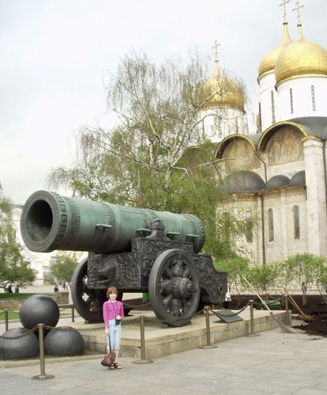

This giant bronze cannon dated to 1586 was intended for defense of the walls of Moscow, but it was never fired.
Photo by R. Dunn

2. Siberian fur traders
From the ninth-century Vikings to the eighteenth-century Russians, the Inner Eurasian fur trade offered a path to wealth and power. With Russian military expansion along the Inner Eurasian river system, the fur trade kept pace with imperial control. As fur-bearing animals in western Russia were depleted, musket-armed Cossacks pushed eastward into Siberia. These newcomers used firepower to require indigenous people to give them furs as tribute, with serious penalties for failure to do it. Reaching the Pacific Ocean in 1638, the hunt for sea otter pelts enriched the fur trade. Russian fur traders explored and colonized the islands and coastlands of today’s Alaska, Canada, and the US, reaching as far south as Bodega Bay north of San Francisco.
3. Portuguese ship captains in the Indian Ocean
Portuguese ships, which were suited for the rough Atlantic Ocean, were designed to carry cannons on decks close to the waterline, with special gun ports to keep out the seawater. Ships carried guns on both sides. These cannons could blast the hulls of lighter Indian Ocean trading vessels with ease. Although they were newcomers to the Indian Ocean in 1498, the Portuguese used shipboard cannons during the following decades to force coastal rulers to accept their goods in trade or risk having their ships sunk and their ports bombarded. The Portuguese gained access to Chinese and Japanese ports. They also tried to restrict the passage of other European ships through the Strait of Malacca between the Indian Ocean and the South China Sea, until other Europeans with similar weapons challenged them. While the Portuguese failed to dominate the Indian Ocean or control trade for long, their cannon-bearing ships as well as their aggressive policies altered long-standing trade patterns in the region and set the stage for eventual European domination.

4. The sultans of the Ottoman empire
Mehmet the Conqueror used expert gunners to build a huge cannon to help take the city of Constantinople in 1453, ending the Byzantine empire. The Ottoman sultans, already powerful, expanded their territory using a carefully-developed, loyal army. Using artillery and handguns in their annual campaigns, the Ottomans took lands in southern Europe, Southwest Asia, and North Africa. They built a navy on the Mediterranean to challenge the Venetians and others, and they used and protected the trade routes on the Red Sea and the Muslim holy cities of Makka (Mecca) and Madina (Medina). In the early sixteenth century, however, the Ottoman navy suffered defeat by the Portuguese navy at the Strait of Hormuz. Its armaments on light galleys were not a match for the cannons of the heavy Portuguese warships. The Ottoman navy did manage to protect the port of Aden and the entrance to the Red Sea, but they did not challenge the Portuguese on the open waters of the Indian Ocean again.

5. European slave traders and African rulers
Tapping into trade networks in West Africa, European slave merchants made alliances to purchase captives of war from local African leaders. They offered Indian cloth, products of the Americas, and other goods to purchase slaves. A Dutch trader in 1700 wrote from the African Gold Coast, “The main military weapons are muskets or carbines, in the use of which these Africans are wonderfully skillful. … We sell them very great quantities … but we are forced to do this. For if we did not do it, they would easily get enough muskets from the English, or from the Danes, or from the Prussians. …” By 1730 “the annual imports of guns into West Africa had reached the figure of 180,000. … In meeting the heavy demand for arms, the flintlock proved crucial. It enhanced the military capability of its owners and furnished the means of violence for political organizations …” that could make use of it. Trade and warfare went together in the formation of new African states that controlled land, labor, and resources such as gold.

6. North American fur traders
French and English fur traders, like their Siberian counterparts, enlisted the services of woodland American Indians to trap beavers and other fur-bearing animals for the rapidly-expanding hat trade in Europe. European forts on the St. Lawrence River and the Great Lakes were defended by artillery and soldiers bearing muskets. The Europeans spread the taste for metal, cloth, beads, and other goods, including guns, among the Indian peoples in the region. Relations among Indian groups changed because competition for fur-bearing territory provoked wars among them. And Europeans pushed farther and farther west as animal populations were depleted.

7. North American Plains Indians
Apache, Shoshoni, Blackfoot, Comanche, and Dakota tribes were among the peoples that spread the use of horses and mounted warfare and hunting across the Great Plains. The Dakota received guns from the French, who armed them to compete with Indians who supported the English. The Dakota hunted buffalo on horseback using guns and came to dominate the northeastern plains, trading with European merchants on the Mississippi. Gradually, they gave up lives of cultivating the soil. Plains tribes preserved buffalo meat as pemmican and sold it to fur traders as they moved westward in Canada.

8. Japanese Samurai
The case of Japanese adoption of gunpowder weapons is remarkable. In 1543, a few Portuguese went to Japan bearing arquebuses, a type of matchlock musket. A local aristocratic leader bought examples of the handguns and gave them to his sword-smiths. The Japanese tradition of metalwork was highly developed, so it was easy for them to reproduce the simple guns. Interest in the new weapons grew among some Japanese clans, and the guns became widely produced and sold among military elites. Elite clan leaders equipped and trained lower-class Japanese farmers to use matchlocks in battle. Although guns required training, it was much less than the training samurai, or noble warriors, needed for their military skills. Firearms training proved an effective way for commanders to gain battlefield advantage. In 1584, this arms race led to victory by a commoner, Toyotomi Hideyoshi. Even though he tried to disarm the peasants and bring the samurai under central control, his death led to more warfare. The Tokugawa Shogunate was established in 1600. This long-lasting ruling group greatly limited the use of guns in Japan, restricting their manufacture and use, and giving the government control over them. The Shogun maintained peace and preserved the social status of the samurai. The tradition of the sword won out over the rule of gunpowder weapons. Although the Japanese became skilled in the manufacture and use of gunpowder weapons, Japan became the only country that rejected them following military success.

9. Ming and Qing emperors of China
The Chinese probably invented gunpowder and the earliest gunpowder weapons. However, the Ming emperors, after defeating the Mongols, were more interested in defense than offense. Moreover, early cannons were not reliable enough to be effective against nomadic warriors. Unlike their European counterparts, Chinese rulers would not benefit from besieging towns and fortresses. Instead, they needed to defend their northeastern frontier, and for this they had to deploy a large infantry equipped with crossbows. Gunpowder and incendiary weapons were a supplement to traditional methods of warfare. Ming commanders studied superior Turkish, Portuguese, and Dutch artillery designs and ordered Chinese metal founders to copy them. China’s traditional defenses and the distaste Confucian government officials had for professional soldiers resulted in a growing lag between China and lands further west in developing firearms technology.

10. France in the reign of Louis XI (1423-83) and in the Mid-Sixteenth Century
Compare the two maps of France and, using the text on gunpowder in the readings, infer and discuss the effects of gunpowder weapons on the French monarchy.
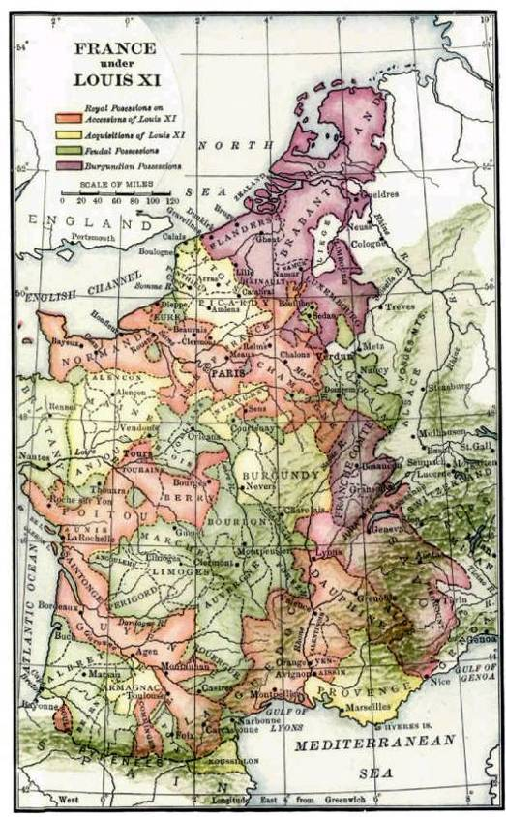
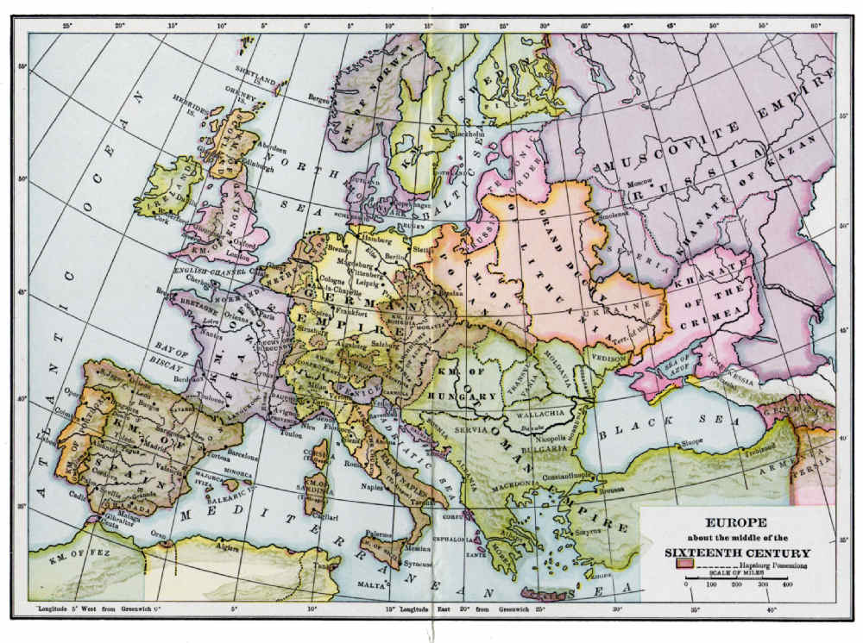
Europe in the Mid-Sixteenth Century

France under Louis XI (1423-83) during the Hundred Years’ War

Advantages of Gunpowder Weapons for this Group | Disadvantages of Gunpowder Weapons for this Group
1.
2.
3.
4.
5.
6.
7.
8.
9.
10.

Lesson 5
Portraits of Potentates

Preparation
Prepare copies of Student Handouts 5.1-5.3 and maps from pages 33-36. (These maps also appear in the Big Era Six PowerPoint Overview Presentation.)

Introduction
Centralizing monarchs with gunpowder armies gained power over lesser rulers in their realms and expanded both their territories and their tax-gathering capabilities. While warfare was expensive and some monarchs went into heavy debt to finance their military adventures, successful rulers also greatly expanded their state’s agricultural and commercial wealth. Rulers displayed this wealth in portraits executed for posterity by skilled artists. Through close visual analysis, these portraits can reveal a lot about the time and the rulers.

Activities
- Distribute Student Handout 5.1 (Portraits of Potentates) and ask students to examine the portraits. (Larger versions can be found online through a quick search of the names and dates of reign of each potentate.)

- Distribute Student Handout 5.2 (Trading Card Template). Ask students to create trading cards of the monarchs shown in Student Handout 5.1, listing their dates of reign and the capital cities from which they ruled. Students should also do research and write a brief biography (100-150 words) of one or more of these rulers, describing at least three major events in their reign. The trading cards can be used as comparative material for essay assignments in DBQ format, for review, or for role-playing activities.

- Using the maps on pages 33-36, have students locate the places where the monarchs ruled. (These maps also appear in the Big Era Six PowerPoint Overview Presentation.) Also, have students find the capital city where they resided.

- Distribute Student Handout 5.3 (Visual Analysis of the Potentates’ Portraits). Ask students to choose three of the portraits in Student Handout 5.1 and take notes on the questions and categories included in Student Handout 5.3. Teachers may also assign groups to work on three specific rulers and then compare notes as a class. Additional portraits may be used for regional studies or longitudinal studies of specific dynasties.

Extension Activities
- Assign individual students to create additional trading cards for other world rulers from the period, including Inca and Aztec rulers in the Americas, African rulers, or others. Display all cards on a classroom mobile made with strings and dowels or coat-hanger wire.

- This activity can be used to introduce the concepts of sovereignty, absolute monarchy, divine right of kings, and similar concepts that modern democratic ideas later challenged. Ask students to list ways in which these portraits placed the sovereign on a different level from the rest of society. For fun, students may think of, or research, advertisements that tell consumers that they can “live like kings” as an aspiration reflected in material culture.

Assessment
Write an essay using Student Handouts 5.1-5.3 in which you compare and contrast rulers from this period and identify common patterns.

Lesson 5

Student Handout 5.1—Portraits of Potentates

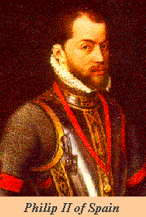
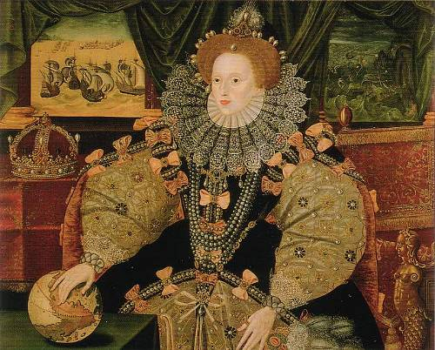
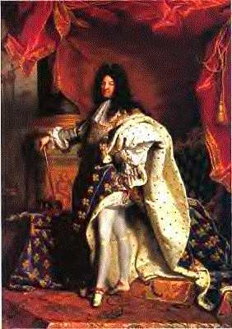
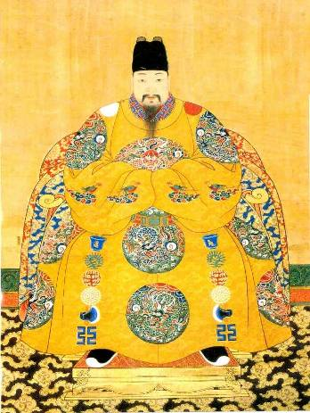
Philip II
Spain
1556-1598
Elizabeth I
England
1558-1603
Louis XIV
France
1643-1715
Xizong
Ming China
1620-1627

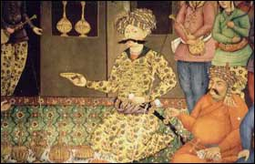
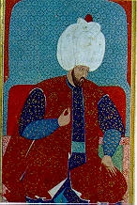
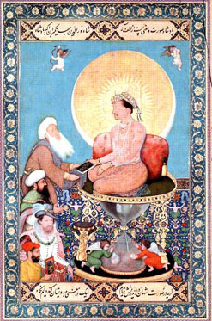
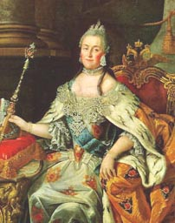
Shah Abbas the Great
Safavid Empire of Persian
1587-1629
Jahangir
Mughal Empire of India
1556-1605
Catherine the Great Russia
1762-1796
Sultan Sulayman
Ottoman Empire
1520-1566

Lesson 5

Student Handout 5.2—Trading Card Template

Portrait | Ruler’s name
 | Dates of rule
 | Capital city, city of residence
 | Country or empire

Biography

Three important events during this ruler’s reign
1.

2.

3.

Lesson 5

Student Handout 5.3—Visual Analysis of the Potentates’ Portraits

Name of Ruler in the Portrait

List 10 items of costume and accessories that you notice in the portrait

Identify and describe 3 examples of visual imagery the artist used in the painting to show that this ruler is a powerful figure

List and describe 5 luxury items illustrated in the portrait that demonstrate advanced levels of trade and manufacture or arts in the country

What visual ideas can you identify that all of the portraits share?

What differences can you identify among the portraits?

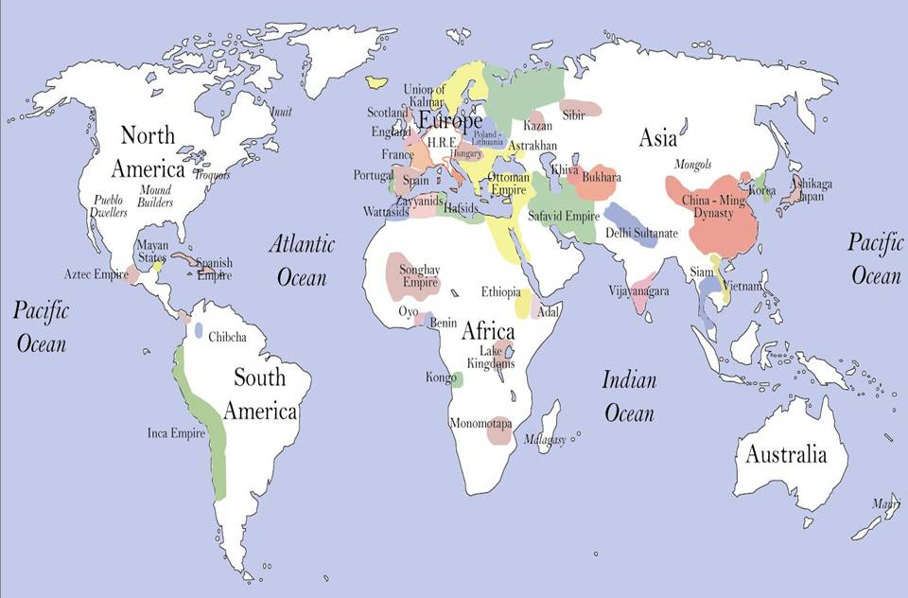
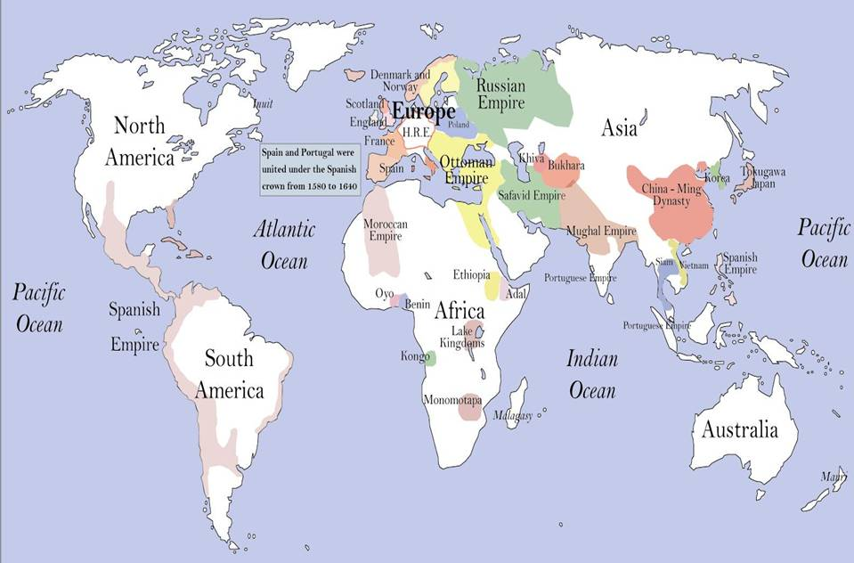
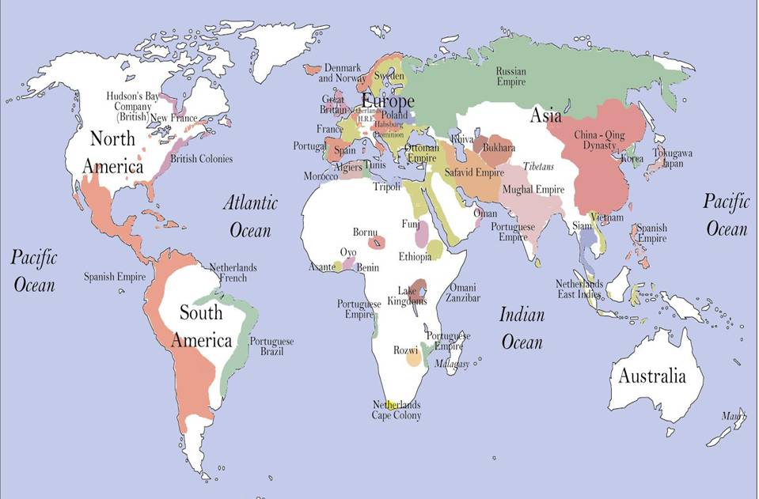
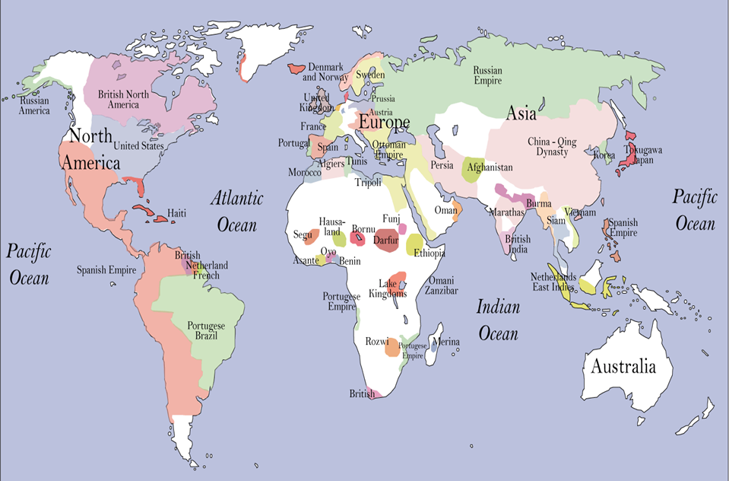
This unit and the Three Essential Questions

How do you think the development and use of gunpowder weapons might have affected physical and natural environments in different parts of Afroeurasia? Consider by comparison how wars have affected the environment in recent times.
Research and report on roles that girls and women of the non-elite classes may have played in the manufacture of firearms and in the deployment of large armies between the fifteenth and eighteenth centuries. (One clue to consider: not only soldiers but all sorts of people accompanied armies in the field.)
The historian William McNeill (Keeping Together in Time: Dance and Drill in Human History [Cambridge: Harvard University Press, 1995]) has made a historical connection between dance and precision military drill and maneuver. How do you think they might be alike or different?

This unit and the Seven Key Themes
This unit emphasizes:

Key Theme 2: Economic Networks and Exchange

Key Theme 3: Uses and Abuses of Power

Key Theme 6: Science, Technology, and the Environment

This unit and the Standards in Historical Thinking
Historical Thinking Standard 1: Chronological Thinking
The student is able to (F) reconstruct patterns of historical succession and duration in which historical developments have unfolded, and apply them to explain historical continuity and change.

Historical Thinking Standard 2: Historical Comprehension
The student is able to (I) draw upon visual, literary, and musical sources including: (a) photographs, paintings, cartoons, and architectural drawings; (b) novels, poetry, and plays; and (c) folk, popular, and classical music, to clarify, illustrate, or elaborate upon information presented in the historical narrative.

Historical Thinking Standard 3: Historical Analysis and Interpretation
The student is able to (D) draw comparisons across eras and regions in order to define enduring issues as well as large-scale or long-term developments that transcend regional and temporal boundaries.

Historical Thinking Standard 4: Historical Research Capabilities
The student is able to (A) formulate historical questions from encounters with historical documents, eyewitness accounts, letters, diaries, artifacts, photos, historical sites, art, architecture, and other records from the past.

Historical Thinking Standard 5: Historical Issues-Analysis and Decision-Making
The student is able to (F) evaluate the implementation of a decision by analyzing the interests it served; estimating the position, power, and priority of each player involved; assessing the ethical dimensions of the decision; and evaluating its costs and benefits from a variety of perspectives.

Resources for teachers and students
Bingham, Marjorie Wall. An Age of Empires, 1200-1750. New York: Oxford University Press, 2005. This is one of the excellent books in Oxford University Press’s illustrated The Medieval and Early Modern World series for precollegiate readers.

Black, Jeremy. War in the Early Modern World. Boulder, CO: Westview Press, 1999.

Chase, Kenneth. Firearms: A Global History to 1700. Cambridge: Cambridge University Press, 2003.

Dale, Stephen Frederic. The Muslim Empires of the Ottomans, Safavids, and Mughals. New York: Cambridge University Press, 2010.

Eltis, David. The Military Revolution in Sixteenth-Century Europe. New York: J. B. Tauris, 1995.

Gies, Frances and Joseph. Cathedral, Forge, and Waterwheel: Technology and Invention in the
Middle Ages. New York: Harper Collins, 1994.

Goldstone, Jack A. Revolution and Rebellion in the Early Modern World. Berkeley: University of California Press, 1991.

Hasan, Ahmad Yusuf. Islamic Technology: An Illustrated History. Cambridge: Cambridge University Press, 1986.

McNeill, William H. The Age of Gunpowder Empires, 1450-1800. Washington, DC: American Historical Association, 1989.

Needham, Joseph. Science and Civilization in China, Cambridge: Cambridge University Press, 1954.

Neiberg, Michael S. Warfare in World History. London: Routledge, 2001.

Pacey, Arnold. Technology in World Civilization: A Thousand-Year History. Cambridge, MA: MIT Press, 1990.

Parker, Geoffrey. Europe in Crisis, 1598-1648. 2nd ed. Malden MA: Blackwell, 2001.

Smith, Richard L. Ahmad al-Mansur: Islamic Visionary. New York: Pearson, 2006.

Conceptual links to other teaching unit
The Great Global Convergence
1400 – 1800
6.3  Rulers with Guns:  The Rise of Powerful States  1400-1700 |  | 6.4  The Global Economy  Takes Shape  1500 – 1800

In the same centuries that rulers were using gunpowder technology to forge larger states and to more effectively control their own subjects, a globe-encircling economy was taking form as a result of the opening of new oceanic passages. Military power and trade reinforced each other. Rulers across Afroeurasia used armies to extend and safeguard overland trade routes. European naval vessels equipped with cannons blasted their way into the trade of the Indian Ocean and China seas. European states used guns to help carve out empires in the Americas. Thereafter, they were able to extract commodities such as silver and sugar, which increased their wealth and power even more. Gunpowder warfare was so expensive that rulers had to raise large sums of money. Taxing trade was an important source of income for acquiring firearms.

“Gunpowder,” New World Encyclopedia, http://www.newworldencyclopedia.org/entry/Gunpowder
“Gun and Gunpowder,” Silk Road Foundation, http://www.silk-road.com/artl/gun.shtml
“Transfer of Islamic Technology to the West,” History of Science and Technology in Islam, http://www.history-science-technology.com/Articles/articles%2072.htm
Wikipedia, http://en.wikipedia.org/wiki/File:FireLanceAndGrenade10thCenturyDunhuang.jpg
Arnold Pacey, Technology in World Civilization: A Thousand-Year History (Cambridge, MA: MIT Press, 1990), 45-9.
Ibid., 48-9; Yaacov Lev, War and Society in the Eastern Mediterranean, 7th-15thCcenturies (Leiden: Brill, 1997), 352.
Pacey, Technology, 50-2.
Johan Verachtert, “Een blik op de buskruitindustrie in de Lage Landen: het buskruit-bedrijf van Maximiliaan en Jacques Blommaert (1738-1798),” http://www.ethesis.net/buskruit/buskruit_deel_I_hfst_4.htm. The image represents an example of an early fourteenth-century cannon, from Walter de Milimete’s “Officiis Regum.”
William H. McNeill, The Age of Gunpowder Empires, 1450-1800 (Washington, DC: American Historical Association, 1989), 4-5.
“The Project Gutenberg EBook of Artillery through the Ages, by Albert Manucy,” http://www.gutenberg.org/files/20483/20483-h/20483-h.htm
The Project Gutenberg EBook of Artillery through the Ages by Albert Manucy, http://www.gutenberg.org/files/20483/20483-h/20483-h.htm
Ibid.
Johan Verachtert, “Een blik op de buskruitindustrie in de Lage Landen: het buskruit-bedrijf van Maximiliaan en Jacques Blommaert (1738-1798),” http://www.ethesis.net/buskruit/buskruit_deel_I_hfst_4.htm
The original Tannenberg gonne, displayed in the Germanic Museum in Nuremberg. http://www.musketeer.ch/blackpowder/handgonne.html
Painting of a siege by Qinte Curce, 1468, British Museum, London. Source: “Handgonnes,” http://www.musketeer.ch/blackpowder/handgonne.html
“The Musket Drill,” created by J. E. Quest using frames from H. Hexham’s The Principles of the Art Militaire. Source: http://www.geocities.com/Yosemite/Campground/8551/drill.html (no longer available).
Eric R. Wolf, Europe and the People without History (Berkeley: University of California Press, 1997), 182-4.
“Sultan Qaboos Cultural Center, http://www.indianoceanhistory.org/
McNeill, Age of Gunpowder Empires, 14-15, 33-6.
Wolf, People without History, 209-11.
Ibid.
Wolf, People without History, 176-8.
Michael S. Neiberg, Warfare in World History (London: Routledge, 2001), 37.
Ibid.
The Project Gutenberg eBook of An Introduction to the History of Western Europe by James Harvey Robinson, http://www.gutenberg.org/files/26042/26042-h/26042-h.htm

