Big Era 6

The Great Global Convergence

1400-1800 CE

Landscape Teaching Unit 6.4
The Global Economy Takes Shape
1500-1800 CE
Table of Contents
Why this unit? | 2
Unit objectives | 2
Time and materials | 2
Author | 3
The historical context | 3
This unit in the Big Era timeline | 4
Lesson 1: The Global Economy, A Study in Products: Introductory Mapping Activity  tT | 5
Lesson 2: Fur | 11
Lesson 3: Indigo | 17
Lesson 4: Tea | 22
Lesson 5: Assessment: Analysis of the Global Economy | 27
This unit and the Three Essential Questions | 29
This unit and the Seven Key Themes | 29
This unit and the Standards in Historical Thinking | 29
Resources | 30
Conceptual links to other lessons | 31
Why this unit?
Historians view the creation of new societies in the Atlantic Rim as a significant turning point in world history. In Landscape Unit 6.2, “The Columbian Exchange and its Consequences: 1400-1650,” we explored the story of how peoples began to interact regularly across the Atlantic Ocean and how those interactions affected the environment, as well as social, biological, and cultural institutions around the world. The focus in this unit is on the creation of a global economy owing to the interaction of peoples in the Americas, Europe, Africa, and Asia, an economy that would put the world on a path towards globalization.

This unit leads students through investigations of the creation of this global economy that included peoples from all over the world. The first lesson will introduce students to the three products they will learn about as representative samples of some of the goods that were in demand in the global economy. Students will map where these products originated. The three lessons that follow highlight each of these products—fur, indigo, and tea—and allow students to trace their journey through the world using map work and primary or secondary sources. Students will become familiar with the economic terms “producer” and “consumer” and will also have to think about the role of the movers of those products who, thanks to developments in maritime technology, were able to create new markets and new demand for products. Finally students will use their completed maps and other sources to analyze who dominated global trade by 1800.

Unit objectives
Upon completing this unit, students will be able to:
- Describe the development of a global economy from 1500-1800 and analyze whether this development represents a process of globalization.
- Analyze the role of maritime technology in creating a global economy.
- Define the role of various producers, movers, and consumers in creating, transporting, and using the various products that created a global economy from 1500-1800.
- Discuss who dominated global trade by 1800 and why.

Time and materials
This unit will take one week or less of 45-minute class periods. The first day will be an introduction to the unit (Lesson 1) and the following periods will focus on one or more of particular products (Lessons 2 through 4). The final day will address the culminating assessment (Lesson 5).

Materials are included in the unit but students will need an atlas or Internet tools to locate particular countries.

Author
Esther Adams taught social studies at Walter Johnson High School in Bethesda, Maryland. Her courses included AP World History. She spent her first two years of teaching at the Walworth Barbour American International School in Tel Aviv, Israel. More recently she has taught for Teach for America in Texas.

The historical context
The emergence of a truly global economy was another consequence of the Great Global Convergence, which linked together all major regions, except Antarctica, in a single web of exchange. Silver was the great lubricator of global trade. In the 1550s, silver mined in the Americas became available to Spain, then to the rest of Western Europe. Silver financed Europe's increasing involvement in the world market, which was centered in East and South Asia well into the eighteenth century. By 1800, the world economy was shifting toward the Atlantic as its center.

Far-reaching changes in maritime shipbuilding and navigation greatly speeded global exchange in Big Era Six. New maritime technology, plus the European innovation of mounting cannons on shipboard, permitted the rise of the Spanish, Portuguese, Dutch, British, and French maritime empires. These empires were larger and more diverse than any earlier ones. New firearms technology also contributed to the expansion of Afroeurasian land empires that were better organized (for controlling their subjects and collecting taxes from them) than earlier agrarian empires. These states included the Turkish Ottoman, Safavid Persian, Mughal Indian, Qing Chinese, and Romanov Russian empires, plus others in Inner Eurasia, West Africa, and Southeast Asia.

The world economy was Asia-centered at the beginning of Big Era Six, but it gradually underwent a major shift in organization. By 1800, it was becoming focused on the Atlantic world. How did this come about, and what were the main consequences? The linking of Afroeurasia with the Americas was the most important factor. The sudden arrival in the sixteenth century of vast quantities of silver on world markets led to a rapid increase in world commercial exchanges of all kinds. This was as true for Asia, where the economies of both China and India were based on silver coinage, as it was for Europe. In the long run, it seems clear that Europeans benefited the most from this development. But this was not apparent at the time.

In the sixteenth century, European participation in the trade of Africa and Asia was seriously limited. Europeans did not produce commodities or finished goods that Asians wanted to buy. American silver, which American Indians and African slaves extracted from the earth, provided a solution for capitalist entrepreneurs. These merchants could purchase Asian commodities (pepper, spices, coffee, tea, porcelain, carpets, silk, and cotton cloth) with American silver and, to some extent, gold. The Japanese also supplied silver to the Asian market. Once Europeans with precious metals to sell entered the trade of Asia, they also profited as specialists in moving goods from one part of Asia or Africa to another—Chinese porcelain to India, for example, or Indian textiles to West Africa. The trade boom in maritime Asia soared to new heights between the sixteenth and eighteenth centuries. Because it greatly benefited European states and merchants, however, the weight of the world economy began to shift from East and South Asia to the Atlantic world.

This unit in the Big Era Timeline

Big Era Six 1400-1800 CE

The Global Economy Takes Shape
1500-1800

Lesson 1
The Global Economy, A Study in Products:
Introductory Mapping Activity

Preparation
Have you ever stopped to think how the shirt you are wearing or the candy bar you are eating got to you? Sure, you bought it at the store, but where did it come from before it reached you? Do you know how many people from different places around the world were involved in making the product you are enjoying?

Introduction
These are questions that historians have been asking about products for a long time. Our world has been economically connected for several centuries through a process we call globalization. You may have heard of this term. Globalization is the process by which peoples around the world have become increasingly interconnected through rapid communication and transport. Globalization involves the intensification of economic, social, cultural, political, and biological interchange worldwide, resulting on the one hand in a general acceleration of change and on the other in efforts to strengthen the bonds of identity and community on the local and regional levels. In this series of lessons you will learn how our entire world became economically interconnected for the first time beginning approximately 1500 CE. Although interregional trade across Afroeurasia had been going on for centuries, the Columbian Exchange and the opening of passages across the Atlantic and Pacific began to shape a truly globalized economy.

Thanks to advances in maritime technology and the increased volume of trade that followed these developments, people from both sides of the Atlantic became exposed not only to different peoples and ideas but also to different products that facilitated a new desire for buying and selling, or producing and consuming. These lessons will introduce you to a few of the many products that illustrate the global nature of this new economy. You will meet the people who made or cultivated the product (the producers), the people who got the product to the people who wanted it (the movers), and finally the people who wanted and received the product (the consumers). In the unit assessment, you will investigate the question of who really controlled the global economy by 1800. Did a particular country or people dominate the trade of all of these products in 1800?

In this first lesson, you will be introduced to the three products that you will follow in this teaching unit. Your job will be to read primary and secondary source excerpts and figure out where the products were first developed or cultivated and label them on the map.

Activities

1. Student Handout 1.1 provides the maps students will use throughout the lessons to label where each product originates, moves, and is consumed. Students have two choices of maps, one centered on the Pacific Ocean and one on the Atlantic Ocean. They will need to use an atlas to locate particular countries and to draw them on the map to label the precise origin of the product. They will also need to create a legend, or key, for their map so they can easily distinguish one product from another. They should use a different symbol for each product, and they can create that symbol. Make sure they write their legend on the lower left-hand corner of Student Handout 1.1.

2. Using Student Handout 1.2, have students read about the origins of the fur trade in North America. They should label on the map where the purchase of beaver furs took place. They may choose their symbol for Fur, perhaps the letter “F” or a picture of the animal whose fur was used to make products from fur pelts. Whatever they choose, this will be their symbol for fur throughout the whole unit.

3. Using Student Handout 1.3, have students read about the origins of indigo. They should label on the map where indigo production took place. They may choose their symbol for Indigo, perhaps the letter “I” or the color of indigo. Whatever they choose, this will be their symbol for indigo throughout the whole unit.

4. Using Student Handout 1.4, have students read about the origins of tea. Students should label on the map where tea was cultivated. They may choose their symbol for Tea, perhaps the letter “T” or a symbol of a tealeaf. Whatever they choose, this will be their symbol for tea throughout the whole unit.

Feel free to have students substitute the map on Student Handout 1.1 with a larger one if they need more space. Students will be using a different map each day to trace how products move through the global economy. It would be ideal if you as the teacher made transparencies of the maps—one for each of the products. On the last day of the unit, lay the maps on top of each other to show students how the movement of products overlapped all over the world as part of the assessment activity.

Assessment
Now that students have labeled where all three products originated, they should look carefully at their first map. They should write in a few sentences any observations they can make about where the products were produced. What kind of conclusions can they make based solely on where the products originated? What other kinds of information do they need in order to explain the global economy from 1500 to 1800?

Lesson 1

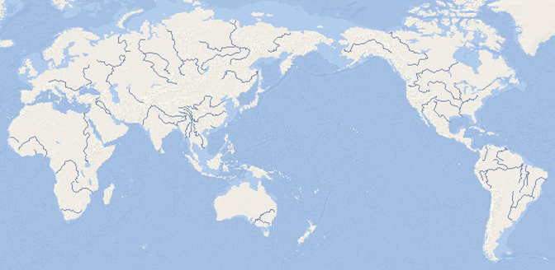
Student Handout 1.1

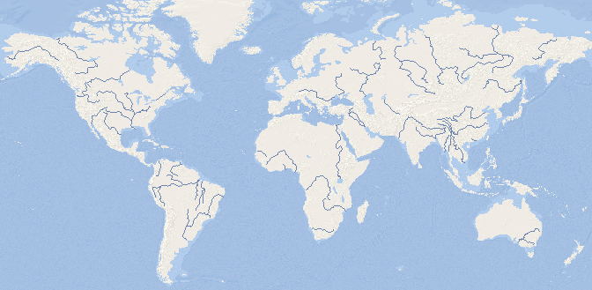

Lesson 1

Student Handout 1.2—Origins of Fur

During the 1500s, Europeans began exploring the east coast of mainland North America. They traded items such as knives, hatchets, and beads to Native Americans for fur and meat. Indian trappers such as the Iroquois brought beaver furs from the interior to the St. Lawrence River and traded there for manufactured goods from Europe. Out of these early exchanges a formal fur trade was born in North America. It began in the area that is today modern Quebec. Because the best pelts were from areas that had severe winters, most trade was in Canada. Some trade, however, also developed along the Mississippi River and to the west in the Rocky Mountains.

Lesson 1

Student Handout 1.3—Origins of Indigo

True indigo comes from a plant species called Indigofera, which is a subtropical shrub that grows to be 4-6 feet tall. The leaves of the indigo plant are what make the beautiful blue dye that indigo is famous for around the world. The word indigo comes from ancient Greek, meaning “the Indian dye” or indiko. This is a clue about where the ancient Mediterranean world got indigo from.

Many different species of Indigofera have been found all over the world from Australia to Madagascar. Many societies have used the plant’s blue dye for religious, cultural, social, political, and aesthetic purposes. Various species of the plant have been found in Guatemala and Peru, where they were used for a variety of purposes long before Europeans came to the Americas. Indigo also grows wild all over the African coast and has been used as a symbol of wealth and fertility in West African societies for centuries. Modern day countries like Mali, Cameroon, Nigeria, Niger, and Burkina Faso all have a rich history of dye techniques using indigo. Asian societies including India, Indonesia, Japan, and China have a long tradition of using indigo to print, dye, and do artistic work with textiles.

Lesson 1

Student Handout 1.4—Origins of Tea

Tea is made of the dried leaves, buds, and flowers of the tea plant. It originated in Asia in what is now the border region between India and China. The first Chinese written reference to tea goes back to the first century BCE. By the fourth century BCE, tea was deliberately grown as a medicinal, religious, and popular drink. It first became the national beverage of China during the Tang Dynasty (618-907 BCE).

Lesson 2
Fur

Preparation
Have you ever thought about where your favorite hat comes from? Was it made in one place? How did it get from where it was made to your favorite store? What kind of profit do hat makers get?

Introduction
The fur trade in North America began between the Iroquois and Europeans in the early 1500s. Within a few years, French, English, and Dutch fur traders were bartering with the Iroquois throughout the Mohawk Valley in order to compete to control the trade. Even though other furs were traded such as fox and mink, the beaver became the most valuable fur by far. Why? Beaver fur is soft, smooth, waterproof, easily shaped, and long-lasting. It also became the most fashionable type of felt hat in Europe from the 1600s until the 1830s. Beaver pelts were made into hats in Western Europe and Russia after a long and specialized process. Both rich and middle class Europeans were willing to pay a lot of money for beaver hats.

Over-hunting in Europe had created a real need for a new source of beaver fur, so the European discovery of the North American beaver was a big deal for traders. Whoever controlled the trade of fur in North America stood to profit immensely. The first Europeans to dominate the trade were French. Explorers such as Samuel de Champlain established trading posts in their territory called New France. Nations such as the Iroquois and Huron would trade fur pelts in order to get items of new interest to them, such as knives, pots, wool blankets, axes, and guns. Mirrors became one of the most essential trade items because men could use them to dress and paint themselves without the help of their female relatives. Indigenous men and women were both involved in the fur trade. The men captured the beavers, and the women tanned the hides and removed the rougher outer fur before trading them to the Europeans for manufactured goods.

Then in 1670, a major change occurred. The British founded the Hudson Bay Company. It soon controlled all the fur trade in the lands around the Hudson Bay. This is called having a monopoly. In order to trade with the various Indian nations, the Hudson Bay Company set up trading posts where the fur could be brought in exchange for money or goods. This arrangement worked well for a while, and merchants sent furs to London instead of Paris. British manufacturers made money selling their hats and other fur products back to indigenous and European consumers in North America. Generally throughout the 1770s, fur trade took place at the large trading posts established by European trading companies. Then in 1783, the North West Company was founded in order to compete with the Hudson Bay Company by looking for new sources of fur in the northern and western regions of Canada. This was the first joint stock company in Canada and possibly North America. Competition between the British and the French for control of the fur trade continued through the nineteenth century. Russian merchants, who trapped and traded sables and other fur-bearing animals in Siberia, also got into the North American game. They established a fur trading company in Alaska when it was a territory claimed by the Russian empire. In 1799 they founded the Russian-American Company.

Activities

1. Students should label on the map they are using from Student Handout 2.1 places where beaver fur was produced in North America, where it was sent, and where it was consumed.

2. Students should answer the following questions using the information they have read in this lesson’s Introduction and in Student Handouts 2.2 and 2.3:

a. Who is the producer of the fur? What does the producer get for trading or selling the fur?

b. Who is the mover of the fur? What do movers get for transporting the goods?

c. Who is the consumer? What do consumers give in order to get the goods they want?

d. How did the fur trade benefit the people who produced the fur, transported it, and consumed it or used the products made from it?

Ideally for question 2c students should see two consumers, both Europeans and Native Americans. Europeans wanted the hats and Native Americans wanted the European goods of particular interest to them.

Assessment

1. Have students create a timeline of important dates in the fur trade.

2. Ask students to look at the hats in Student Handout 2.2. What observations might they make about the types of hats produced over time?

3. Analyze the data in Student Handout 2.3. What conclusions might they make about the fur trade in North America from 1600 to 1800?

Lesson 2

Student Handout 2.1

Lesson 2

Student Handout 2.2
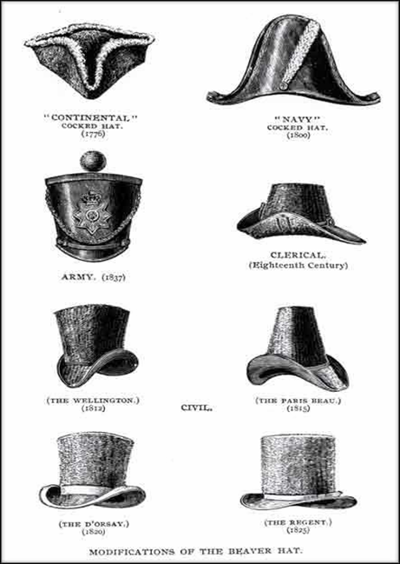

Modifications of the beaver hat
Horace T. Martin
HBCA, PAM 1987/363-C-308/2 (N58-98)
Taken From Castorologia, published in London, 1892
Hudson’s Bay Company Archives
Provincial Archives of Manitoba

Lesson 2

Student Handout 2.3

In 1722-1723, three French forts along the Great Lakes supplied the following goods in exchange for about 8,000 beaver pelts:

1605 sewing needles
632 catfish hooks
273 men's woolen shirts
336 women's woolen shirts
214 children's woolen shirts
217 butcher knives
2,109 other knives
243 pounds of red and yellow copper cauldrons
328 axes
59 guns
4,493 gun flints
3,640 pounds of shot and balls
6,463 pounds of flour

French exports to Europe

 | About 30,000 beaver skins a year
1680s | About 140,000 beaver skins a year
 | About 200,000 beaver skins a year

Lesson 3
Indigo

Preparation
Think more about the materials that go into making your hat. How did it come to be that particular color that you love?

Introduction
Although the indigo plant has been found in many different parts of the world for centuries, the large-scale cultivation of indigo started in sixteenth-century India. European maritime explorers like Vasco da Gama opened up direct sea links to India beginning in the late fifteenth century. Consequently, Portuguese, English, and Dutch traders brought the indigo plant to Europe from India. By the late 1600s, indigo was being marketed in most European nations. Why the desire for indigo? It was exotic, it was superior to the woad plant used in Europe to produce blue dye, and it helped satisfy the new hunger that Europeans had for items from far corners of the globe. European consumers wanted indigo-dyed fabrics, paints, and laundry bluing (which made white fabrics appear whiter). The East India Company imported huge quantities of Indian indigo in the mid-1600s. Indian farmers were hard-pressed to keep up with the demand, but European nations also resented the Indian monopoly of the indigo trade. Since indigo could not grow in Europe's temperate climate, European merchants began to plant it in their tropical colonies in the Caribbean. The best indigo came from Guatemala and the French West Indies and sold for prices two or three times higher than that produced by other American colonies. Still, no American indigo producer could match the quality of the Indian product. Eventually, the British established commercial cultivation and production of indigo in India. Plantations began in 1777, and by 1788 most of the production of indigo purchased by the East India Company originated from India. As a dye it replaced American supplies, which were disrupted during the American Revolution. The East India Company supplied the textile industries of the Industrial Revolution. Indigo was used to dye European military uniforms, as well as the blue coats the Continental Army wore in the American Revolution.

West Africa also had a rich history of indigo production, primarily through the work of West African women. Although Africans were not initially bought and sold by Europeans for their skills with indigo, it quickly became apparent that many possessed particular knowledge about the complicated process of producing the dye. Consequently, African slaves worked on plantations in the tropical Americas to produce indigo and indigo dye.

Eliza Lucas Pickney (1722-1793) was a woman who brought the indigo plant to South Carolina and oversaw a valuable export business to England. Her father had left her in charge of three plantations and eighty adult slaves when he moved back to Antigua to become governor. In 1739, he sent her cassava, alfalfa, ginger, cotton, and indigo seeds. After many trials she managed to produce enough indigo in 1747 to make up a shipment for England. As a result, indigo became the staple crop of South Carolina from the late 1740s to the Revolutionary War.

Activities

1. Ask students to label on the Student Handout 3.1 map where indigo was produced, where it was moved, and where it was consumed.

2. Have students answer the following questions using the lesson introduction and Student Handouts 3.2, 3.3, and 3.4.

a. Who is the producer of the indigo? What does the producer get for trading or selling the indigo?

b. Who is the mover of the indigo? What do movers get for transporting the goods?

c. Who is the consumer? What do consumers give in order to get the goods they want?

d. How did the trade benefit the people who produced the indigo, transported it, and consumed or used it or the products made from it?

Assessment

1. Have students create a timeline of important dates in the indigo trade.

2. Ask students to analyze the data in the table in Student Handout 3.2. What kind of observations might they make about the exporting of indigo from South Carolina from 1745 to 1775? Between what years did the largest exporting of indigo seem to happen? Ask student why they think those years might have been important? (Students may look for clues in the lesson Introduction.)

After students answer question 2 of the assessment, you may want to share this information with them: By 1775, indigo produced one third of the colony’s income and South Carolina’s planters were exporting 1.1 million pounds of indigo, which is worth $30 million today.

Another interesting fact is that after European scientists determined how to chemically synthesize indigo in the late nineteenth century, the Indian indigo growing industry fell rapidly into decline.

Lesson 3

Student Handout 3.1

Lesson 3

Student Handout 3.2

South Carolina Indigo Exports
1745-1775

Year | Pounds
1745 | 5,000
1748 | 134,118
1754 | 216,000
1757 | 894,500
1775 | 1,107,660

Source: Adapted from William James Hagy, This Happy Land: The Jews of Colonial and Antebellum Charleston (Tuscaloosa: University of Alabama Press), Table 26; and Marc Egnal, New World Economies: The Growth of the Thirteen Colonies and Early Canada (New York: Oxford UP, 1998), Figure 6.11.

Lesson 3

Student Handout 3.3
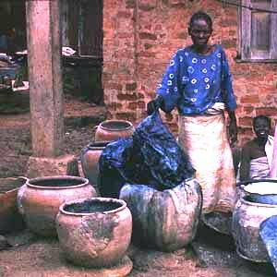

Indigo dying in West Africa
Web source no longer available

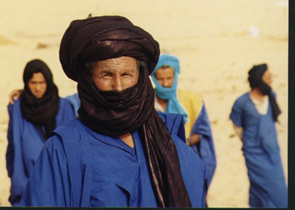

Tuareg “blue people” wearing indigo garments
The Tuareg people live mainly in Mali, Niger, Libya, Algeria, and Burkina Faso. They are sometimes called the "blue people” because their traditional robes are made of indigo pigment and therefore stain the wearer's skin dark blue.
Web source no longer available

Lesson 3
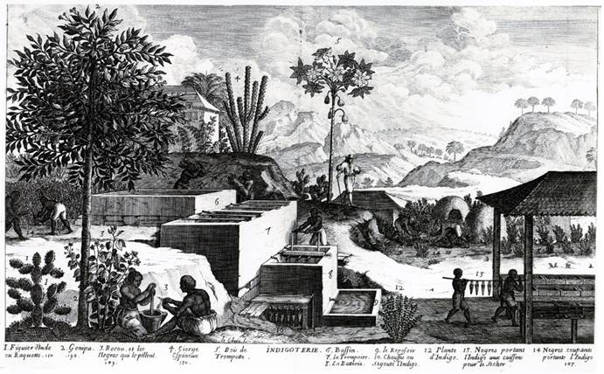
Student Handout 3.4
Indigo Plant Farm
This print depicts and labels the key parts of the process of producing indigo. Slaves are working at different parts of the production process. In 1789, over 3,000 plantations in Saint Domingue (modern day Haiti) produced indigo.
DLC-RB F2001 D97 1 Jean-Baptiste du Tertre, Histoire générale des Antilles habitées par les Français, 4 vols. (Paris: T. Lolly, 1667).
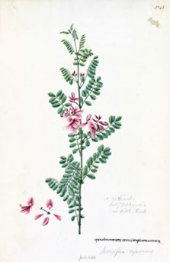

Indian
indigo plant

Lesson 4
Tea

Preparation
What is your favorite beverage? Is it popular just among your friends or in other places in the world? Why do Americans drink so much coffee, and the British drink more tea? Is it because Starbucks is an American company? What is the most common hot drink in China?

Introduction
“Better to be deprived of food for three days than of tea for one.”
Chinese proverb
“Thank God for tea! What would the world do without tea? How did it exist?”
Sydney Smith, British writer (1771-1845)

These two quotes exemplify the power of tea in the two countries best known for tea. Not only did tea grow in demand from 1500 to 1800, but it also grew in profit for the Chinese. As tea became more popular, the British paid more and more silver to the Chinese in exchange for tea. In addition, tea had to be imported from China, and the Chinese tightly controlled the number of chests of tea leaves that left its docks. A Dutch ship brought the first shipment of tea to the Netherlands in 1610, and by the 1650s tea was known in England.

At the beginning of the eighteenth century, almost no one drank tea. By the end of the century, enough tea was coming into Britain for everyone in the country to have a cup or two a day. What allowed for this rapid change? Tea became fashionable thanks to Charles II’s queen, Catherine of Braganza, a Portuguese princess who had grown up drinking tea. When she married Charles in 1662 and came to England, she made tea a fashionable drink in court and among aristocrats. Subsequently, a whole tea culture emerged, including the teashop, tea parties, tea gardens, and the marketing of tea to women, who had not been permitted in the men-only coffeehouses of London. The ultimate expression of this practice was “tea time,” where tea became the center of the afternoon meal. Sweetened with sugar produced by slaves in the Americas, tea became the favored drink of workers during the Industrial Revolution. It also stimulated mass production of products to hold tea, notably the complete tea set or tea service, which rich and middle class British consumers had to have.

Transporters such as the British East India Company (BEIC) brought tea to England. In fact, this company enjoyed a British monopoly on exports from the East Indies. Once the company established offices in trading at the port of Canton in China at the beginning of the eighteenth century, the volume of tea entering Britain soared, while prices fell. Therefore, common people, as well as the elite, could enjoy tea. By the early 1720s, tea was the number-one export from China. At the height of prosperity of the BEIC, more than 50 percent of its Asian export value was in tea! In 1773, Parliament passed the Tea Act, which eliminated the tax the BEIC had paid the British government for importing tea to Britain and its colonies in the Americas.

Activities

1. Ask student to label on the Student Handout 4.1 map where tea was produced, where it moved and where it was consumed.

2. Have students answer the following questions using the lesson introduction and Student Handouts 4.2 and 4.3:

a. Who is the producer of the tea? What does the producer get for trading or selling the tea?

b. Who is the mover of the tea? What do movers get for transporting the goods?

c. Who is the consumer? What do consumers give in order to get the goods they want?

d. How did the tea trade benefit the people who produced the tea, transported it, and consumed it?

Assessment

1. Ask students to create a timeline of important dates in the tea trade.

2. Have students analyze the data in Student Handout 4.2. What conclusions might they make about the tea trade from China to England?

Lesson 4

Student Handout 4.1

Lesson 4
Student Handout 4.2

British tea purchases from China

1700-25 | 400,000 pounds
1760 | 2,600,000 pounds
1800 | 23,300,000 pounds
1808 | 26,000,000 pounds

http://history.binghamton.edu/hist130/docs/teaopium.htm

Value of Tea Exported from China to England

1781-1790 | 16.4 million ounces of silver
1800-1810 | 26 million ounces of silver

http://humanities.cqu.edu.au/history/52148/modules/imperial_commoditiesA.html

Lesson 4
Student Handout 4.3

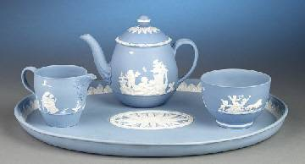
A Josiah Wedgwood Tea Set
http://www.abcir.org/images/000175.jpg

Lesson 5
Assessment: Analysis of the Global Economy

Directions: You have spent the last few days looking at three different products produced, moved, and consumed between 1500 and 1800. Complete Tasks 1 and 2, and then you will be ready for the assessment activity.

Task 1
Examine the three timelines you have made that show some of the important dates in the production, trade, and use of fur, indigo, and tea in the global economy. Do any similarities and/or differences stand out to you regarding the chronological events related to each of these products? What observations can you make about the activities of the British East India Company in terms of indigo and tea?

Task 2
Make a chart like the one below and complete it. Use this to help you complete the assessment activity.

 | Producer | Mover | Consumer
Fur

Indigo

Tea

Directions: Now that you have completed Tasks 1 and 2, choose one of the following to complete as an assessment activity.

1. What conclusions can you make about the world economy in 1800? Was it truly global?
Write a thesis statement answering this question and use evidence from your maps, timelines, lesson assessments, and what you have read and learned in this unit to support your thesis in a one-page response.

2. “Consumption is the sole end and purpose of all production; and the interest of the producer ought to be attended to, only so far as it may be necessary for promoting that of the consumer.”
Adam Smith, The Wealth of Nations, Book IV Chapter VIII

Adam Smith is one of the most famous economists in modern history, and he is viewed by many as the father of capitalism. Based on what you have examined in this unit regarding the global economy, do you agree with his statement? Write a thesis statement answering this question and use evidence from your maps, timelines, lesson assessments, and what you have read and learned in this unit to support your thesis in a one-page response.

This unit and the Three Essential Questions

What impact did the fur trade have on the northern regions of North America, specifically the northern United States and Canada, in terms of environmental change and animal habitats?

Why do you think humans are so fascinated by products they have never seen before? What makes humans embrace a foreign product? Research an example of a specific product that became part of the global economy through commercial exchange. How did this product affect a specific society in history?
In order to move all of the products in the global economy, ships and navigational tools had to be improved and great advancements in maritime technology had to be made. Research one of the advances developed between 1500 and 1800 and explain how it contributed to the moving of products in the global economy.

This unit and the Seven Key Themes
This unit emphasizes:

Key Theme 2: Economic Networks and Exchange

Key Theme 6: Science, Technology, and the Environment

This unit and the Standards in Historical Thinking
Historical Thinking Standard 1: Chronological Thinking
The student is able to (F) reconstruct patterns of historical succession and duration.

Historical Thinking Standard 2: Historical Comprehension
The student is able to (G) draw upon visual, literary, and musical sources.

Historical Thinking Standard 3: Historical Analysis and Interpretation
The student is able to (E) analyze cause-and-effect relationships and multiple causation, including the importance of the individual, the influence of ideas, and the role of chance.

Historical Thinking Standard 4: Historical Research Capabilities
The student is able to (A) formulate historical questions.

Historical Thinking Standard 5: Historical Issues-Analysis and Decision-Making
The student is able to (C) identify relevant historical antecedents.

Resources teachers and Students
Bailey, Katharine. Radisson & des Groseilliers: Fur Traders of the North (In the Footsteps of Explorers). New York: Crabtree Publishing, 2006.

Crosby Jr., Alfred W. The Columbian Exchange, Biological and Cultural Consequences of 1492. Westport, Connecticut: Greenwood Press, 1972. Lays a great foundation for products that circulated in the early global economy.

Knight, Frederick. “In An Ocean of Blue: West African Indigo Workers in the Atlantic World to 1800.” In Michael A. Gomez, ed. Diasporic Africa, A Reader. New York: New York UP, 2006, 28-44. Essay that focuses on the Lucas estate in South Carolina as an example of the impact of African workers on both South Carolina indigo production and the larger Anglo-American world.

Marks, Robert B. The Origins of the Modern World: A Global and Environmental Narrative from the Fifteenth to the Twenty-First Century, 3rd ed. Lanham, MD: Roman and Littlefield, 2015.

McFarlane, Alan, and Iris MacFarlane. Green Gold: The Empire of Tea. London: Ebury Press, 2004.

McKinley, Catherine E. Indigo. London: Bloomsbury, 2012.

McNeill, J.R and William H. McNeill. The Human Web: A Bird’s-Eye View of World History. New York: W. W. Norton, 2003. Excellent overview of larger themes in world history. Sections six and seven pertain specifically to this unit.

Pomeranz, Kenneth, and Steven Topik, eds. The World that Trade Created: Society, Culture, and the World Economy, 1400 to the Present. Armonk, NY: M. E. Sharpe, 2013.

Standage, Tom. A History of the World in Six Glasses. New York: Walker and Co., 2006. A fun and readable book with a great section on tea in the global economy.

“UK Tea Council.” http://www.tea.co.uk/. Click on “A Brief History” for information conveyed in an engaging way.

Wolf, Eric R. Europe and the People Without History. Berkeley: University of California Press, 1982. A classic scholarly work by an anthropologist on the development of the modern global economy. Includes a full chapter on the fur trade.

Conceptual links to other teaching units
This unit has explored economic “globalization” in the early modern centuries by focusing on three products of great importance. The next unit also explores economic changes in part, but it focuses on one large region of the world, the Atlantic Ocean and the lands that rimmed it. The Atlantic economy boomed in the early modern era, but, as we will see, its expansion relied heavily on the trade in African slaves to American commercial plantations and mines.

