**Big Era 6**

#### The Great Global Convergence

#### 1400-1800 CE

****

**Landscape Teaching Unit 6.5**

**The Making of the Atlantic Rim**

**1500-1800 CE**

**Table of Contents**

|  |  |
| --- | --- |
| Why this unit? | 2 |
| Unit objectives | 2 |
| Time and materials | 2 |
| Authors | 2 |
| The historical context | 3 |
| This unit in the Big Era timeline | 5 |
| Lesson 1: Maps and the Making of the Atlantic Rim  tT | 6 |
| Lesson 2: Migration and Demography in the Atlantic Rim | 13 |
| Lesson 3: Women in the Atlantic Rim | 22 |
| Lesson 4: Men in the Atlantic Rim | 37 |
| Assessment | 46 |
| This unit and the Three Essential Questions | 47 |
| This unit and the Seven Key Themes | 47 |
| This unit and the Standards in Historical Thinking | 47 |
| Resources | 48 |
| Conceptual links to other lessons | 50 |

**Why this unit?**

Historians view the creation of new societies in the Atlantic rim, that is, the lands bordering the Atlantic Ocean, as a significant turning point in world history. After 1500, the Columbian Exchange led to permanent changes in the world. The story of how peoples in Europe, Africa, and the Americas interacted and produced effects on the environment and on social, political, and economic institutions around the world is explored in Landscape Teaching Unit 6.2, “The Columbian Exchange and its Consequences, 1400-1650.” The focus in this unit is on the creation of new societies in the Atlantic basin between 1500 and 1800. New societies emerged and existing societies were altered in almost all the rim lands, as peoples in one region brought their agricultural technology, languages, religions, and perspectives of the world to the other regions.

This unit leads students through an investigation of the formation of this new world region, which included peoples of European, African, and Native American origin. The first part of the investigation is a comparison of several maps made by Europeans that show the European perspective on the names and geographic relationships among the three regions. The second lesson leads students to analyze the voluntary and forced migrations of peoples within the Atlantic basin. Two lessons follow in which students compare stories of people who contributed to the new societies that emerged in the 1500-1800 period. The stories serve as a reflection of the millions of lives that were altered when the Atlantic rim world was created as an interactive “world.” In using the analytical tools of the historian, students question the extent to which peoples in each region helped create the new societies of the Atlantic rim.

# Unit objectives

*Upon completing this unit, students will be able to:*

1. Analyze how Europeans, Native Americans, and Africans contributed to the creation of the Atlantic rim.
2. Compare the contributions different peoples made to the new societies of the Atlantic rim.

# Time and materials

Teaching all lessons in the unit will take a week or less of 45-minute class periods, depending how many of the four lessons the teacher presents.

# Authors

Sharon Cohen teaches world history at Springbrook High School in Silver Spring, Maryland. She was a member of the Advanced Placement World History Test Development Committee from 2002 to 2014 and a founding member of the editorial board for *World History Connected: The EJournal of Learning and Teaching*. Ms Cohen also produced print and electronic curriculum materials for the College Board on apcentral.collegeboard.com.  In addition, she wrote the print and web curriculum materials for the *Bridging World History* video series and lessons for HHistoHthe *World History Matters* website at George Mason University. She joined the World History for Us All development team in 2002.

Esther Adams taught social studies at Walter Johnson High School in Bethesda, Maryland. Her courses included AP World History. She spent her first two years of teaching at the Walworth Barbour American International School in Tel Aviv, Israel. More recently she has taught for Teach for America in Texas.

**The historical context**

In 1492, the Genoese entrepreneur and pious Christian Christopher Columbus directed three caravels across the Atlantic Ocean toward what he assumed would turn out to be a new route to Asia. Although he did not publish a full account of his motives, the notations he made in his books and private journals tell us that he wanted to make enough money for a new crusade against the Ottoman empire, which controlled the Christian Holy Land. Columbus succeeded in making money for himself and for Isabel and Ferdinand, his royal sponsors and monarchs of the newly-formed Spain. But he relinquished his crusade plans to subdue the “pagans” he encountered in the Caribbean Sea islands. Investigation of the Columbian beginnings to the creation of the Atlantic rim shows us some of the motivations and methods of the Europeans who helped create new societies in that region.

Earlier Teaching Units have introduced ideas about the cultural **syncretism** and borrowing that enabled the Portuguese to develop a new sailing technology enabling them to travel to eastern Atlantic islands—the Madeira, Canary, Azores, and Cape Verde islands. In addition to maps, astrolabes, and compasses, Columbus took with him to America sugar cane plants from his mother-in-law’s plantation in the Madeira Islands. It seems clear that Columbus thought he might encounter natural environments similar to that of the Atlantic islands. He could therefore start his own sugar plantation, using slave labor, as planters in the Madeiras and Canaries did. The early and intimate connection Columbus made between travel, trade, and profits informed much of the new societies that developed over the following three hundred years.

The migrations of peoples across the Atlantic led to the foundation of new kinds of societies in the Americas. For many Europeans, the migration was temporary. Like Columbus, they were anxious to make enough money to change their socio-economic status back home. Many other Europeans had no choice; they were transported to the Americas as punishment for greater and lesser crimes and sent to work as slaves or **indentured servants** on sugar plantations. For example, a few hundred European Jews and Muslims ended up as galley slaves in the Caribbean. A larger number of Europeans indentured themselves to gain passage to the Caribbean or North America to work in colonial enterprises.

During the first hundred years of European contact with the peoples of the Americas, the Aztec and Inca empires were conquered and millions of native peoples died, many of them owing to their lack of immunities to what had become common childhood diseases in Afroeurasia. In the Western Hemisphere, the demographic collapse among **Amerindians** (Native Americans) was especially catastrophic in places that had high, dense populations. These places included the Caribbean islands, central Mexico, the Mayan highlands of southern Mexico and Central America, and the Andes Mountains. The “**Great Dying**,” the most devastating epidemiological event known in world history, was set off when Spanish and Portuguese invaders, followed by other immigrants from Europe and Africa, introduced disease pathogens to Amerindian populations as part of the Columbian exchange of numerous organisms. (Recently, the Mexican epidemiologist Rodolfo Acuña-Soto has presented evidence that epidemics in Mexico in 1545 and 1576 may have been caused by an indigenous virus carried by rats.[[1]](#footnote-1)) Owing to the long separation between the Western and Eastern Hemispheres, these populations did not evolve significant natural immunities to Afroeurasian infections, which included measles, smallpox, influenza, typhus, and tuberculosis.

Millions of African men and women were transported unwillingly across the Atlantic to work in the production and sale of sugar, silver, and other commodities. European sea merchants transported these Africans, who had been captured and enslaved in their homelands. Between 1450 and 1810, 10 to 12 million enslaved Africans arrived in the Americas. A majority of the total, about 6 million, crossed the Atlantic from 1700 to 1807. Beginning in 1897, the British navy began to intercept ships transporting slaves from Africa. Historians have estimated that 42 percent of these men and women were taken to the Caribbean, 38 percent to Brazil, and only 5 percent to North America. The trade was disastrous for some parts of tropical Africa. African slave traders aimed to capture and sell mainly young women and men because they were the age group best fit to work and reproduce. The trade therefore drained African societies of millions of productive people. The slave trade’s effect on **demography** was not uniform, though. The transfer of slaves from region to region affected the size of populations, and the new crops from the Americas, notably cassava and maize, contributed to higher birth rates. The population of sub-Saharan Africa in 1900 was about 95 million. If the Atlantic slave trade had not occurred, it might have been much higher.

In the Americas between 1500 and 1800, the proportion of people of African origin in the overall population steadily grew. From a demographic perspective, the Americas were becoming increasingly “Africanized.” However, Europeans continued to arrive in the Western Hemisphere as well, about 2 million of them during those 300 years. After 1800, European migration to the Americas began to surge. It was in the next era (Big Era Seven) that the demographic “Europeanization” of the Americas really took off.

**This unit in the Big Era Timeline**

**Big Era Six 1400-1800 CE**

**The Making of the Atlantic Rim**

**1500-1800**

***Lesson 1***

***Maps and the Making of the Atlantic Rim***

**Preparation**

Look at local maps of your school neighborhood and discuss how they were made. What is the orientation of the map: is north at the top? Why or why not? How were the place names given? Do the place names, including that of your school, reflect local history in any way? If you could rename your school, the street that it’s on, or other places in the local area, what kind of names would you use? Why? Who assigned the names? Who decides who it is that gets to assign names? Was it the local residents, the local government, the builder, the federal government, or the real estate agents? Discuss the power that the people who named places, streets, and schools might have had.

**Introduction**

The naming of the Americas helped to link Europe and the Western Hemisphere for many Europeans. For example, the name “America” came from a man named Amerigo Vespucci. As a citizen of Florence, Vespucci (1452-1512) worked for the Medici family, including the famous Lorenzo de Medici. He went to Spain in the late fifteenth century as an agent of the Medicis and met Christopher Columbus after his return from his first voyage. Vespucci aided Columbus in finding funding for the second expedition. When Martin Waldseemüller, a German geographer, made the first map that included what Columbus encountered, he named it America after Amerigo Vespucci.

A similar naming process happened on European maps of Western Africa. At first, the Portuguese used local names on their maps of West Africa. But after establishing permanent trade missions, the Portuguese maps included Portuguese names that they gave to places they visited frequently. Students will look at some of these maps and note the names the **cartographers** used to identify the regions and places on their maps.

**Activities**

Ask students to answer the following questions for each of the five maps in Student Handout 1.1.

1. Where does the cartographer use European names for places on the map?
2. Where do you think the cartographer used local names for places on the map?
3. What factors might have influenced the cartographer in using a local name on his map in some places and European names in other places?

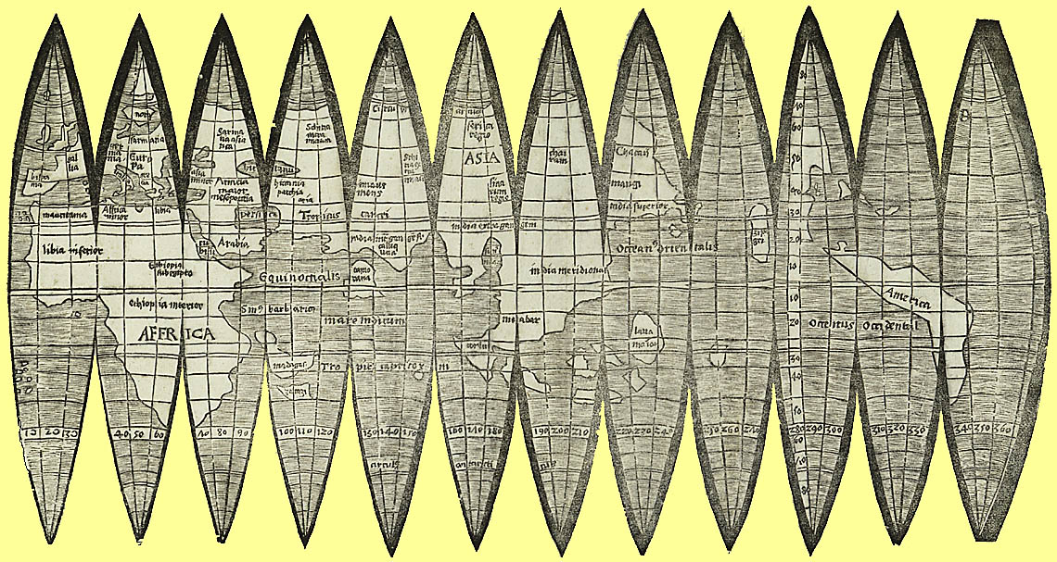

**Martin Waldseemüller**

**The 1507 Globular Map of the World**

This is the first globular map to use the term “America” in designating the continents of the New World. It was originally published to accompany Waldseemüller’s *Cosmographiae introductio*.

James Ford Bell Library, University of Minnesota

http://gallery.lib.umn.edu/exhibits/show/maps-and-mapmakers--martin-wal

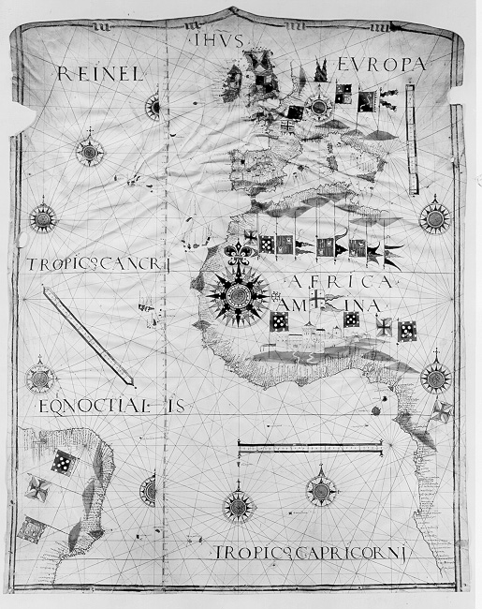

**Jorge Reinel, Portolan chart of the Atlantic Ocean, Portugal, ca. 1534**

**This map focuses on the triangle of navigation between Europe, Africa, and Brazil.**

James Ford Bell Library, University of Minnesota

https://www.lib.umn.edu/bell/maps/reinel



**Map of America by Diego Gutiérrez**

**1562**  
Library of Congress, Geography and Maps, Concordance of Images

<https://www.loc.gov/rr/geogmap/guide/gm029001.j>

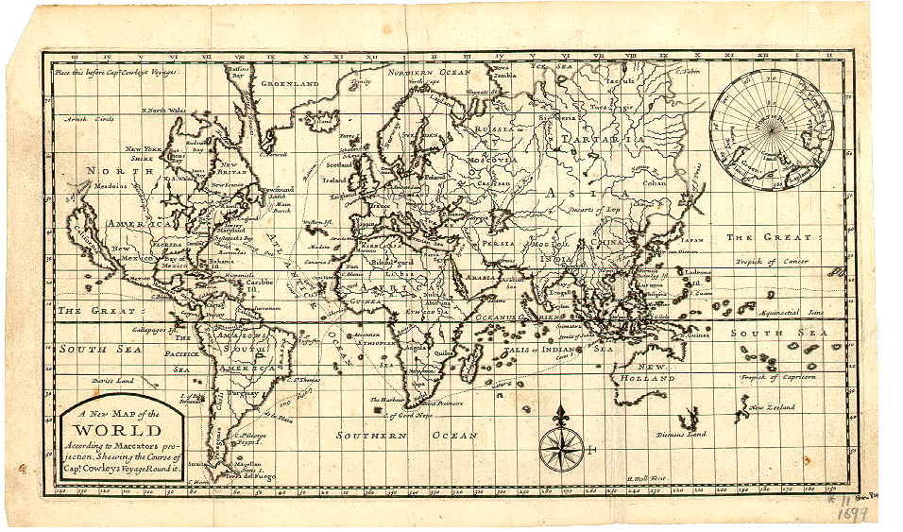

**A New Map of the World, According to Mercator's Projection, Showing the Course of Capt. Cowley's Voyage Round it, London, H. Moll, 1699**

The Map Collection, Yale University

https://www.library.yale.edu/MapColl/oldsite/map/wrld1699.htm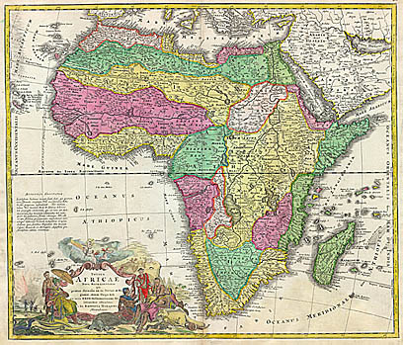

**Johann Baptist Homann**

***Totius Africae nova repraesentatio qua praeter diversos in ea status et regiones,***

***etiam origo Nili ex veris rr. pp. missionariorum relationibus***

***ostenditur / â Io. Baptista Homanno Norimbergae***

**Nürnberg : s.n., 1707**

James Ford Bell Library, University of Minnesota

https://primo.lib.umn.edu/primo-explore/fulldisplay?docid=UMN\_ALMA21502647280001701&context=L&vid=TWINCITIES&lang=en\_US&search\_scope=default\_scope&adaptor=Local%20Search%20Engine&tab=default\_tab&query=creator,exact,Johann%20Baptist%20Homann,AND&sortby=rank&mode=advanced&offset=0

**Assessment**

Write a short response to the following question:

How do you think historical maps reflected European attitudes toward the Americas and Africa after 1500?

***Lesson 2***

***Migration and Demography in the Atlantic Rim***

**Preparation**

Look at the map of the Atlantic rim in Student Handout 2.1 and note the relative size of Africa, South America, North America, and Europe.

**Introduction**

In this lesson students practice identifying patterns of demographic change and migration in the Atlantic rim from 1500 to 1800. They also use data to speculate on causes of these changes and on these patterns of migrations. Students consider how the voluntary and involuntary migration of peoples from both Africa and Europe to the Americas drastically altered the societies of the Atlantic rim.

In doing this lesson, students might be asked to keep in mind that at least 5 million slaves, mostly women, were sent to the Mediterranean region, Southwest Asia, and other parts of Asia by way of the Red Sea, the Sahara Desert, and the Indian Ocean.

**Activity: Forced Migration From Africa**

Ask students to use the data in the table in Student Handout 2.2 to answer the questions below:

1. Which region in the Americas received the most Africans from 1519 to 1700?
2. What island in the Americas received the most Africans from 1701 to 1800?
3. Create a bar graph showing the receiving regions and the numbers of Africans taken over time (see example below).



1. What might have been some of the economic causes for the changes in the number of involuntary migrants from Africa to the Americas from 1519 to 1800?
2. What effects might the increase in African forced migration have had on societies in each of the regions that received them? For example, how do you think cuisine might have changed or agricultural techniques shifted?

Ask students to use the data in the tables in Student Handouts 2.3, 2.4, and 2.5 to answer the questions below.

1. From which region in Africa did most slaves originate?
2. What might have been some of the causes for this region being the center for slave exports from Africa to the Americas during the period 1519 to 1800?
3. What do the tables in Student Handouts 2.4 and 2.5 tell you about the demographic effect of the Atlantic slave trade on various regions in west and south central Africa?

Ask students to use the data in the tables in Student Handout 2.6 (Africanization of the Americas) to answer the following questions.

1. In which regions of the Americas did the size of the European population grow? When did the most dramatic growth in the population happen?
2. In which regions of the Americas did a part of the population decline? Why do you think the decline happened?
3. Use the data from Student Handout 2.2 and the data from Table 4 of Student Handout 2.6 to explain one reason for population growth in Brazil from 1519 to 1800.
4. Given that England’s population was 4,303,043 in 1607 and 5,026,877 in 1700, and that the total emigration number from England to the Americas by 1700 was 350,000, what effects do you think emigration to the Americas had on English society?
5. What effects do you think the voluntary and involuntary migration of peoples from Europe had on societies in the Americas?
6. What effects do you think the forced migration of peoples from Africa had on societies in the Americas?

**Lesson 2**

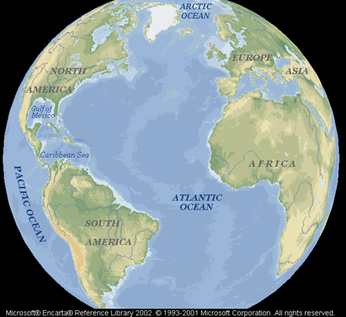***Student Handout 2.1*Lesson 2**

***Student Handout 2.2***

**Volume of Transatlantic Slave Trade**

**by Region of Disembarkation (in thousands)**

**1519 to 1800**

|  | British Mainland North America | Barbados | Guianas | French Wind-wards | St.  Do-mingue | Spanish American Mainland (incl. Brazil) | Dutch Caribbean |
| --- | --- | --- | --- | --- | --- | --- | --- |
| 1519–1600 |  |  |  |  |  | 151.6 |  |
| 1601–1650 | 1.4 | 25.4 |  | 2.0 |  | 187.7 | 2.0 |
| 1651–1675 | 0.9 |  | 63.2 | 8.2 | 6.5 |  | 38.8 |
| 1676–1700 | 9.8 | 82.3 | 27.8 | 16.6 | 4.8 | 7.0 | 26.0 |
| Total % | 1.90% | 16.93% | 14.31% | 4.21% | 1.78% | 54.45% | 6.42% |

|  | British Mainland North America | Barbados | Guianas | French Wind-wards | St. Do-mingue | Spanish American Mainland (incl. Brazil) | Dutch Caribbean |
| --- | --- | --- | --- | --- | --- | --- | --- |
| 1701–1725 | 37.4 | 91.8 | 24.4 | 30.1 | 44.5 | 30.0 | 30.5 |
| 1726–1750 | 96.8 | 73.6 | 83.6 | 66.8 | 144.9 | 12.7 | 10.2 |
| 1751–1775 | 116.9 | 120.9 | 111.9 | 63.7 | 247.5 | 5.0 | 15.3 |
| 1776–1800 | 24.4 | 28.5 | 71.2 | 41.2 | 345.8 | 10.2 | 6.9 |
| Total % | 13.92 | 15.90 | 14.70 | 10.19 | 39.53 | 2.92 | 2.83 |

Source: “Slave Voyages” https://www.slavevoyages.org; National Park Service, Park Ethnography Program, African-American Heritage and Ethnography, The Transatlantic Slave Trade, https://www.nps.gov/ethnography/aah/aaheritage/histContextsD.htm.

**Lesson 2**

***Student Handout 2.3***

**Volume of Transatlantic Slave Trade**

**by Region of Embarkation (in thousands)**

**1519 to 1800**

|  | Sene-gambia | Sierra Leone | Wind-ward Coast | Gold Coast | Bight of Benin | Bight of Biafra | West Central Africa | Southeast Africa |
| --- | --- | --- | --- | --- | --- | --- | --- | --- |
| 1519–1600 | 10.7 | 2.0 |  | 10.7 | 10.7 | 10.7 | 221.2 |  |
| 1601–1700 | 60.6 | 3.9 | 0.8 | 90.9 | 247.8 | 135.6 | 698.8 | 14.1 |
| Total % | 4.70% | 0.39% | 0.05% | 6.69% | 17.02% | 9.63% | 60.59% | 0.93% |

|  | Sene-gambia | Sierra Leone | Wind-ward Coast | Gold Coast | Bight of Benin | Bight of Biafra | West Central Africa | Southeast Africa |
| --- | --- | --- | --- | --- | --- | --- | --- | --- |
| 1701–1725 | 39.9 | 7.1 | 4.2 | 181.7 | 408.3 | 45.8 | 257.2 | 14.4 |
| 1726–1750 | 69.9 | 10.5 | 14.3 | 186.3 | 306.1 | 166.0 | 552.8 | 5.4 |
| 1751–1775 | 130.4 | 96.9 | 105.1 | 263.9 | 250.5 | 340.1 | 714.9 | 3.3 |
| 1776–1800 | 72.4 | 106.0 | 19.5 | 240.7 | 264.6 | 360.4 | 816.2 | 41.2 |
| Total % | 5.13 | 3.62 | 2.35 | 14.31 | 20.17 | 14.97 | 38.41 | 1.05 |

Source: “Slave Voyages” https://www.slavevoyages.org; National Park Service, Park Ethnography Program, African-American Heritage and Ethnography, The Transatlantic Slave Trade, https://www.nps.gov/ethnography/aah/aaheritage/histContextsD.htm.

**Lesson 2**

***Student Handout 2.4***

**Proportion of Children among the Enslaved Africans**

**Crossing the Atlantic (per cent)**

|  |  |  |  |  |  |  |  |  |  |
| --- | --- | --- | --- | --- | --- | --- | --- | --- | --- |
| **Region** | **1651-75** | **1675-1700** | **1701-25** | **1726-50** | **1751-75** | **1776-1800** | **1801-25** | **1826-50** | **1851-67** |
| Senegambia | - | 5.4 | 9.1 | 12.0 | 30.2 | 16.7 | 25.7 | 19.7 | - |
| Sierra Leone | - | 7.3 | 6.5 | - | 34.3 | 25.5 | 41.1 | 41.9 | - |
| Windward Coast | - | - | - | 35.3 | 42.7 | 24.9 | 34.5 | 29.3 | - |
| Gold Coast | 6.4 | 8.8 | 17.5 | 15.1 | 21.4 | 19.4 | 38.0 | 46.2 | - |
| Bight of Benin | 6.5 | 12.3 | 19.6 | 26.1 | 19.3 | 14.4 | 22.5 | 36.1 | 18.8 |
| Bight of Biafra | 12.8 | 9.7 | 23.9 | 18.4 | 34.3 | 19.7 | 29.7 | 39.3 | - |
| West Central | - | 19.8 | 24.5 | 32.1 | 30.4 | 18.3 | 41.0 | 52.9 | 41.6 |
| South East Africa | - | - | - | - | - | 29.6 | 47.0 | 62.4 | - |
| Origin Not known | 9.1 | 18.1 | 22.9 | 23.7 | 27.1 | 34.5 | 46.0 | 29.6 | - |
| Average | 10.5 | 11.3 | 19.3 | 22.6 | 28.8 | 22.2 | 42.6 | 40.7 | 35.9 |

Source: Paul E. Lovejoy, “International Slave Trade: Causes and Consequences," In Motion, The African-American Migration Experience, New York Public Library, Schomburg Center for Research in Black Culture, *In Motion: The African-American Experience, www.inmotionaame.org/texts/viewer.cfm?id=1\_001T&page=1.*

**Lesson 2**

***Student Handout 2.5***

**Proportion of Females among Enslaved Africans**

**Crossing the Atlantic (per cent)**

|  |  |  |  |  |  |  |  |  |  |
| --- | --- | --- | --- | --- | --- | --- | --- | --- | --- |
| **Region** | **1651-75** | **1676-1700** | **1701-25** | **1726-50** | **1751-75** | **1776-1800** | **1801-25** | **1826-50** | **1851-67** |
| Senegambia | - | 27.0 | 31.0 | 21.3 | 37.8 | 31.6 | 46.8 | 32.6 | - |
| Sierra Leone | - | 23.2 | 31.9 | - | 41.4 | 34.8 | 32.0 | 28.1 | - |
| Windward Coast | - | - | - | 39.7 | 38.4 | 33.0 | 26.3 | 25.7 | - |
| Gold Coast | 42.7 | 46.8 | 32.9 | 32.2 | 37.9 | 34.2 | 28.1 | 28.7 | - |
| Bight of Benin | 41.3 | 41.0 | 36.0 | 40.8 | 46.2 | 34.3 | 24.3 | 34.9 | 27.7 |
| Bight of Biafra | 50.3 | 41.1 | 48.3 | 24.6 | 39.9 | 42.6 | 35.0 | 34.3 | - |
| West Central | - | 40.1 | 26.2 | 32.8 | 32.5 | 35.2 | 29.1 | 26.8 | 24.7 |
| South East Africa | - | - | - | 47.3 | - | 28.5 | 30.5 | 19.4 | 13.2 |
| Origin Not known | 38.5 | 40.6 | 34.5 | 33.6 | 43.4 | 30.1 | 31.3 | 24.8 | 27.3 |
| Average | 45.0 | 41.3 | 33.9 | 33.8 | 38.5 | 45.1 | 31.2 | 31.7 | 24.5 |

Source: Source: Paul E. Lovejoy, “International Slave Trade: Causes and Consequences," In Motion, The African-American Migration Experience, New York Public Library, Schomburg Center for Research in Black Culture, *In Motion: The African-American Experience, www.inmotionaame.org/texts/viewer.cfm?id=1\_001T&page=1.*

******

“The Schooner ""Virginie"" was captured at sea by British cruisers and adjudicated at a court established at Sierra Leone under international anti-slave trade treaties. The image is of a picture of the first page of the court’s register of ""Liberated Africans"" taken from the ""Virginie"". The register was kept as a formal record of emancipation that helped protect the individual from subsequent re-enslavement. The image is reproduced courtesy of the British National Archives.”

Source: “Slave Voyages,” Resources – Image Gallery, Register of Africans from the Schooner “Virginie,” https://www.slavevoyages.org/resources/images/category/Manuscripts/1.

**Lesson 2**

***Student Handout 2.6—Africanization of the Americas***

**Table 1**

|  |  |
| --- | --- |
| **Estimated Total Population (of Primarily English, Scottish, Irish,**  **German, or Dutch Heritage) in British North America** | |
| 1630 | 4,646 |
| 1640 | 26,634 |
| 1650 | 50,358 |
| 1680 | 144,536 |
| 1700 | 234,159 |
| 1720 | 475,000 |
| 1760 | 1,500,000 |
| 1770 | 1,634,000 |

Note: Between 1718 and 1775, the British government transported about 50,000 felons, more than half of all English emigrants to America during that period. About 80 percent of the convicts went to Virginia and Maryland between 1707 and 1775.

**Table 2**

|  |  |
| --- | --- |
| **Estimated Total Non-English Population north of the Rio Grande in 1776** | |
| Amerindians | about 800,000 |
| French nationals | about 75,000 |
| Spanish nationals | about 25,000 |

**Table 3**

|  |  |  |  |  |  |
| --- | --- | --- | --- | --- | --- |
| **Estimated Population Numbers in Latin America (South of the Rio Grande)** | | | | | |
| Date | Amerindians | Peninsulares | Criollos | Mestizos | Total |
| 1570 | 3,340,000 | 6,600 | 11,000 | 2,437 |  |
| 1646 | 1,260,000 | 13,800 | 16,800 | 109,042 |  |
| 1800 |  | | | | 12,500,000 |

Note: Peninsulares = born in Spain, Criollos = parents born in Spain, Mestizos = Amerindian and Spanish mixed ancestry

**Table 4**

|  |  |
| --- | --- |
| **Estimated Total Population Numbers**  **for Portuguese Colony of Brazil** | |
| 1580 | 60,000 |
| 1600 | 150,000 |
| 1680s | 350,000 |
| 1700 | 1,000,000 |
| 1750 | 1,500,000 |
| 1800 | 2,000,000 |

***Lesson 3***

***Women in the Atlantic Rim***

**Preparation**

Imagine that you are a historian. What clues would you look for to figure out the characteristics of a society? What information would you examine in detail? What individuals would be important to learn about? One way to think about the people you are coming to know as a historian is to create some categories that can organize the data you collect on each person. Are their contributions mostly political, social, cultural, or economic? Are they adding new types of technology, religious ideas, trade methods, political leadership, or art? Think about these questions as we prepare to look at some very interesting people in the new societies of the Atlantic rim.

**Introduction**

The interactions of peoples in the Atlantic rim produced new societies, but how do historians figure out how these new societies were created? One of the clues they use is to examine the stories of individual men and women who played a role in creating the new society. In order to learn about these individuals, historians use both **primary and secondary sources**.

In this lesson, you will read short biographies and excerpts from primary sources regarding two women who lived in the Atlantic rim as new societies emerged. Moreover, you will examine some visual depictions of these women. You will also read secondary sources by other historians to get to know these fascinating individuals. You will work like a historian with these secondary and primary sources to determine the contribution each of these people made to new societies.

**Activities**

## **Woman 1: Doña Marina, or La Malinche**

Ask students to do the following:

1. Read both the biography of Doña Marina, also known as La Malinche in Student Handout 3.1 and the descriptions of her in Student Handouts 3.2, 3.3, and 3.4.

2. Describe Doña Marina’s role in the Spanish conquest of the Aztec Empire. Be as specific as possible in your description.

3. Look at the images on Student Handout 3.5. What do you notice about the figures depicted in each image? Who do they represent? What similarities and differences do you notice between the two images? By looking at the two images, what can you say about the status of La Malinche in Spanish and American Indian society?

4. Use the secondary sources in Student Handout 3.6 to describe why you think La Malinche is viewed as such a controversial figure in Mexican society today.

5. Analyze which sources were most helpful in determining Doña Marina’s contribution to the new society created after the Spanish conquest of the Aztec Empire.

**Woman 2: Pocahontas**

Ask students to do the following:

1. Read the biography of Pocahontas using Student Handout 3.7 and the description of her role in the John Smith excerpt in Student Handout 3.8. Why was Pocahontas important to the English?

2. Look at the images on Student Handouts 3.9 and 3.10. What do you notice about the figures depicted in each image? Who do they represent? By looking at the two images, what can you say about the status of Pocahontas in English and American Indian societies?

3. After reading the secondary sources in Student Handout 3.11, describe the controversy over Pocahontas.

4. What was her significance for the new society being created in British North America?

**Assessment**

Ask students to answer all of the following questions in complete sentences:

1. Compare La Malinche and Pocahontas. How were they similar and how were they different in their roles in the creation of Atlantic rim societies?

2. Whose voices are missing from these primary and secondary source descriptions about La Malinche and Pocahontas?

3. Why do you think those voices are missing? What do you think this can tells us about women’s roles in the Atlantic rim?

4. Write a thesis statement summarizing your analysis of the contributions La Malinche and Pocahontas made to the processes that created the new societies in the Atlantic rim, 1500-1800.

**Teacher Notes on Assessment**

The assessment questions are designed to help students realize the importance of the role of gender and how that affects the contributions La Malinche and Pocahontas made to the new societies they helped create. We have no sources directly from these two women, so students should be encouraged to brainstorm the reasons for the paucity of primary sources from and about women. An extension to that discussion could be how the small supply of primary sources from and about women affects how these women were viewed both in their own times and by later historians. This discussion also brings up the issue of social class, which students should also ponder. Consider the following quote regarding La Malinche:

The difficulty with her name reflects difficulty about understanding her background and status. Cortés only mentions her twice in his letters. In the first case, he simply refers to her as his translator, “an Indian woman.” In the second case, he calls her Marina without the Doña normally used by Spanish men when discussing honorable, upper class women. How does one interpret this? Did he consider her to be lower class because of her social origins as an Indian slave given to him? Did he consider her to be a whore regardless of her social class? Did he believe that Indian women did not deserve to be honored with the same respect as Spanish women? Historians can never know for sure because the records are silent.

Source: Nancy Fitch, “The Conquest of Mexico,” American Historical Association, Teaching and Learning in the Digital Age: Reconceptualizing the Introductory Survey Course, https://www.historians.org/teaching-and-learning/teaching-resources-for-historians/teaching-and-learning-in-the-digital-age/the-history-of-the-americas/the-conquest-of-mexico.

**Lesson 3**

***Student Handout 3.1—Biography of Doña Marina or La Malinche***

Chroniclers used the names Doña Marina and La Malinche to identify the woman who helped the Spanish conquer the Aztec empire. After the death of her father (whom legend identifies as a noble of an enemy group of the Aztecs), her mother remarried and had a son with her new husband. Her mother claimed to her neighbors that her daughter died, but she really gave her away to some traveling merchants, who sold her as a slave to the Maya living in Tabasco. By the time Cortés arrived, she had learned the Mayan dialects used in the Yucatán but was still a native speaker of Náhuatl, the language of the Mexica and other non-Mayan-speaking peoples in the empire. She was in a group of young women given to Hernán Cortés as slaves by the Chontal Mayan ruler (cacique) of Tabasco in 1519.

She was baptized Marina and eventually became a consort of Cortés. Before meeting her, Cortés had relied on a Spanish priest, Gerónimo de Aguilar, to speak with the Maya who lived along the coast. After being shipwrecked off Cozumel, Aguilar learned to speak some Mayan languages. Aguilar was unable to speak Náhuatl, however, so Cortés began using Marina and Aguilar as an interpreting team. Doña Marina learned Spanish quickly, becoming the sole interpreter for the Spanish conquistadors in communicating with the Aztec ruling elite. Bernal Díaz, one of Cortés’ soldiers and author of *The True History Conquest of New Spain*, confirmed that Marina directly interpreted for Cortés. Their son became a colonial official but was accused of being a traitor in 1548 and was executed by the Spanish colonial government. The term La Malinche could mean “the woman of Malinche.” Malinche meant “captain,” a title that Hernán Cortés used for himself during the conquest of the Aztec Empire.

Source: Nancy Fitch, “The Conquest of Mexico,” American Historical Association, Teaching and Learning in the Digital Age: Reconceptualizing the Introductory Survey Course, https://www.historians.org/teaching-and-learning/teaching-resources-for-historians/teaching-and-learning-in-the-digital-age/the-history-of-the-americas/the-conquest-of-mexico.

**Lesson 3**

***Student Handout 3.2—Second Letter from Hernán Cortés to King Charles I***

This is the second letter from Cortés to the Spanish King Charles I, 1519. It was published in Hernán Cortés, *Cartas y relaciones de Hernán Cortés al emperador Carlos V*, ed. Pascual de Gayangos (Paris: A. Chaix, 1866).

During the three days I was there, they provided very poorly for our wants, and each day worse than the former one; and the nobles and principal men of the city very seldom came to see or to speak to me. Being somewhat perplexed by this treatment, the female interpreter [Malinche] that I had, who was a native of this country, and whom I obtained at Putunchán on the Rio Grande, (as I have already mentioned in my former dispatch), was informed by another female, a native of this city, that a numerous force of Moctezuma lay very near the city, and that the inhabitants had carried out their wives and children and wearing apparel, as an attack was meditated that would destroy us all; and that if she wished to save herself, she should go with her, as she could protect her. My interpreter told this to Gerónimo de Aguilar, another interpreter, whom I had obtained in Yucatán, of whom I also wrote to your Highness, and he gave me the information; when I took one of the natives of the city, and drew him aside privately so that no one saw me, and interrogated him on the subject, this man confirmed all that the Indian women and the natives of Tlaxcala had stated. Judging from this information, as well as the signs that I had observed, I determined to anticipate their movements, in order to prevent being taken by surprise; and sent for the nobles of the city, to whom I said that I wished to speak with them, and shut them in a room by themselves.

Source: American Historical Association, Teaching and Learning in the Digital Age: Reconceptualizing the Introductory Survey Course, Nancy Fitch, The Conquest of Mexico, Cortés Meets Cholulans, pp. 68-69, https://www.historians.org/teaching-and-learning/teaching-resources-for-historians/teaching-and-learning-in-the-digital-age/the-history-of-the-americas/the-conquest-of-mexico/letters-from-hernan-cortes/cortes-meets-cholulans.

**Lesson 3**

***Student Handout 3.3—Fifth Letter from Hernán Cortés to King Charles I***

This is the fifth letter from Cortés to the Spanish King Charles I, 1526-1527. It was published in Hernán Cortés, *Cartas y relaciones de Hernán Cortés al emperador Carlos V*, ed. Pascual de Gayangos (Paris: A. Chaix, 1866).

He [the Amerindian Canec] answered that until then he had served no overlord nor knew of any whom he ought to serve, although it was true that five or six years ago people of Tabasco had passed that way and told him how a captain with certain people of our nation had entered their land and three times defeated them in battle, and afterwards had told them that they were to be vassals of a great lord, and all the other things which I was now telling him. He therefore wished to know if this great lord of whom I spoke were indeed the same. I replied that I was the captain of whom the people of Tabasco had spoken, and that if he wished to learn the truth he had only to ask the interpreter with whom he was speaking, Marina, who traveled always in my company after she had been given to me as a present with twenty other women. She then told him that what I had said was true and spoke to him of how I had conquered Mexico and of all the other lands which I held subject and had placed beneath Your Majesty’s command. He appeared very pleased to learn of this and said that he also wished to be Your Majesty’s subject and vassal, and that he considered himself most fortunate to be under the sway of a prince so powerful as I told him Your Highness is.

Source: American Historical Association, Teaching and Learning in the Digital Age: Reconceptualizing the Introductory Survey Course, Nancy Fitch, The Conquest of Mexico, Cortés on Malinche, http://www.historians.org/tl/LessonPlans/ca/Fitch/cortes7.html.

**Lesson 3**

***Student Handout 3.4—Account of Bernal Díaz del Castillo***

Bernal Díaz del Castillo’s account of the Spanish conquest was published as *Historia verdadera de la conquista de la Nueva España*, 4 vols. (Mexico: Oficina Tipográfica de la Secretaría de Fomento, 1904, 1905).

The Spaniards are with a group of indigenous people led by a man identified only as “the fat Cacique.” Moctezuma sends messengers to “the fat Cacique” to advice them against dealing with Cortés. Those around “the fat Cacique” became very agitated, since they didn’t know whether to support the Spaniards or Moctezuma.

At this moment, surprised at what he saw, Cortés asked our interpreters, Doña Marina and Jerónimo de Aguilar, why the caciques were so agitated since the arrival of those Indians, and who they were. And Doña Marina who understood everything very well, told him what was going on; and then Cortés summoned the fat Cacique and the other chiefs and asked them who these Indians were and why they made such a commotion about them. They replied that they were the tax collectors of the great Moctezuma and that they had come to inquire why they [the fat Cacique and the other chiefs] had received us in their town without the permission of their lord, and that they now demanded twenty men and women to sacrifice to their god, Huitzilopochtli, so that he would give them victory over us, for they said that Moctezuma had declared that he intended to capture us and make us slaves.

Cortés reassured them and told them not to be afraid, for he was here with all of us in his company and that he would punish them [Moctezuma’s tax collectors].

Source: American Historical Association, Teaching and Learning in the Digital Age: Reconceptualizing the Introductory Survey Course, Nancy Fitch, The Conquest of Mexico, Díaz del Castillo Reports on Usefulness of Doña Marina, http://www.historians.org/tl/LessonPlans/ca/Fitch/DIAZ4.htm.

**Lesson 3**

# Student Handout 3.5—Two Images of La Malinche

Malinche Interprets for Cortés with Tlaxcalans

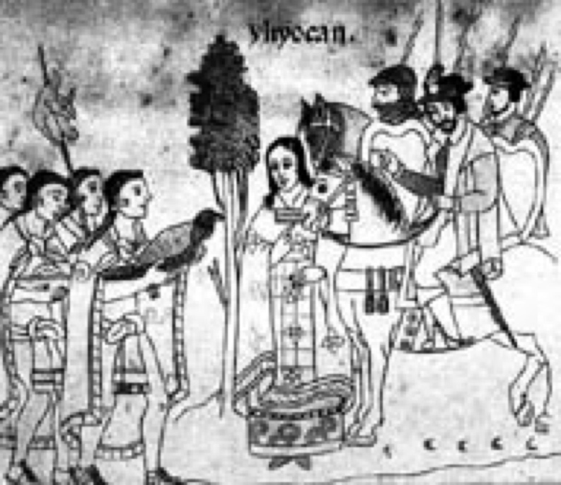

Source: American Historical Association, Teaching and Learning in the Digital Age: Reconceptualizing the Introductory Survey Course, Nancy Fitch, The Conquest of Mexico, Divisions and Conflicts Between the Tlaxacalans and the Mexicas. *El Lienza de Tlaxcala*, N.p., n.p., 1890. http://www.historians.org/tl/LessonPlans/ca/Fitch/tlaxcala.htm

Malinche Interprets Moctezuma's Speech for the Spaniards

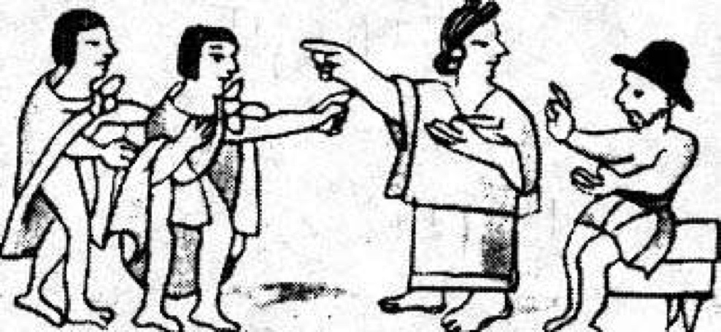

Source: American Historical Association, Teaching and Learning in the Digital Age: Reconceptualizing the Introductory Survey Course, Nancy Fitch, The Conquest of Mexico, Moctezuma Learns of Malinche. Fray Bernardino de Sahagún. *Historia general de las cosas de Nueva España*. Edited by Francisco del Paso y Troncoso. 4 vols. Madrid: Fototipia de Hauser y Menet, 1905. http://www.historians.org/tl/LessonPlans/ca/Fitch/aztec6a.htm.

**Lesson 3**

***Student Handout 3.6—Secondary Sources on La Malinche***

###### Secondary Source 1

We as Mexicans not only have to contend with Eve’s great sin, but with Malinche’s as well, we unfortunately, receive a double dose of corruption.

Source: Novelist Carlos Fuentes, qtd. in Borderlands, El Paso Community College Local History Project. Susana Cano, Juan Sandoval, and Norma Torres, Malinche Remains Controversial, http://www.epcc.edu/nwlibrary/borderlands/17\_la\_malinche.htm.

###### Secondary Source 2

###### Some historians say that Malina’s decision to help Cortés—if indeed she had any choice—was based on his resemblance to Quetzalcóatl and her faith. Malina knew well the prophecy of Quetzalcóatl: he would return in a “reed” year to terminate the Aztec world and create a new one. Marina remained at the side of Cortés throughout the conquest of the Aztecs and accompanied him on expeditions through central America.

Malina would bear Cortés a son named Don Martín Cortés Tenepal in 1522. This child, the result of a union between an Indian and Spaniard, is said to have begun a new ethnic group of people called the mestizos. Cortés subsequently gave her to another Spanish officer, Juan Jaramillo, with whom she had a daughter, María Jaramillo. Malina’s son rose to prominence in the new order but later was suspected of treason and executed in 1568. Her daughter was robbed of her inheritance, much like Malina had been.

Source: Borderlands, El Paso Community College Local History Project. Susana Cano, Juan Sandoval, and Norma Torres, Malinche Remains Controversial, http://www.epcc.edu/nwlibrary/borderlands/17\_la\_malinche.htm.

###### Secondary Source 3

Mexico City has museums that commemorate its modern art, its Indian heritage, stamps, and even the house where Leon Trotsky lived and was assassinated. But the only commemorative to the woman who helped Cortés forge alliances with various Indian nations against the Aztecs is an insult.

To be called a malinchista is to be called a lover of foreigners, a traitor.

“For Mexico to make this house a museum, would be like the people of Hiroshima creating a monument for the man who dropped the atomic bomb,” said Rina Lazo, a prominent Mexican muralist who lives at 57 Higuera Street with her family. “We’re not malinchistas, but we want to conserve Mexican history.”

La Malinche, who took part in the Spanish conquest and gave birth to one of Cortés’ children, has become a symbol of a nation that is still not entirely comfortable with either its European or its Indian roots.

But even though Mexican and Mexican-American intellectuals have begun to rethink her meaning, La Malinche is for the most part portrayed as the perpetrator of Mexico’s original sin and as a cultural metaphor for all that is wrong with Mexico.

“It will take another century before this house could become a museum,” Ms. Lazo said. “The gringos and Spaniards will keep knocking on the door, but the Mexicans will only knock when they no longer hold grudges and feel resentments, and that will take time.”

Source: Clifford Krauss, “A Historic Figure Is Still Hated by Many in Mexico,” *New York Times*, March 26, 1997. http://www.emayzine.com/lectures/la.htm.

###### Secondary Source 4

At birth, she was given the name Malinali, or Malinalli, one of the twenty days in the Mexica calendar. The name Tenepal was added afterward, according to the prevailing custom of adding a second name later in life. Tenepal is derived from the root *tene*, which means in a figurative sense one who has a facility with words, a person who speaks with animation, which perfectly describes her role. The Spanish baptized her Marina. The Aztecs had no letter “r” in their alphabet, so they substituted the letter “l” for it, and added “tzin” as a sign of respect. Thus, Malintzin was equivalent to Doña Marina, but became Malinche when the Spaniards mispronounced it.

*Source*: John Taylor, “Reinterpreting Malinche,” http://userwww.sfsu.edu/~epf/2000/jt.html#\_edn1.

**Lesson 3**

***Student Handout 3.7—Biography of Pocahontas***

Matoaka was the daughter of the ruler of the Powhatans. Her father ruled over thirty other Algonquin-speaking tribes along the Tidewater coastal region. She also was named Pocahontas, which means “mischief” in the Algonquin language. Pocahontas was taken prisoner by the English colonists in 1612 for ransom and in order to have some leverage over Matoaka. During her captivity she became a Christian and was baptized Rebecca. In 1614, she married the English plantation owner, John Rolfe, and had a son named Thomas Rolfe. They went to England in 1616 to help promote the tobacco-producing colonies of the Virginia Company. They enjoyed being the favorite guests among the rich and famous of London, including the British King James I. On the voyage back to Virginia in 1617, Pocahontas died of a pulmonary disease, possibly pneumonia or tuberculosis.

**Lesson 3**

***Student Handout 3.8—Primary Source from John Smith***

Having feasted him [Smith] after their best barbarous manner they could, a long consultation was held, but the conclusion was, two great stones were brought before Powhatan: then as many as could laid hands on him, dragged him to them, and thereon laid his head, and being ready with their clubs, to beats out his braines, Pocahontas the King’s dearest daughter, when no intreaty could prevaile, got his head in her armes, and laid her own upon his to save him from death; whereat the Emperour was contented he should live to make him hatchets, and her bells, beads, and copper. . .

Source: John Smith**, *The Generall Historie of Virginia, New-England & the Summer Isles, Together with The True Travels, Adventures and Observations, and A Sea Grammar,*** Vol. 1 (Glasgow: J. MacLehose and Sons, 1907), 101.

**Lesson 3**

***Student Handout 3.9—Theodore De Bry Woodcut of Pocahontas***

Captain Smith is saved by Pocahontas, 1627

(This is an image of the scene described in Student Handout 3.8)

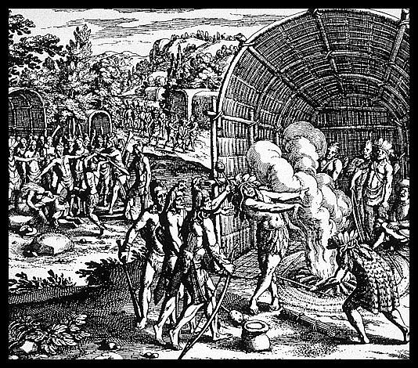

Theodore de Bry of Frankfurt was a copperplate engraver and publisher. This engraving was part of a series de Bry created on “Woodcuts of Natives in North America, especially Virginia.”

# Source: Theodore De Bry Copper Plate Engravings, Contributed by Professor Troy Johnson, Cal State Long Beach.

<http://www.csulb.edu/~gcampus/libarts/am-indian/woodcuts/001_001_0037_1335.jpg>

**Lesson 3**

***Student Handout 3.10—Life Portrait of Pocahontas***

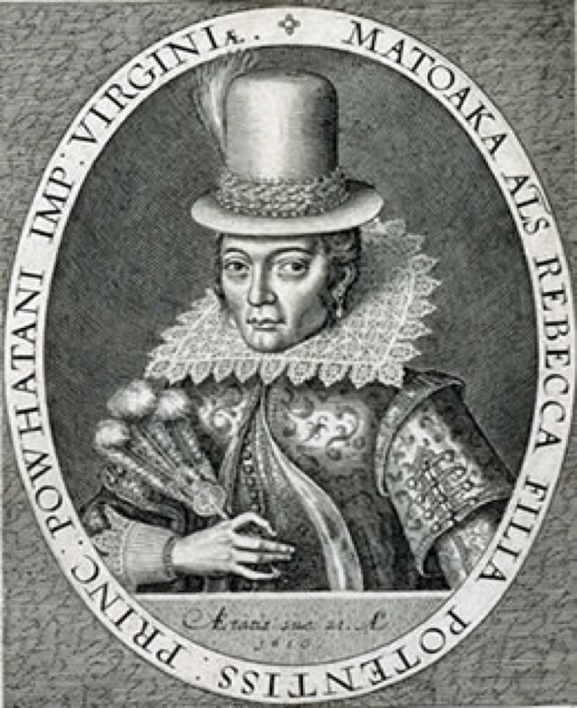

The inscription reads:

“Matoaka, also known as Rebecca, daughter of the most powerful prince

of the Powhatan Empire of Virginia at the age of 21 in the year 1616.”

The portrait was engraved by Simon Van de Passe in 1616 while Pocahontas was in England. It was published in John Smith’s *Generall Historie of Virginia* in 1624. This was the only portrait of Pocahontas made within her lifetime.

Source: John Smith**, *The Generall Historie of Virginia, New-England & the Summer Isles, Together with The True Travels, Adventures and Observations, and A Sea Grammar,*** Vol. 1 (Glasgow: J. MacLehose and Sons, 1907), illustration found between pp 104 and 105.

**Lesson 3**

***Student Handout 3.11—Secondary Sources on Pocahontas***

According to Captain John Smith, the leader of the English group determined to claim and colonize Virginia through a settlement at Jamestown. In 1607, the eleven-year-old Pocahontas saved him from being killed by her father. Historians now suggest that Smith’s ordeal was part of a Powhatan ritual to include him as a member of their community, and Pocahontas played a pre-determined role in pleading for his life. According to Smith’s account in his book published 17 years later, Pocahontas also brought needed food supplies to him and the other Jamestown residents during the subsequent winter. Smith left Powhatan land and went back to England for recovery from an accidental gunpowder wound in 1609. Smith mentioned the 1607 incident in one of several chronicles he composed about his New World expeditions over the course of two decades. For reasons that form the crux of the “great debate,” Smith apparently chose to suppress the 1607 episode in his early chronicles, including *A True Relation*, published in 1608, and his 1612 *Map of Virginia*. While he alluded to the event briefly in a 1622 publication, the first complete account appeared in 1624, seventeen years after the fact, in Smith’s *Generall Historie of Virginia, the Summer Isles, and New England*. Like many of Smith’s chronicles, the rescue story is narrated in the third person. The scene took place about one month after a group of Powhatans captured Smith while he was exploring the Chickahominy River.

Along with this captivating recollection, Smith included in the *Generall Historie* a copy of a letter he claimed to have sent Queen Anne in 1616, the year in which Pocahontas traveled to England after marrying colonist John Rolfe. The letter commended her to the queen with what was apparently Smith’s earliest reference to the rescue. The original letter was lost and became known only by its inclusion in the *Generall Historie*.

Alden Vaughn, in his book *American Genesis: Captain John Smith and the Founding of Virginia*, sums up the relationship between Smith and Chief Powhatan as follows: “Throughout his stay in Virginia, John Smith and Powhatan jostled for power. They had a grudging admiration for each other, and at times exhibited a superficial cordiality. But each considered the other his prime adversary, to be destroyed if necessary.”

In *Powhatan's World and Colonial Virginia: A Conflict of Cultures*, Frederic Gleach goes further, postulating the groups’ mutual ulterior motives in their dealings with each other: “Through actions that were largely misunderstood by the other group, each group initially sought to demonstrate its superiority in the relationship and to persuade the other to adopt ‘appropriate’ ways of living. . . Both employed trade, negotiation and military strength in the pursuit and demonstration of advantage, each group in its own terms. All can be seen as attempts to bring the other to civility.”

**Source:** Helen Mondloch. **“Rescue and Redemption: The Great Debate over Pocahontas and John Smith,”** *The World & I* 17: 9 (Sept 2002), 173.

***Lesson 4***

***Men in the Atlantic Rim***

**Activities**

#### Man 1: Inca Garcilaso de la Vega

Ask students to do the following:

1. Read the biography of Inca Garcilaso de la Vega using Student Handout 4.1

2. Answer this question: How is Inca Garcilaso similar to or different from La Malinche?

3. Using the primary and secondary sources in Student Handouts 4.2 and 4.3, answer the following questions.

* With what societies of the Atlantic rim does Inca Garcilaso identify?
* Does he seem to identify with one more than the other?
* Why or why not?

#### Man 2: Olaudah Equiano (Gustavus Vassa)

Ask students to do the following:

1. Read the biography of Olaudah Equiano (Gustavus Vassa) using Student Handout 4.4.

2. After you have read the biography and the primary and secondary sources in Student Handouts 4.5 and 4.6, answer the following questions.

* What do you think were Equiano’s personal goals?
* Why do you think he wrote the autobiography *The Interesting Narrative*?
* What do you think Equiano hoped to accomplish or prove?
* With what societies of the Atlantic rim does Equiano identify?
* Does he seem to identify with one more than the other? Why or why not?
* The last excerpt in Student Handout 4.6 suggests that perhaps Equiano was not born in Africa but in South Carolina. In your opinion, does that affect Equiano’s message? Why or why not?

## **Assessment**

Ask students to choose one of the following assessments to complete in a one-page response.

1. Compare the primary sources by Inca Garcilaso and Equiano and how they portray their indigenous peoples’ place in the Atlantic rim. Both Garcilaso and Equiano want to prove that their non-European heritage has important contributions to make to societies in the Atlantic rim. What are the contributions that they discuss? Why do they feel it is so important for them to make their readers aware of these contributions?

2. Is it important to you, the historian, that other historians have doubted the truth of Garcilaso and Equiano’s accounts? Why or why not? Why might Garcilaso and Equiano have made up part of their accounts? Does this affect the importance of our understanding as historians of their contributions to the Atlantic rim? How? Why or why not?

#### 3. Compare the Atlantic rim identities of La Malinche and Pocahontas to those of the two men. How did these individuals gain a new identity? Is identity only determined by nationality? That is, is your identity determined by what your passport says? What is the role of gender and class in shaping the identities and opportunities of each of these individuals? Are the men freer to create their identities than the women? Why or why not?

**Lesson 4**

***Student Handout 4.1— Biography of Inca Garcilaso de la Vega***

He was born Gómez Suárez de Figueroa in Cuzco on April 12, 1539. His father was the prominent conquistador captain Sebastián Garcilaso de la Vega y Vargas, who conquered the Inca empire in the company of the Spanish Captain Francisco Pizarro. His mother was Isabel Suárez Chimpu Ocllo, niece of the Incan ruler, Huaina Capac and concubine to the Spanish captain. Her status as Inca princess and mother of Sebastián’s first-born son did not prevent Sebastián from later marrying a well-born Spanish woman (Doña Luisa Martel, who was only four years older than Gómez) or marrying Isabel off to a commoner (Juan del Pedroche). Their son was thus one of the first Peruvian **mestizos**, and both sides of the family took care to ensure that he was exposed to the traditions of their respective cultures. He learned first Quechua and then Spanish before embarking on an elementary study of Latin in the city of Cuzco.

The young mestizo sailed to Spain in 1560, made contact with paternal relatives in Andalusia, and may have studied Latin for a time under Pedro Sánchez de Herrera in Seville. By 1563, Garcilaso had proudly assumed his father’s name. He also found to his dismay that his combined Inca and conquistador heritage was of little value in the Peninsula. He repeatedly traveled to Madrid to seek royal patronage and the rehabilitation of his father’s reputation, but he was thwarted by hostile judges and damning accounts of his father’s activities recorded in early chronicles of the Indies. A brief period of military service against rebel Moriscos (Muslim converts to Christianity still living in Spain after the expulsion order in 1492) did not help to improve Garcilaso’s status. After ten years in Spain, he inherited a modest fortune from his paternal uncle. By that time, however, repression following the execution of Tupac Amaru, the leader of an Inca rebellion in 1572, made it inadvisable for those of royal Inca blood to live in Peru. Garcilaso never saw his native land again.

In his last years, he became a minor cleric, took on duties at a charitable hospital, and fathered an illegitimate son (Diego de Vargas). He was occupied with his ongoing attempts to gain recognition from the royal court as well as to have his long-completed books printed. Garcilaso Inca de la Vega died comfortable but disillusioned on April 23, 1616. He was buried in the Córdoba cathedral.

**Lesson 4**

***Student Handout 4.2***—***Primary Sources by Inca Garcilaso***

###### Primary Source 1

In the prologue to *Comentarios Reales de los Incas* (1609):

Though there have been learned Spaniards who have written accounts of the states of the New World, such as those of Mexico and Peru and the other kingdoms of the heathens, they have not described these realms so fully as they might have done. This I have remarked particularly in what I have seen written about Peru, concerning which, as a native of the city of Cuzco, which was formerly the Rome of that empire, I have fuller and more accurate information than that provided by previous writers. . . .

. . . For this reason, impelled by my natural love for my native country, I have undertaken the task of writing these *Commentaries*, in which everything in the Peruvian empire before the arrival of the Spaniards is clearly and distinctly set down, from the rites of their vain religion to the government of their kings in time of peace and war, and all else that can be told of these Indians, from the highest affairs of the royal crown to the humblest duties of its vassals. I write only of the empire of the Incas, and do not deal with other monarchies, about which I can claim no similar knowledge. . . .

. . . This will be fully seen in the course of my history, which I commend to the piety of those who may peruse it, with no other interest than to be of service to Christendom and to inspire gratitude to Our Lord Jesus Christ and the Virgin Mary His mother, by whose merits and intercession the Eternal Majesty has deigned to draw so many great peoples out of the pit of idolatry and bring them into the bosom of His Roman Catholic Church, our mother and lady. . . .

Source: Garcilaso de la Vega, El Inca*, Royal Commentaries of the Incas and General History of Peru,* Part One,Harold V. Livermore, trans. (Austin: University of Texas Press, 1966), 4.

###### Primary Source 2

In the preface to his 1605 history of Hernando de Soto’s expedition:

Conversing over a long period of time and in different places with a great and noble friend of mine [Gonzalo Silvestre] who accompanied this expedition to Florida, and hearing him recount the numerous very illustrious deeds that both Spanish and Indians performed in the process of the conquest, I became convinced that when such heroic actions as these had been performed in this world, it was unworthy and regrettable that they should remain in perpetual oblivion. Feeling myself therefore under obligation to two races, since I am the son of a Spanish father and an Indian mother, I many times urged this cavalier to record the details of the expedition, using me as his amanuensis [scribe].

Source: Garcilaso de la Vega, The Inca*, The Florida of the Inca: A history of the Adelantado, Hernando de Soto, Governor and Captain General of the kingdom of Florida, and of other heroic Spanish and Indian cavaliers,* John G. Varner and Jeannette J. Varner, eds and trans. (Austin: University of Texas Press, 1951), xxxvii.

###### Primary Source 3

And although I may not deserve such esteem, it would be noble and magnanimous idea to carry this merciful consideration still further and to honor in me all of the mestizos Indians and the creoles of Peru, so that seeing a novice of their own race receive the favor and grace of the wise and learned, they would be encouraged to make advancements with similar ideas drawn from their own uncultivated mental resources.

Source: Garcilaso de la Vega, The Inca*, The Florida of the Inca: A history of the Adelantado, Hernando de Soto, Governor and Captain General of the kingdom of Florida, and of other heroic Spanish and Indian cavaliers,* John G. Varner and Jeannette J. Varner, eds and trans. (Austin: University of Texas Press, 1951), xlv.

**Lesson 4**

***Student Handout 4.3***—***Secondary Sources on Inca Garcilaso***

El Inca wrote to gain legitimacy and recognition from Spanish society and to create a place for himself and other indigenous people into the story of the conquest. He sought change through his writings rather than with weapons. He was against the exploitation of natural resources such as minerals (gold, silver) at the expense of the indigenous people. He pushed the Spanish to create agricultural estates for the promotion of honest work.

Source: Jonathan D. Steigman. *La Florida del Inca and the Struggle for Social Equality in Colonial Spanish America* (Tuscaloosa: University of Alabama Press, 2005).

**Lesson 4**

***Student Handout 4.4***—***Biography of Olaudah Equiano, or Gustavus Vassa***

The story of Equiano’s experience as a slave is found in his book, *The Interesting Narrative of the Life of Olaudah Equiano, or Gustavus Vassa, the African,* published in 1789. The story Equiano tells is that at the age of 11 he was kidnapped by a neighboring people, brought to the African west coast, and sold as a slave to Barbados, from where he was later transported to Virginia and England. In 1766, he accumulated enough money to buy his freedom, move to London, become a Methodist, and work as a seafaring merchant. He was involved in an experimental plantation in Central America, where he purchased and oversaw slaves himself. It was the failure of this experience that convinced him of abolition as a cause.

In 1787, he supported the government’s project to found a colony of British Africans in Sierra Leone. Two years later, his autobiography was an immediate success. There were nine editions on both sides of the Atlantic until 1794. In 1792, Equiano married a white English woman named Susanna Cullen, with whom he had two daughters. In 1797, ten years before the slave trade was abolished in Great Britain and the United States, Equiano died a respected and relatively wealthy man.

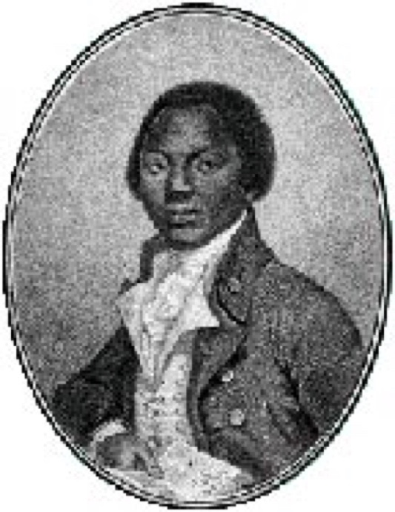

*Source*: Olaudah Equiano, *The Interesting Narrative of the Life of Olaudah Equiano, or Gustavus Vassa, The African, Written by Himself*, Werner Sollors, ed. (New York: W. W. Norton, 2001).

**Lesson 4**

***Student Handout 4.5*—*Primary Sources on Equiano***

###### Primary Source 1

Like the Israelites in their primitive state, our government was conducted by our chiefs or judges, our wise men and elders; and the head of a family with us enjoyed a similar authority over his household with that which is ascribed to Abraham and the other patriarchs. . . .

. . .I thought now of nothing but being freed, and working for myself, and thereby getting money to enable me to get a good education; for I always had a great desire to be able at least to read and write; and while I was on ship-board I had endeavored to improve myself in both. While I was in the Ætna particularly, the captain's clerk taught me to write, and gave me a smattering of arithmetic as far as the rule of three. . . .

. . .Hitherto I had thought only slavery dreadful; but the state of a free negro appeared to me now equally so at least, and in some respects even worse, for they live in constant alarm for their liberty, which is but nominal, for they are universally insulted and plundered without the possibility of redress. ... In this situation, is it surprising that slaves, when mildly treated, should prefer even the misery of slavery to such a mockery of freedom? . . .

*Source*: Olaudah Equiano, *The Interesting Narrative of the Life of Olaudah Equiano, or Gustavus Vassa, The African, Written by Himself*, Werner Sollors, ed. (New York: W. W. Norton, 2001), 30, 67, 90-91.

**Primary Source 2**

On January 28, 1788, Equiano published an article directed toward the white racist James Tobin:

Now, Sir, would it not be more honor to us to have a few darker visages than perhaps yours among us [?]... As the ground-work, why not establish intermarriages at home, and in our Colonies? and encourage open, free, and generous love upon Nature’s own wide and extensive plan, subservient only to moral rectitude, without distinction of the color of a skin?... Away then with your narrow impolitic notion of preventing by law what will be a national honor, national strength, and productive of national virtue***—***Intermarriages!

*Source*: Olaudah Equiano, *The Interesting Narrative of the Life of Olaudah Equiano, or Gustavus Vassa, The African, Written by Himself*, Werner Sollors, ed. (New York: W. W. Norton, 2001), 198-199.

**Lesson 4**

***Student Handout 4.6—Secondary Sources on Equiano***

###### Secondary Source 1

Obviously, then, in the case of Olaudah Equiano, or Gustavus Vassa, the African, assimilation and ethnic self-dramatization always go hand in hand. It is of some significance in this context that Equiano spends his period of apprenticeship mainly on boats and ships, “moving,” as Paul Gilroy writes, “to and fro between nations, crossing borders in modern machines that were themselves micro-systems of linguistic and political hybridity.” Equiano here literally moves between cultures, yet not as the postcolonial hero par excellence***—***not as homeless wanderer and transcultural crossover artist***—***but as an incorporated subject who is adaptable enough to play the role of a free (and national) individual with amazing conviction and persuasiveness.

*Source*: Frank Kelleter. “Ethnic Self-Dramatization and Technologies of Travel in The Interesting Narrative of the Life of Olaudah Equiano, Gustavus Vassa, the African, Written by Himself (1789).” *Early American Literature* (2004) 39.1: 75.

###### Secondary Source 2

Equiano claims that he was born in 1745 in the part of Africa that is now Nigeria. However, as the historians Vincent Carretta and S. E. Ogude have shown, this claim may be false. From the evidence gathered by Carretta, it seems possible that Equiano was not born in Africa, but in South Carolina.

*Source*: Frank Kelleter. “Ethnic Self-Dramatization and Technologies of Travel in The Interesting Narrative of the Life of Olaudah Equiano, Gustavus Vassa, the African, Written by Himself (1789).” *Early American Literature* (2004) 39.1: 70.**Assessment**

You have been introduced to several different and important individuals who helped to shape the various societies of the Atlantic rim from 1500 to 1800. Whether they were mapmakers, slaves, mestizos, or conquistadors, each had a role to play. These unit assessments are designed to get you to think about what you have learned and to demonstrate your understanding of the processes that created the new societies in the Atlantic rim.

Directions to the student: Choose one of the following assessments to complete.

1. Create an annotated timeline to show which person is most historically significant for the creation of new societies in the Atlantic rim. Use your knowledge from the unit and conduct research on your own as well. In addition, create a map showing which part of the Atlantic rim your person was from; if she or he traveled within the Atlantic rim, be sure to show us where and when she or he traveled as well.

2. Each one of the figures in Lessons 3 and 4 goes by more than one name. Using what you learned from this unit, pick one of the individuals from Lesson 3 or 4: La Malinche, Pocahontas, Inca Garcilaso de la Vega, or Olaudah Equiano. Do additional research on their names. Were their names chosen by them or given to them? How does their name reveal their Atlantic rim identity? How does it hide another part of their identity? Which name did they personally go by? By which name are they remembered in history? Why do you think this is?

**This unit and the Three Essential Questions**

|  |  |
| --- | --- |
| envir_icon | How might you explain the forced migration of millions of African slaves to the Americas in terms of environmental and ecological changes in the Americas in the sixteenth and seventeenth centuries? |
| humans_icon | Between 1500 and 1800, only around 2 million Europeans migrated to the Americas, some of them only temporarily. Under those circumstances, why was it possible for so few Europeans to dominate large areas of the Americas politically, socially, and economically? |
| ideas_icon | What part did Christianity play in the ways Africans, Europeans, and Native Americans interact in the Atlantic rim lands? |

**This unit and the Seven Key Themes**

This unit emphasizes:

Key Theme 1: Patterns of Population

Key Theme 3: Uses and Abuses of Power

Key Theme 5: Expressing Identity

**This unit and the Standards in Historical Thinking**

Historical Thinking Standard 1: Chronological Thinking

The student is able to (F) reconstruct patterns of historical succession and duration.

Historical Thinking Standard 2: Historical Comprehension

The student is able to (A) identify the author or source of the historical document or narrative and assess its credibility.

Historical Thinking Standard 3: Historical Analysis and Interpretation

The student is able to (B) consider multiple perspectives.

Historical Thinking Standard 4: Historical Research Capabilities

The student is able to (A) formulate historical questions.

Historical Thinking Standard 5: Historical Issues-Analysis and Decision-Making

The student is able to (A) identify issues and problems in the past and analyze the interests, values, perspectives, and points of view of those involved in the situation.

**Resources**

***Resources for teachers***

Carretta, Vincent. *Equiano, the African: Biography of a Self-Made Man*. Athens: University of

Georgia Press, 2005. Carretta presents compelling evidence that Equiano began life in South Carolina, not in Africa, as his autobiography claims. Equiano, however, did write passionately against slavery and the infamous Middle Passage. This is the definitive biography of Equiano and a useful social history of the late eighteenth-century Atlantic rim. The illustrations and maps provide useful views of that world as well.

Fitch, Nancy. “The Conquest of Mexico.”

<http://www.historians.org/Tl/LessonPlans/ca/Fitch/index.htm>

This is one of the helpful electronic lessons sponsored by the American Historical Association. Nancy Fitch’s unit provides useful explanations, primary source texts and images, as well as suggestions for helping students improve their analytical skills.

León-Portillo, Miguel. *The Broken Spears: The Aztec Account of the Conquest of Mexico.*

Boston: Beacon Press, 1992.

Professor León-Portillo uses primary Náhuatl sources to portray both the Mexica and the Spanish cultures in conflict during the Spanish conquest of the Aztec empire.

National Park Service. “Module I: cultural heritage of Africans in North America associated

with their role in the growth of the Spanish, Dutch, English, and French Colonies.” http://www.cr.nps.gov/ethnography/aah/aaheritage/modI.htm

Thornton, John. *Africa and Africans in the Making of the Atlantic World: 1400–1800*.

Cambridge: Cambridge UP, 1998.

This book explores Africa’s involvement in the Atlantic world from the fifteenth through the eighteenth centuries. It focuses especially on the causes and consequences of the slave trade, in Africa, Europe, and the Americas.

Townsend, Camilla. *Pocahontas and the Powhatan Dilemma: The American Portrait Series.*

New York: Hill and Wang, 2004.

This biography of Pocahontas presents the different roles Pocahontas played within her father’s world and the British colony in Virginia.

Walvin, James. *Making the Black Atlantic: Britain and the African Diaspora*. London: Cassell,

2000.

In a relatively small book, Walvin summarizes the most recent round of scholarship concerning the British end of the Atlantic slave trade, especially the key position Africans held in directing much of the Atlantic Slave Trade.

Other images of La Malinche can be found in a book created by the allies of the Spanish, the Tlaxcalans, called LIENZO DE TLAXCALA. The images can be seen at the Bancroft Library website: <http://bancroft.berkeley.edu/Exhibits/nativeamericans/25.html>

***Resources for students***

“The Aztecs: Empire Builders.” *Calliope: Exploring World History*, Dec. 2005.

Take a private tour of Tenochtitlán, then head for the fields for a closer look at inventive methods you won’t believe. Meet a few Aztec children and learn firsthand what their life was like. You’ll want to go with them to check out a few ball games and to see a *volador* (something like a bungee-jumper).

Cypess, Sandra Messinger. *La Malinche in Mexican Literature: From History to Myth*. Austin: University of Texas Press, 1991Cypess links depictions of Malinche over time with political concerns in Mexico.

Brycchan Carey, Olaudah Equiano, or, Gustavus Vassa, the African, http://www.brycchancarey.com/equiano/.An extensive biographical website created by a British professor of English literature with extracts from Equiano’s autobiography.

“The Incas of Peru.” Calliope Magazine. 2000.

Learn the myths of Lake Titicaca, the sun-god’s birthplace. Find out why ancestor worship and mummy processions were important. Enter the time period when Pachacuti ruled and read how he reorganized the government, firmly established a strict form of taxation, and ordered the building of a great palace in the capital city of Cuzco. You’ll also learn how the Inca built one of the world’s greatest road systems, but used no wheeled vehicles.

Pocahontas, Association for the Preservation of Virginia Antiquities, Jamestown Rediscovery, http://www.apva.org/history/pocahont.html

This is a detailed online biography of Pocahontas on the official Jamestown website.

Pocahontas Myth, Rankokus Indian Reservation, http://www.powhatan.org/pocc.html.

This website of the Powhatan people discusses and debunks the “Pocahontas myth.”

Africans in America Resource Book, The Terrible Transformation, Ouladah Equiano, PBS, <http://www.pbs.org/wgbh/aia/part1/1p276.html>.

PBS’s “Africans in America” series gives online texts and interpretations. The video can be a great tool for students who benefit from a multimedia approach to history.

**Correlations to National and State Standards**

***National Standards for World History***

Era 6: The Emergence of the First Global Age, 1450-1770. 1B: The student understands the encounters between Europeans and peoples of Sub-Saharan Africa, Asia, and the Americas in the late 15th and early 16th centuries.

***California: History-Social Science Content Standard***

Grade Seven, 7.7. Compare and contrast the geographic, political, economic, religious, and social structures of the Meso-American and Andean civilizations. 7.11. Students analyze political and economic change in the sixteenth, seventeenth, and eighteenth centuries (the Age of Exploration, the Enlightenment, and the Age of Reason).

***Virginia History and Social Science Standards of Learning***

WHII.4. The student will demonstrate knowledge of the impact of the European Age of Discovery and expansion into the Americas, Africa, and Asia.

**Conceptual links to other teaching units**

Landscape Teaching Units 6.4 (The Global Economy Takes Shape) and 6.5 (The Making of the Atlantic Rim) focused on large-scale and trans-oceanic developments, especially economic and social. During the 1500-1800 period, Europe, or more specifically, western and central Europe, was coming to play a larger role in world history. Part of the explanation is simply that Europe became a hub of global exchange, whereas before 1500 it had been on the “edge” of Afroeurasia since no communication across the Atlantic or Pacific oceans yet existed. After 1500, the creation of a world-wide system of communication by sea, a system that European mariners were instrumental in building, meant that all sorts of new products, plants, animals, knowledge, and ideas began to flow through Europe. European scholars and intellectuals took great interest in this new knowledge (as did people in other parts of Afroeurasia when new knowledge reached them). This was almost certainly a stimulating factor in the burst of interest in scientific and philosophical inquiry that took place in Europe, especially in the 1600s. Landscape Teaching Unit 6.6 explores the Scientific Revolution in Europe. It also leads students to understand that that movement built, not only on new knowledge, but the knowledge that had been accumulating in Afroeurasia for centuries and of which Europe was an heir. The Scientific Revolution was also one of the foundations of the modern world, which we investigate in Big Era Seven.

1. Rodolfo Acuña-Soto, David W. Stahle, Malcolm K. Cleaveland, and Matthew D. Therrell, “[Megadrought and Megadeath in 16th Century Mexico](http://www.cdc.gov/ncidod/EID/vol8no4/01-0175.htm),” *Emerging Infectious Diseases* 8: 4 (April 2002). [↑](#footnote-ref-1)